**Introduction:**

Region – geographical area

Available Zone = at least 2 per region. Far away so that floods don’t effect both of the available zones,

Edge locations – cloud front- covered later

https://aws.amazon.com/about-aws/global-infrastructure/ review this for updated numbers

**AWS Platform Overview:**

**Compute**

EC2 - elastic compute cloud

EC2 container service – run and manage docker containers

Elastic bean stalk – for developers who don’t know about AWS but just upload code

Lambda – don’t have to worry about underlying virtual machines or OS whatsoever.

Lightsail – VPS – if you don’t want to know anything about AWS.

Batch – used for batch computing in the cloud.

**Storage**

S3 – Simple storage service

EFS – Elastic file system

Glacier – Data archrivals – check once in a year or very rare

SnowBall – large amount of data in to data center. Write it in to disk and then send it to data center manually.

Storage gateway – Eg: store data in head office and then replicate it in other offices

**Databases**

RDS – MySQL server . Amazon MYSQL - Arora

Dynamo DB – For NOSQL

Elastic Cache – Cache the top products.

Redshifting – data ware housing

**Migration:**

AWS Migration hub – to track your migration to integrate with AWS services

Application Discovery service – Automated set of tools. Tracking Dependencies

Database migration service – oracle hated to this. Migrate DB to AWS. **AWS migration hub** helps track of it

Server Migration Service –Serer in to AWS

Snowball – Migrating large of data in to AWS

**Networking & Content Delivery:**

VPC – Firewalls, Etc . there is separate section. Fundamental part of the exam

CloudFront – content delivery network

Route53 – DNS server

API gateway – imp for developer certificate – way of creating own API for your other services to talk to

Direct connect – direct connect to your VPC from your office

**Developer Tools - won’t appear in developer ass exam**

Code star – project mange your code

Code Commit – Store your code

Code Build – After code is ready, this will build

Code Deploy – Deployment services. automates

Code Pipeline – organize, Visulaize the steps to release your software

X-Ray – use to debug issues and to find bottle necks

Cloud 9 - its like an IDE to develop code in AWS console.

**Management tools**

Cloud watch – monitoring service .imp for sysops exam

Cloud formation – for solutions architect job – way of scripting your infrastructure

cloudTrail – log changes to your AWS environment. Stores for one week

config – monitors entire AWS environment. Visualize AWS env – imp for dev exam

OPSworks – similar to Elastic bean uses chef and puppet

Service catalog – Manage catalog of IT services DB, software,..etc. – no for deve exam

Systems manager – used for EC2. Group resources by department, etc - no for deve exam

Trusted advisor – advice for security, open ports, suggestion to save money

Vs inpector in next page

Managed services - if you don’t want to manage services, AWS will do it

**Media Services**

Elastic Transcoder – converts videos according to devices it is played on.

Media Convert, - multi screen broadcast

Package - protects

Live – broadcast,

Tailor - target advertising in to video with good quality

**Machine Learning**

Sage maker – deep learning

Comprehend – sentiment analysis

DeepLens – Artificially aware camera (physical hardware)

Lex – Way of communicating with customers

Machine Learning –

Polly – not for exam. Takes text and converts in to voice

Rekognition – upload a file it will tell what is the image.

Amazon translate – like google translate

Amazon transcribe – automatic speech recognition, speech to text and then use translate to other languages

**Analytics**

Athena – SQL queries against things like Excel, etc in S3 bucket

EMR – for solutions architect – processing large amount of data

Cloud Search – search in discussion forms

Elastic Search Service – same as above

Kinesis – for big data specialty – ingest large data

Kinesis video streams – same for videos

Quick Sight – great AI tool – not for exam

Data pipeline – important for exam developer

Glue – ETL for data

**Security Identity and Compliance**

IAM – Identity access management – important for this exam

Cognito – device authentication service – for mobile devices

Guard Duty – malicious activity in AWS

Inspector – agent on EC2 – schedule for vulnerability check, etc

Macie – looks for personal details

Certificate manger – way of managing SSL certificates

CloudHSM – cloud Hardware security modules

Directory Service – integrating Microsoft directories with AWS

WAF – application level security, SQL injections,

Shield – prevents DDoS attacks

Artifact – for audit and compliance, downloading and inspecting amazon documentation

**Mobile Services**

Mobile Hub – not for exam

PinPoint – push notification for mobile users – not for exam

AWS AppSync – updates data for users

Device Farm – testing apps

Mobile analytics

**AR/VR – code name Sumerian**

Not for exams

**Application Integration –**

Step function – managing different lambda functions

Amazon MQ – Message queues

SNS - simple notification service

SQS – decoupling infrastructure

SWF – simple workflow service – amazon uses it in warehouses

These three are important for dev associate exam

**Customer Engagement –**

Connect- having like a call center in cloud – not for exam

Simple Email Service – send large amount of emails

**Business productivity**

Alexa for business – Eg: send out message to repair printer - not for exam

**Chime –like google hangouts**

Work Docs – Like dropbox – may be important sol architect

Workmail – like google mail

**Desktop and App Streaming**

Workspaces – actual environment in datacenter

App stream – streamed live to you device -

**IOT –**

IOT – sending back sensor info

IOT dev management – to manage in scale

Amazon FReeRtos – for microcontrollers

Greengrass – machine learning interface

**Game development**

Game lift – service to develop games

**Topics for exam:**

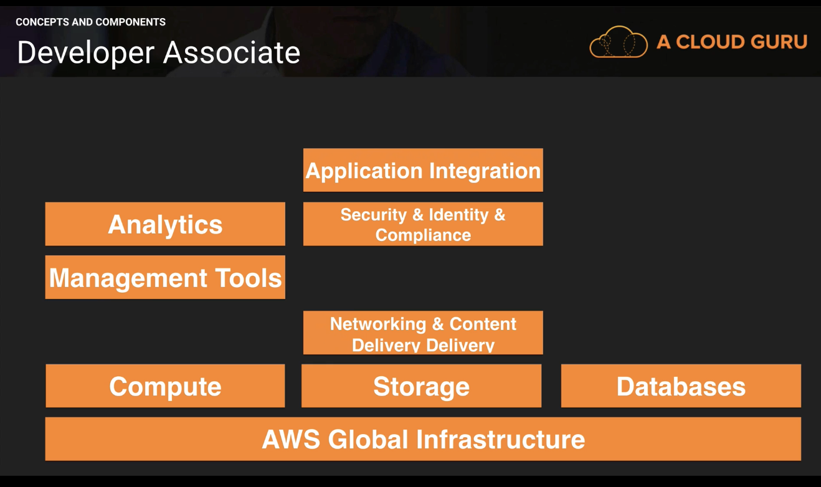

IAM:

-centralized control of your AWS account

- Shared access to your AWS account

- granular permission

- Identity federation (including active directory, Facebook, LinkedIn)

- Multifactor authentication

- Provide temporary access for users/devices and services where necessary

- Allows to set up your own password rotation policy

- integrates with different AWS Services

- Supports PCI DSS compliance

Critical Terms:

Users – End Users

Groups – grouping your users and giving different set of permissions to them

Roles – You create roles and can then assign them to AWS resources

Policies – a doc that defines one or more permissions

101 Lab:

<https://aws.amazon.com/iam/> - amazon link

**IAM is global**. It has no region. When you create users, they can be anywhere in the world.

**Root account** – email address you used to create aws account.

To look in to aws console,

Programmatically 🡪 access key Id, secret access key

Manually 🡪 user id and password

Roles in side tab 🡪 to access permissions to entities

**What are IAM roles?**

IAM roles are a secure way to grant permissions to entities that you trust. Examples of entities include the following:

* IAM user in another account
* Application code running on an EC2 instance that needs to perform actions on AWS resources
* An AWS service that needs to act on resources in your account to provide its features
* Users from a corporate directory who use identity federation with SAML

IAM roles issue keys that are valid for short durations, making them a more secure way to grant access.

**STS - Security Token Service**

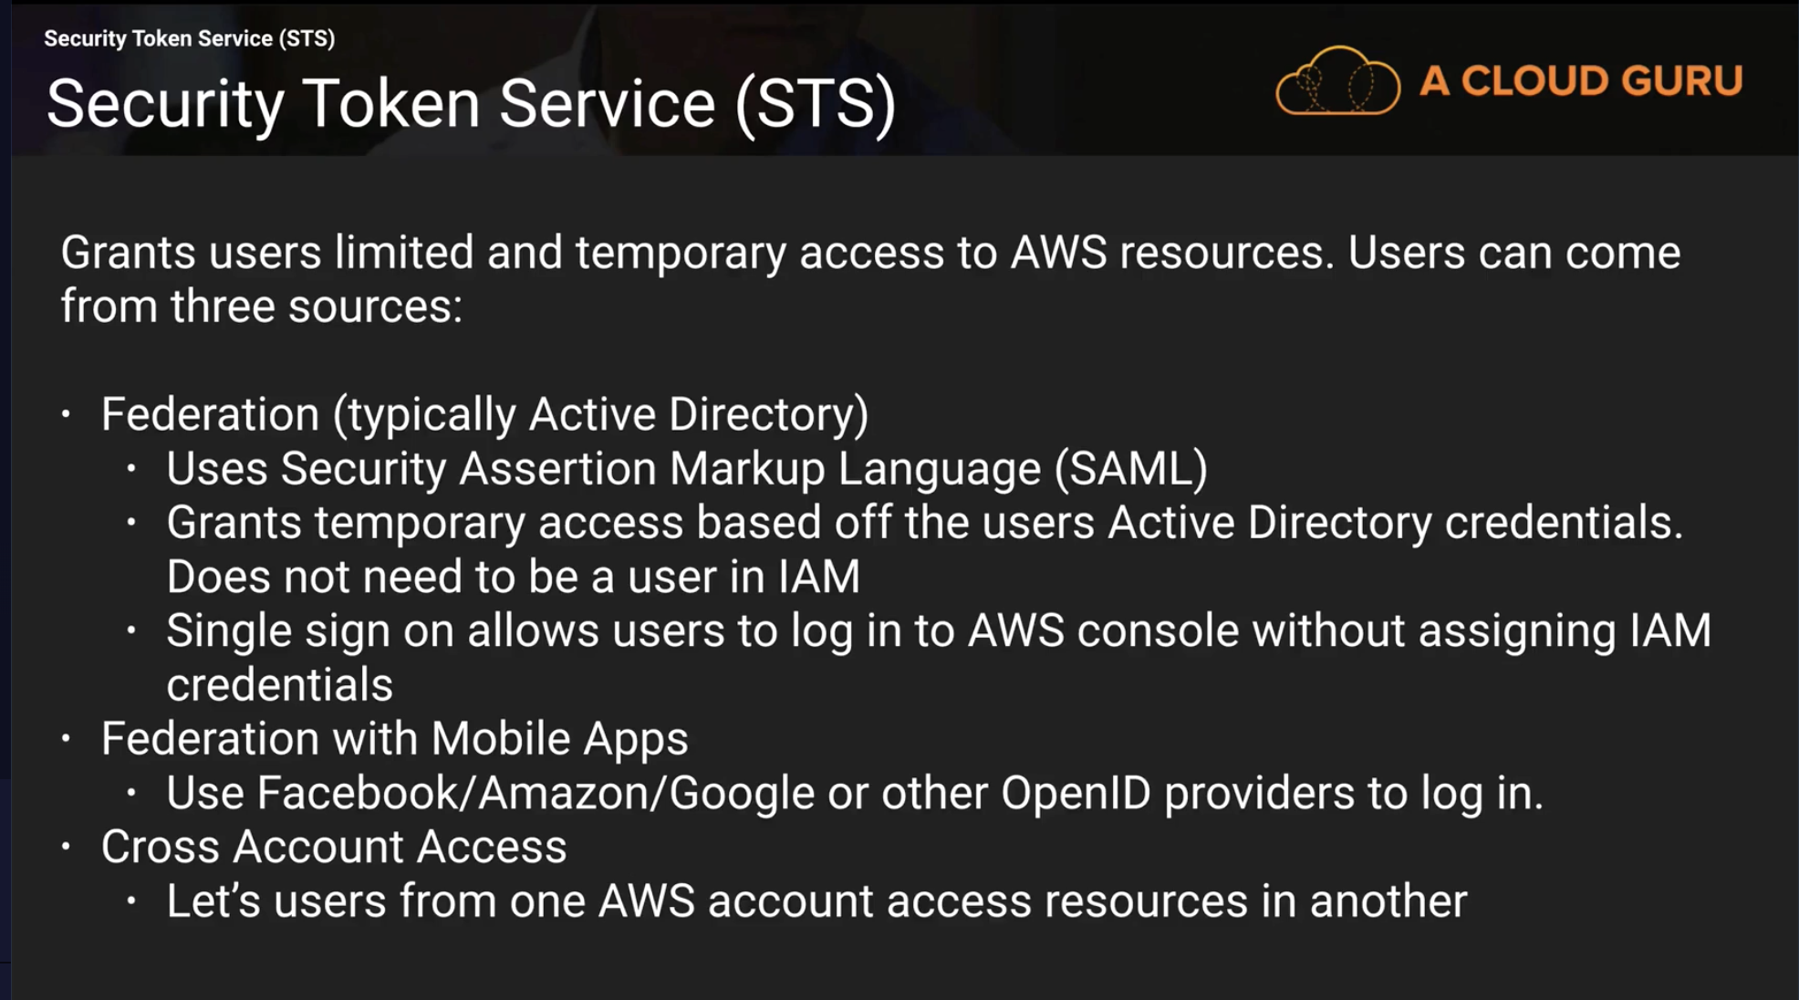

STS Grants users limited and temporary access to AWS resources

Users can come from:

1. Federation - active directory

SAML 🡪 Security Assertion Markup Language

User does not need to be a user in IAM

Temporary access is users active directory credentials

1. Federation with Mobile Apps

Use Facebook/Google …etc open ID providers

1. Cross account access

Between one aws account to another

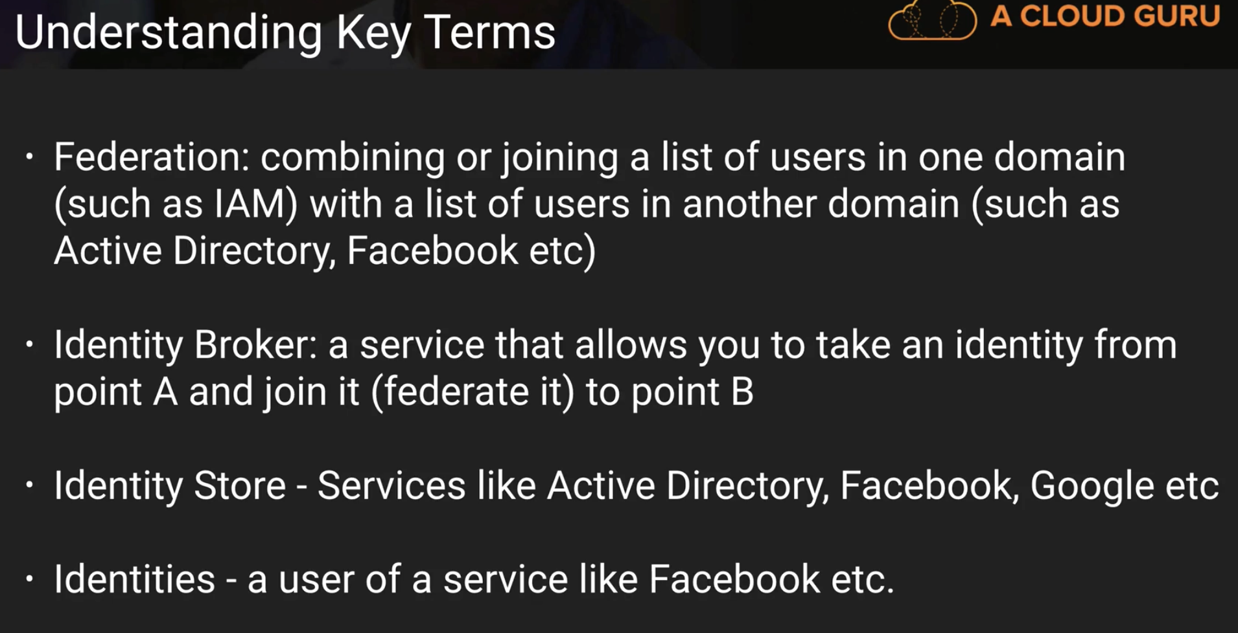

**Imp**: You have to develop your own Identity Broker. It does not come out of the box

**Scenario 1**

**Whole process in simple 3 steps…very very important**

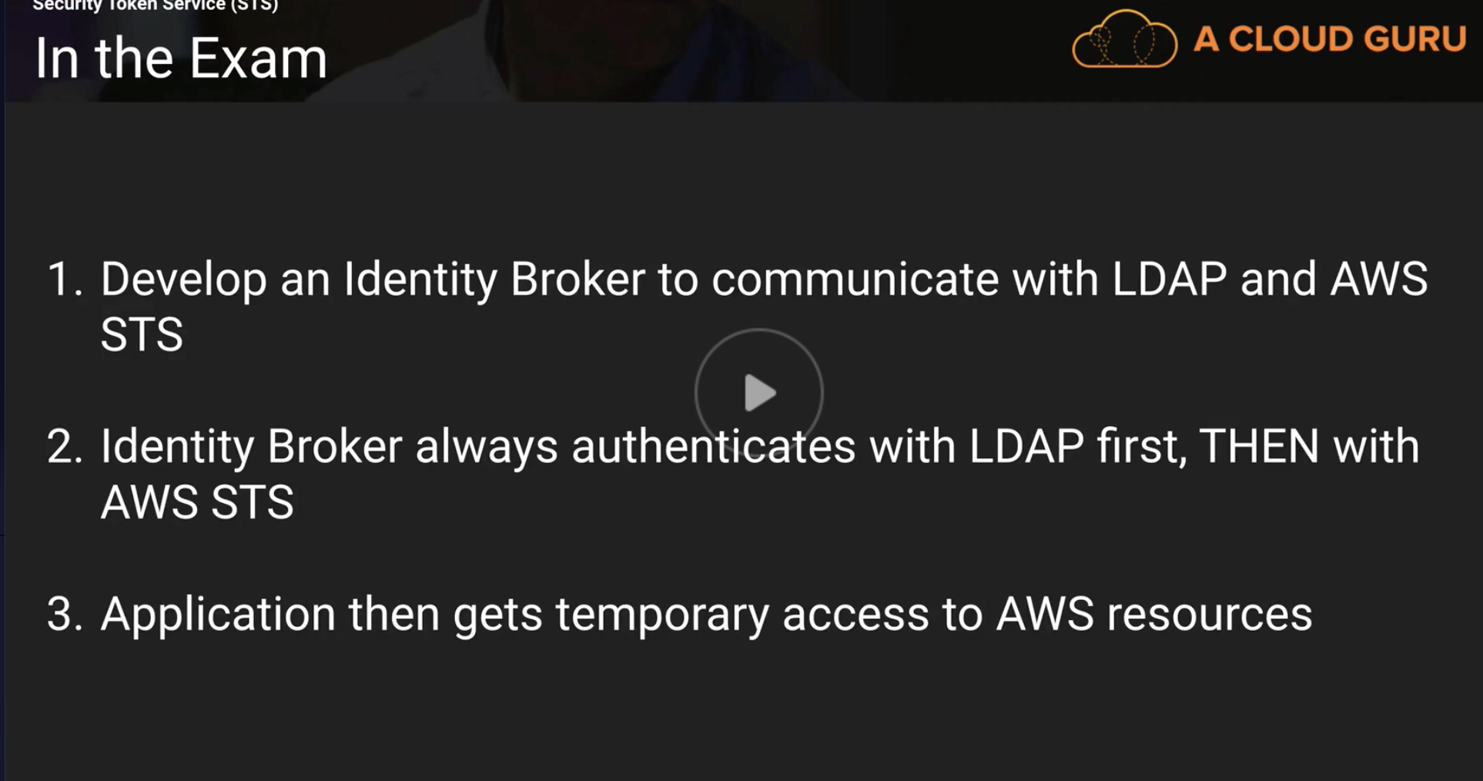

**Scenario 2**

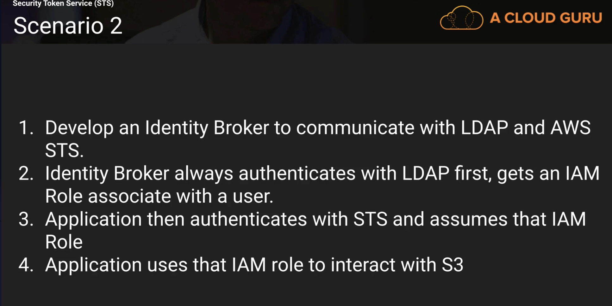

**Active Directory Lesson**

Q) Can you authenticate using Active directory?

Ans) Yes. Using SAML (Security Assertion Markup Language)

Q) order of these two steps remember the order

1) authenticating to Active directory

2) temporary security credential

**Web Identity Federation**

RoleArn 🡪 Inside Web Identity Federation Playground(in IAM)

**PROCESS**:

Authenticate with your identity provider

temp security credentials

Call assume role with web identity

Now you can access AWS RESOURCES

Doing this with programmatically is out of scope for exam

**IAM is universal. It does not apply to regions**

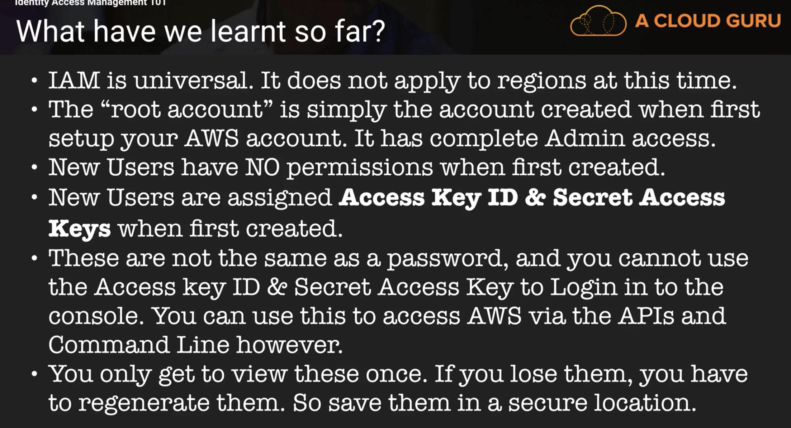

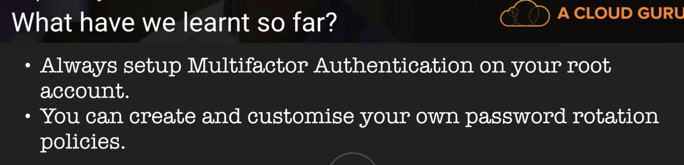

**Ques)**

AWS recommends that EC2 instances have credentials stored on them so that the instances can access other resources (such as S3 buckets).

Ans) False. We use AssumeRole withSAML for this

def: IAM allows you to manage users, groups, and roles and their corresponding level of access to the AWS Platform.

**EC2 101**

Note: Read EC2 FAQs before going to the exam

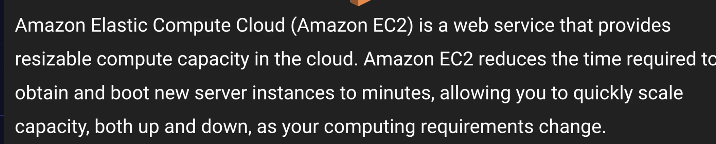

Linux – by second. Other instances pay by hour.

More upfront capacity reservation more discount you get.

Spot – bidding to pay instance. **See below**

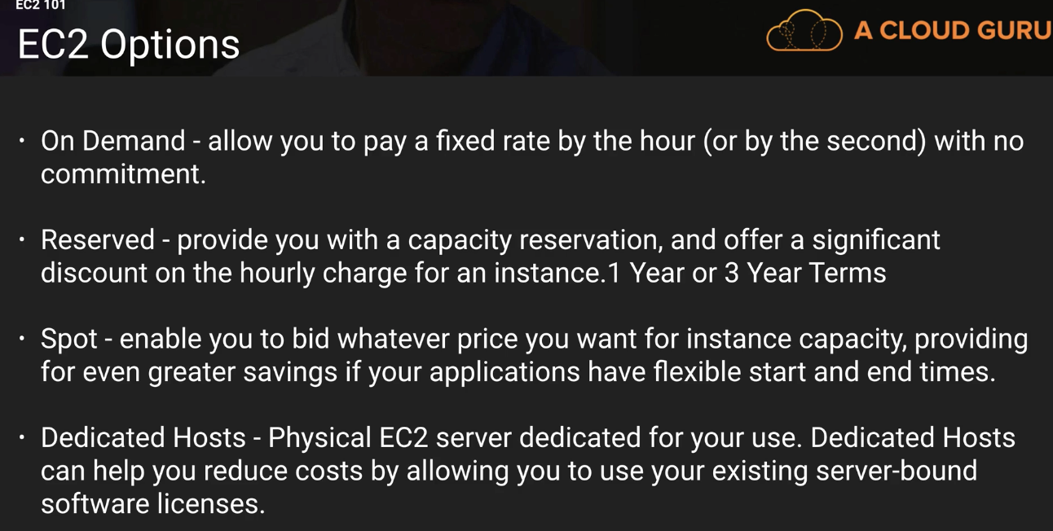

SPOT- research more

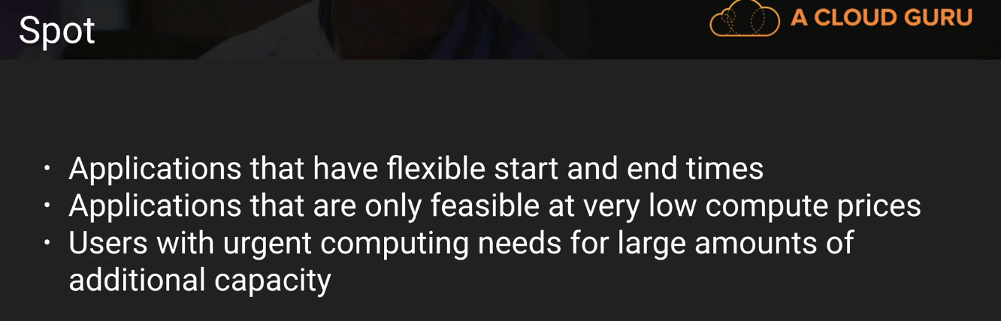

Four different types of EC2 instances – On Demand, Reserved, SPOT, Dedicated Hosts

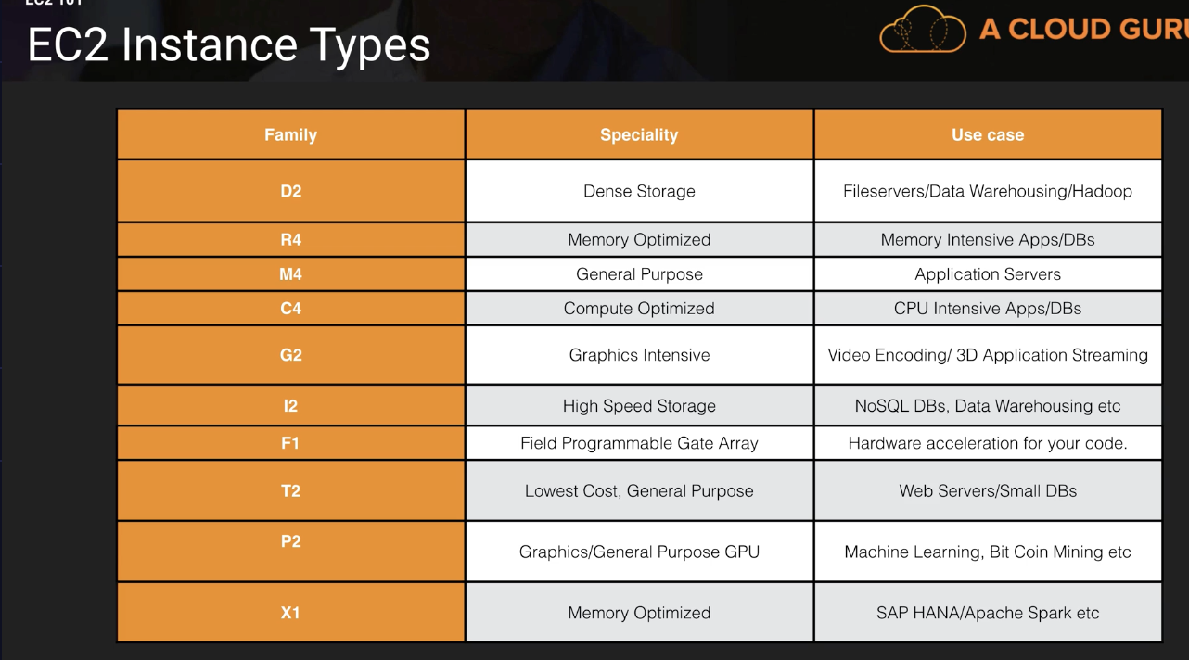

Trick to remember EC2 family types - DR Mc GHIFT PX – anagram

Here H type is a new one. – Hybrid - "H1 instances feature up to 16 TB of HDD-based local storage, deliver high disk throughput, and a balance of compute and memory."

Given a situation and you have to choose type. Note: there might be char which is not a type at all.

EBS:

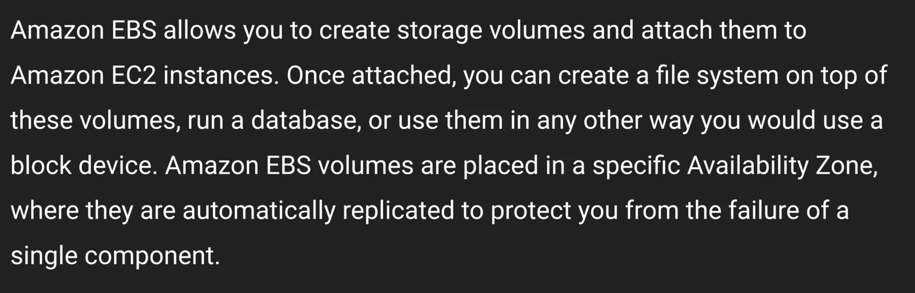

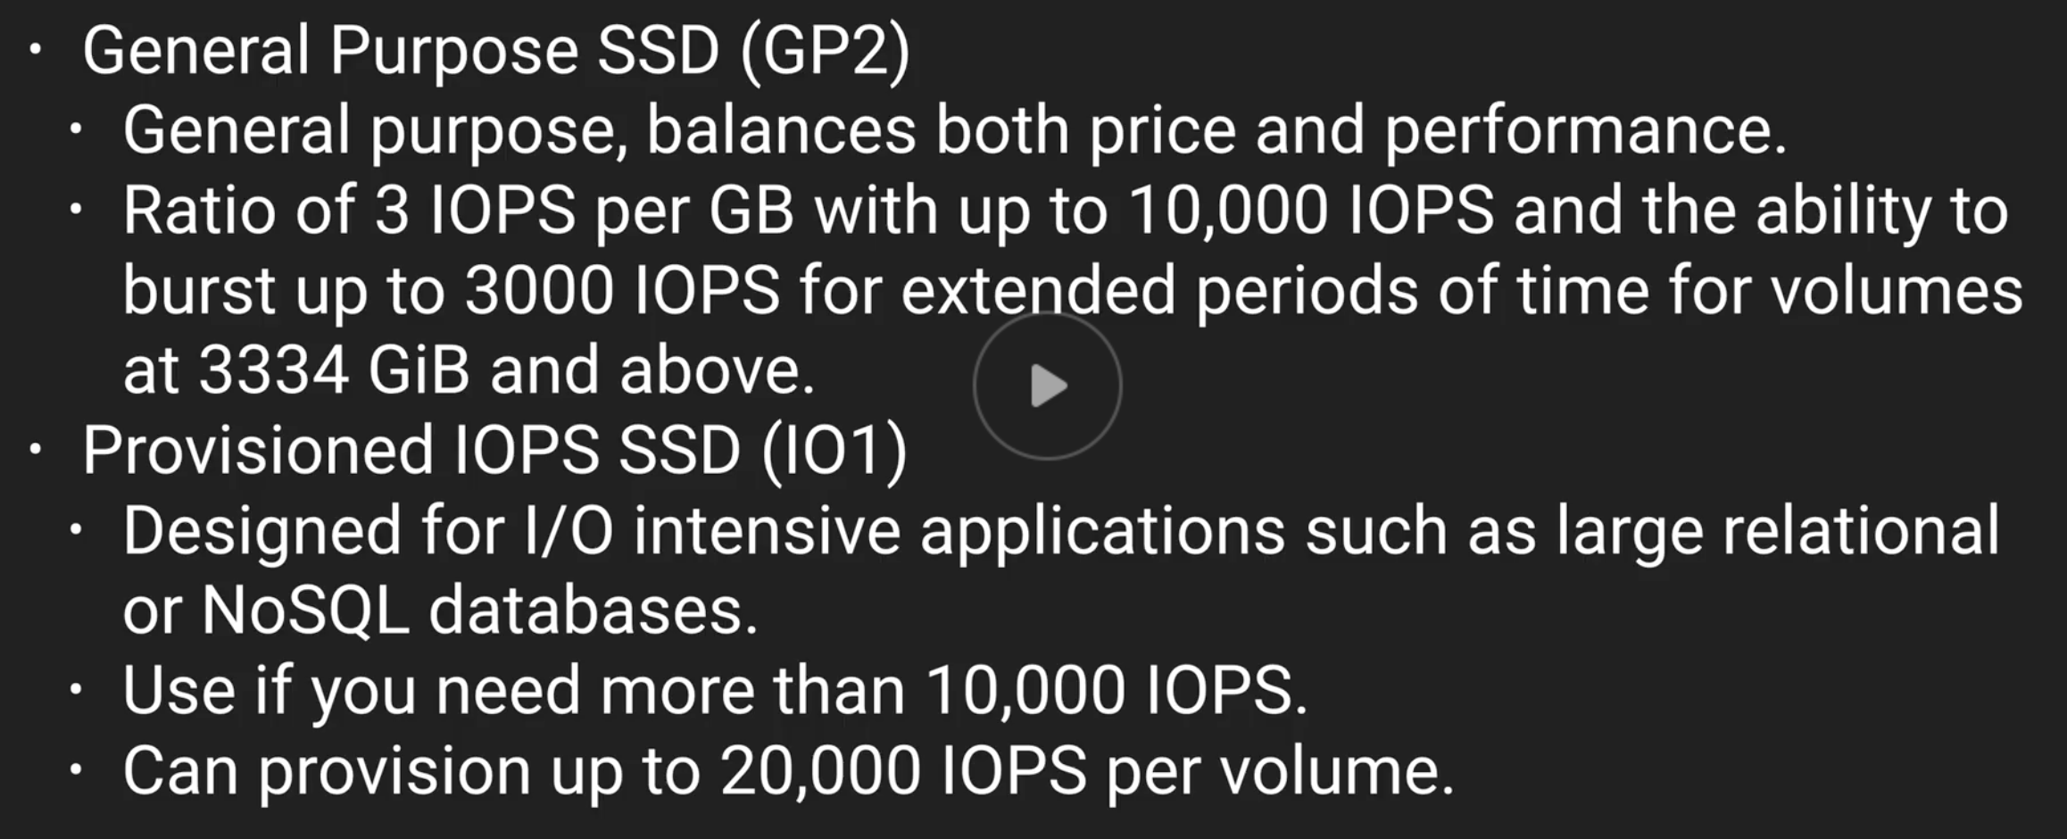

From Above, Note: **Provisioned IOPS SSD** for 10,000 – 20,000 IOPS

**General Purpose SSD(GP2)** for < 10,000 IOPS

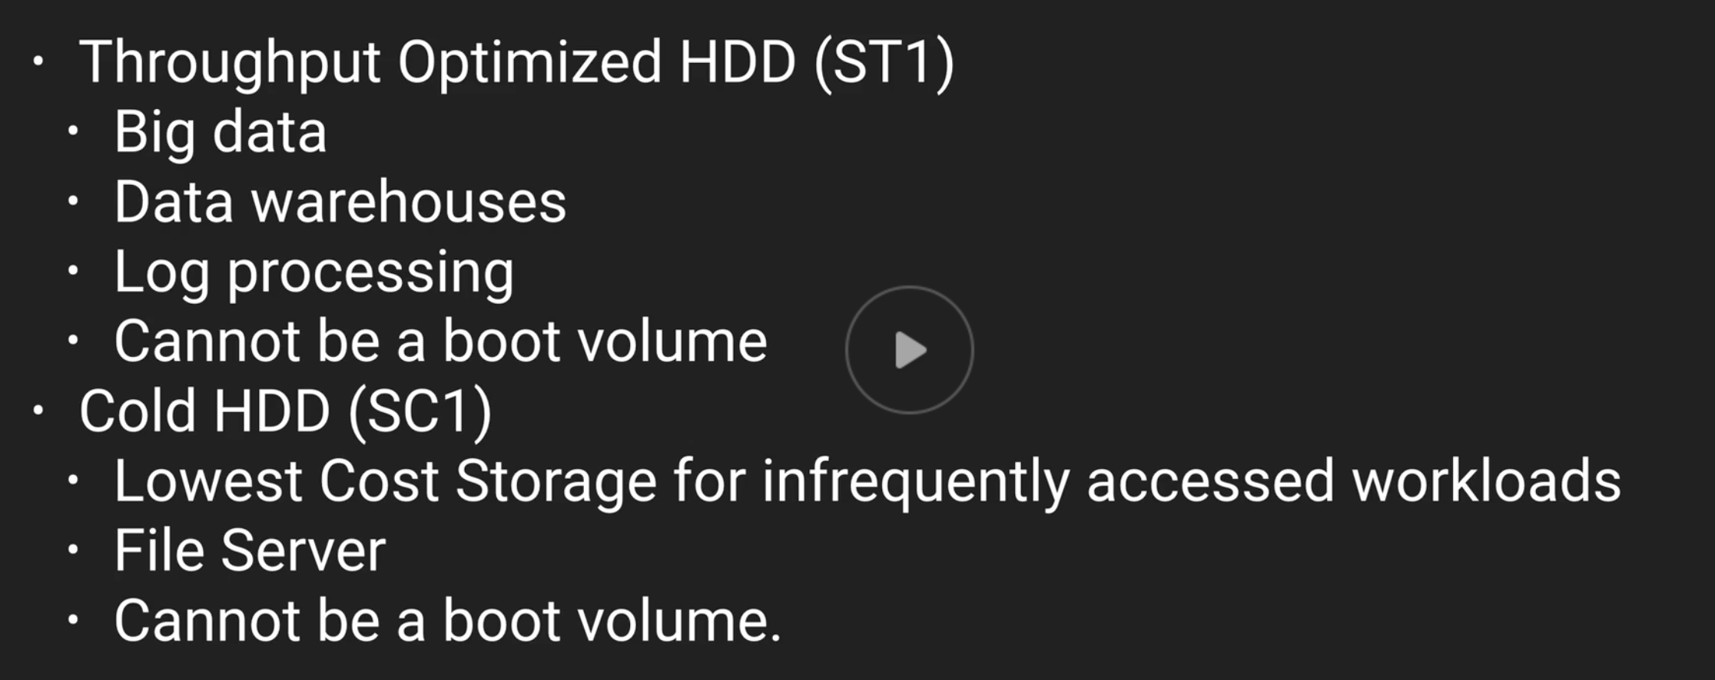

These TWO ARE MAGNETIC STORAGE. OLD SCHOOL ROTATING DISKS

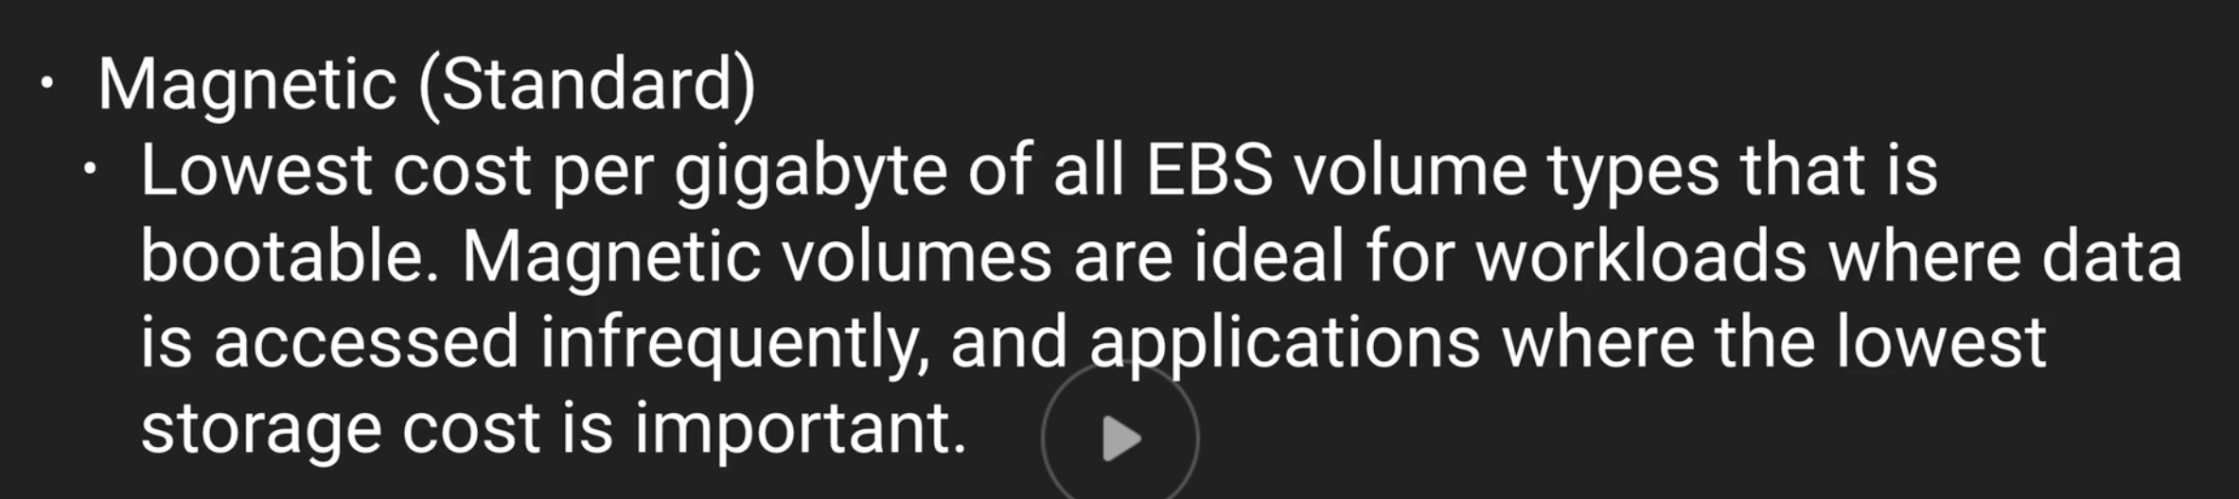

This one is bootable while other two magnetic ones are not.

So there are Total 5 types of storage types

Exam Tips So far:

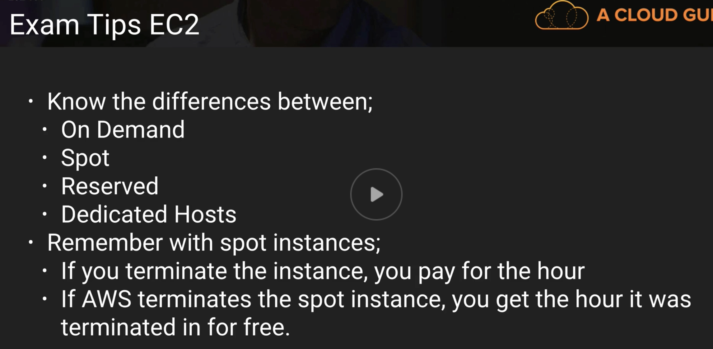

On Demand – allow you to pay a fixed rate by hour (Second for Linux)

Eg: Unpredictable work loads

SPOT – rate goes up and down basing on demand of EC2.

You bid a price. If your spot goes higher than bid price then nothing. Then if SPOT goes down than bid then you provision your EC2 instances. If SPOT goes above bid after you provision ur instances then instances will be terminated.

E.g: Apps that have flexible start and end times. Like some company does data processing 3am on a Sunday when the demand is less.

Reserved – have to sign 1 to 3year contract. Get good discount

Eg: Apps are well tested.

Dedicated - Physical EC2 dedicated for your use.

Eg: for government. , where gov wont allow for multi tenant virtualization

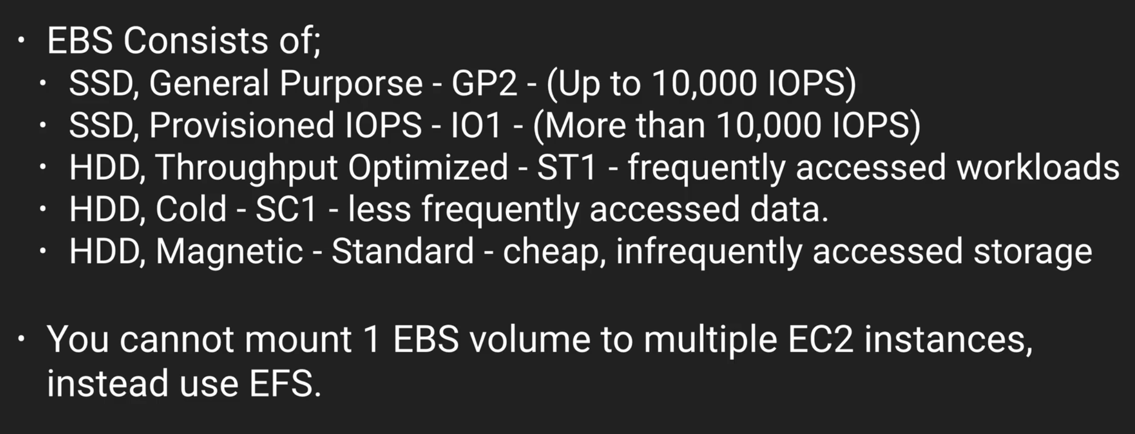can only

Note:

Amazon Machine Images (AMIs)

A given public AMI be used to launch EC2 instances in the same AWS region as the AMI is stored

Note: one subnet is for one availability zone.

Root volume cannot be encrypted directly.

While creating an instance, the tags are for you to know which team of the organization is costing more, etc. so you should tag down to different teams.

System Status check : Checking whether Hypervisor is working fine or not

Instance Status check : checking whether Operating system is getting traffic or not.

**Key Points for Exam:**

Termination protection is by default off. You must turn it on.

By Default, root EBS volume to be deleted when instance terminated. You can turn that off.

EBS Root volume provided by Amazon cannot be encrypted but additional vols can be.

Important Slide:

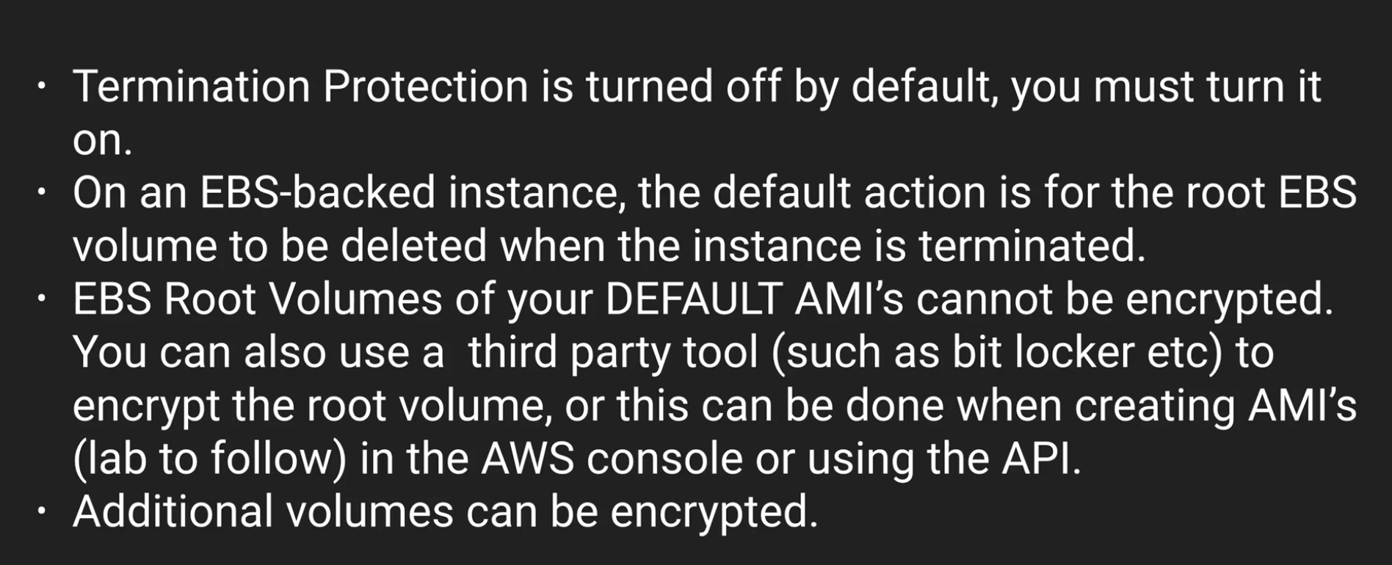

**Security Groups:**

Security group is virtual firewall.

One Instance can have multiple Security groups

Note: Rules across security groups happen immediately.

As soon as you add an inbound rule, out bound rules are added automatically (this I called STATEFUL)

Using security groups, you cannot deny a rule.

All inbound rules are denied by default. All outbound rules are allowed by default.

So you just allow traffic. More on this in **VPC section**

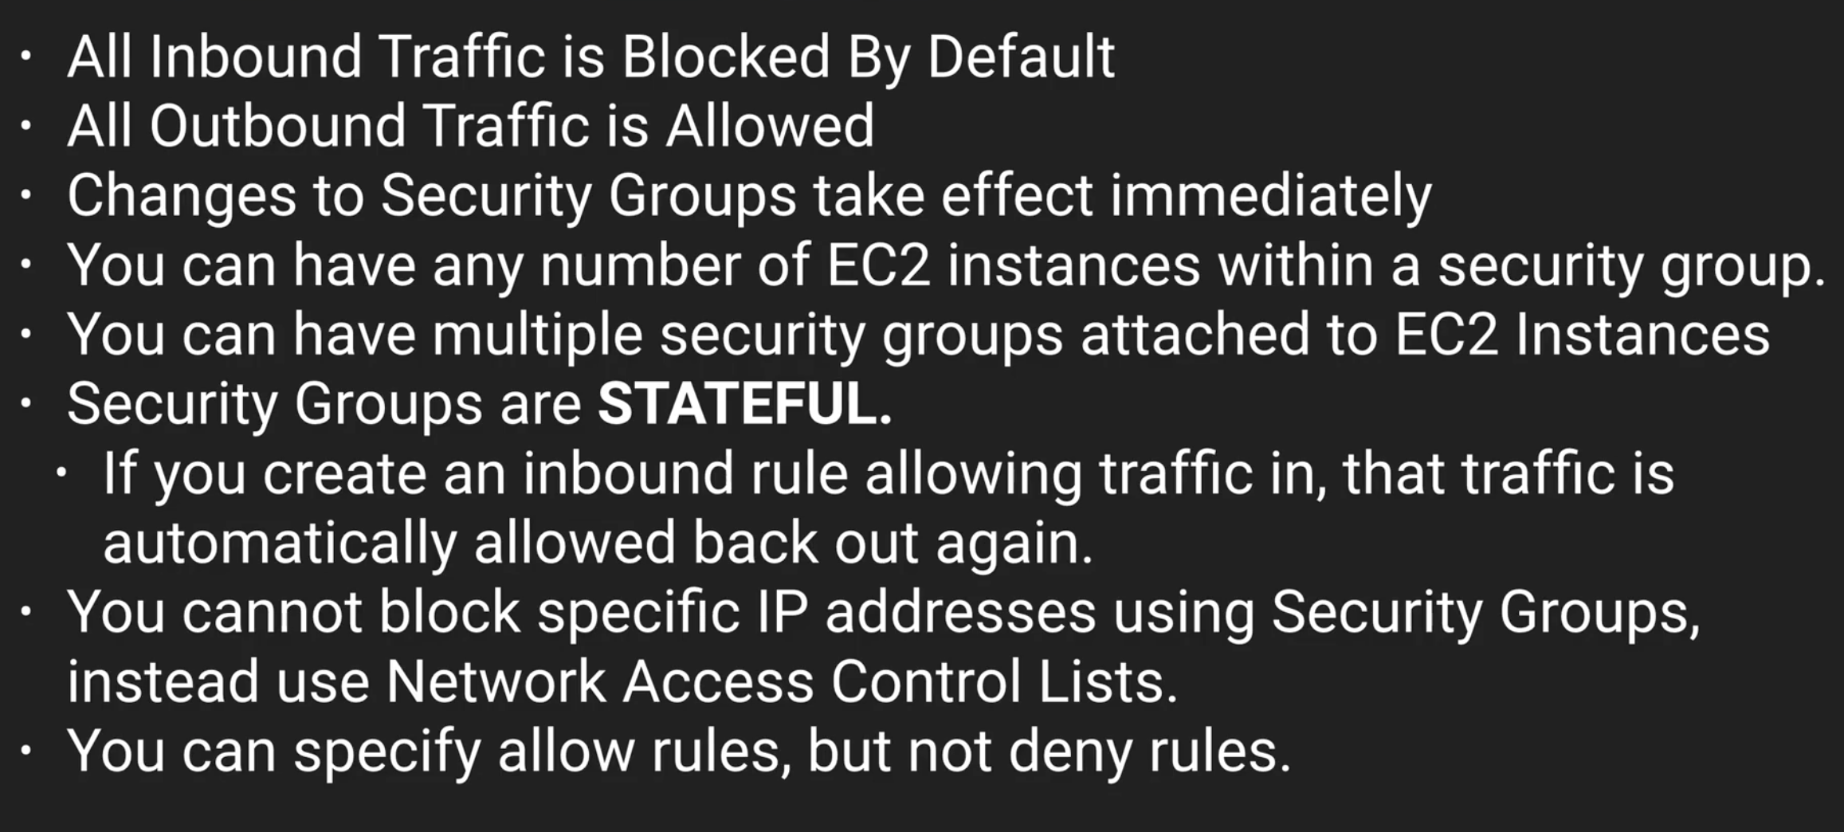

**EBS Volumes LAB**

An EC2 instance and EBS volume have to be in the same availability zones(AZs).

The latency is going to be too much if they are far.

*Other volume types can be modified on the go but Standard volume (magnetic storage**) cannot be modified.**

**\***In order to move EBS vols from one AZ1 to AZ2, you have to create a snapshot first of AZ1 and then you can create new volume in a new AZ2 from this snapshot.

*You can also move EC2 instances:

1🡪 create a snapshot, then create a image from snapshot and then copy to another region

2🡪 create an image directly from instance and then copy to another region or country.

*If you directly delete an instance, only root volume is deleted but the attached other volumes won’t be deleted.

Note: Root volumes generally where the OS sits.

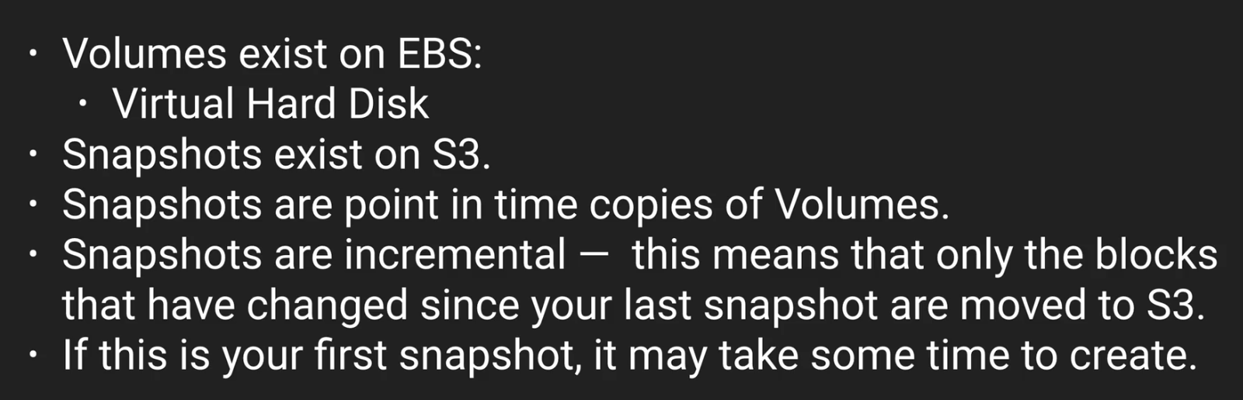

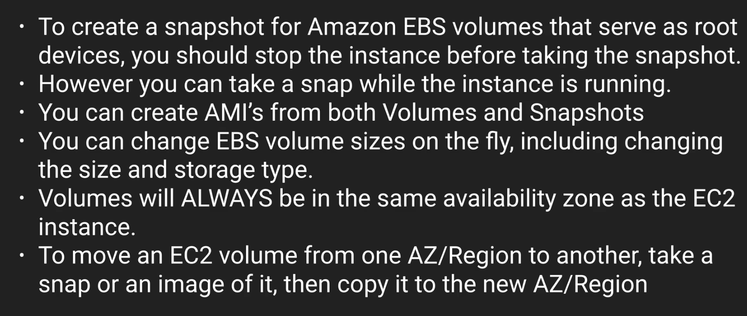

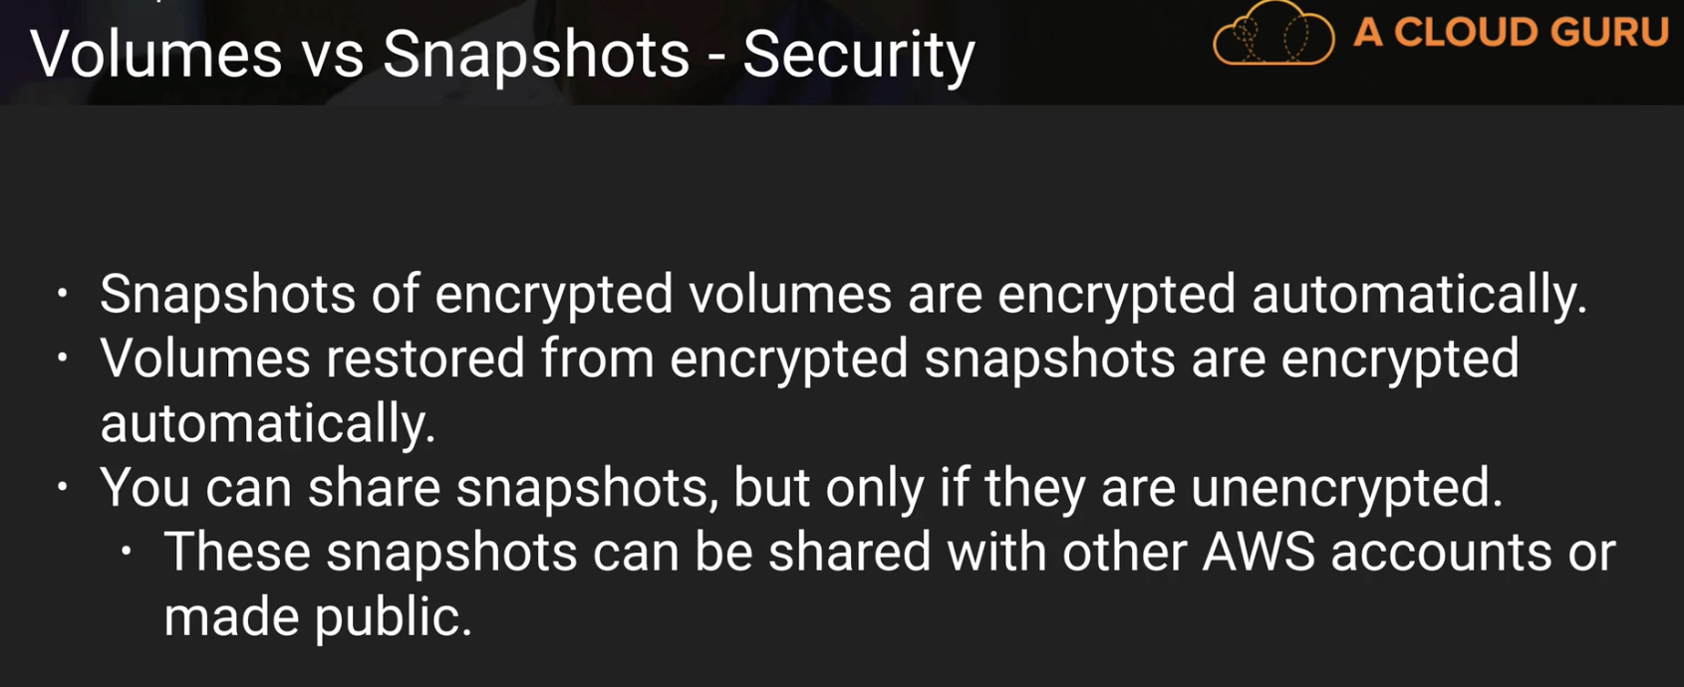

**EFS LAB**

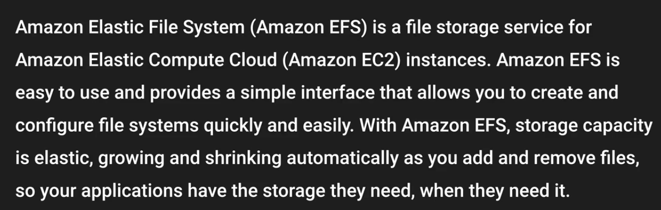

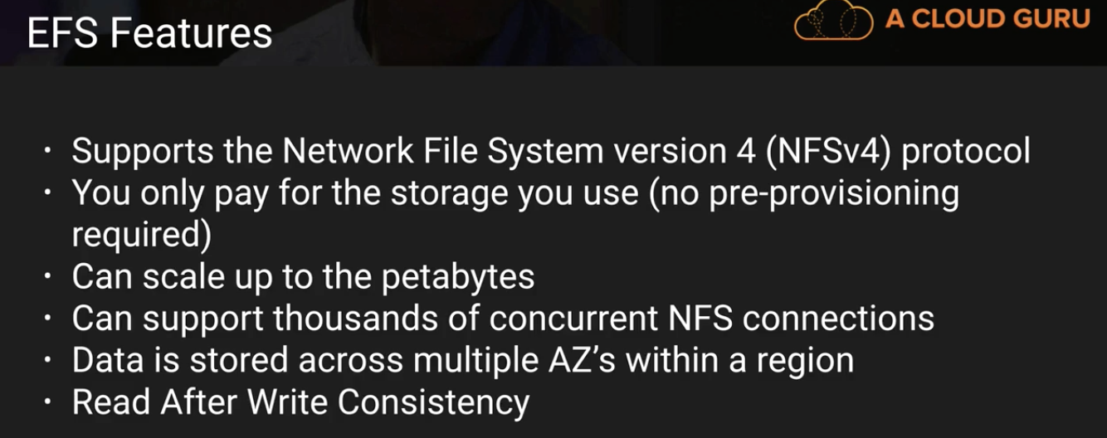

EFS serves like a centralized repository. Multiple EC2 instances connecting to the same EFS and all using same files.

You can make user level and directory level permissions. That will stay same across all EC2 instances.

**AWS CLI Lab**

For security reasons, don’t ever store access key and secret keys in code.  
If you upload your code to Github, it will be big security risk.

**IAM Roles Lab:**

Using User credentials is not all that safe.

Storing them on to EC2 is a security risk. For example, if there are 1000 EC2 instances, if someone compromises one, then you have to change 999 instances. In such cases IAM roles come in to use.

**S3 CLI & Regions:**

When you are downloading files from one bucket to another bucket, it depends bucket’s region to use “**region**” flag in the command. For some regions file will download without region flag but it will not download for some. Whenever it wont download using **region** flag will help.

**CLI Commands Developer Exam Lab:**

aws ec2 describe-instances – your current instances

aws ec2 describe-images – this will return all the images available (thousands of them.)

aws ec2 run-instances – to launch or create instances

aws ec2 start or stop is to start or stop instances. Don’t get confused

aws ec2 terminate instances to terminate

**Bash Scripting Lab**

All buckets are private by default. So, if you upload a html to a bucket and try to open it you will get “**access denied**”.

You can use a bash script to run some commands automatically when you launch an instance.

You can add this bash script in the advanced details section of step3(configure instance details) while creating an instance.

Cloud Layers:

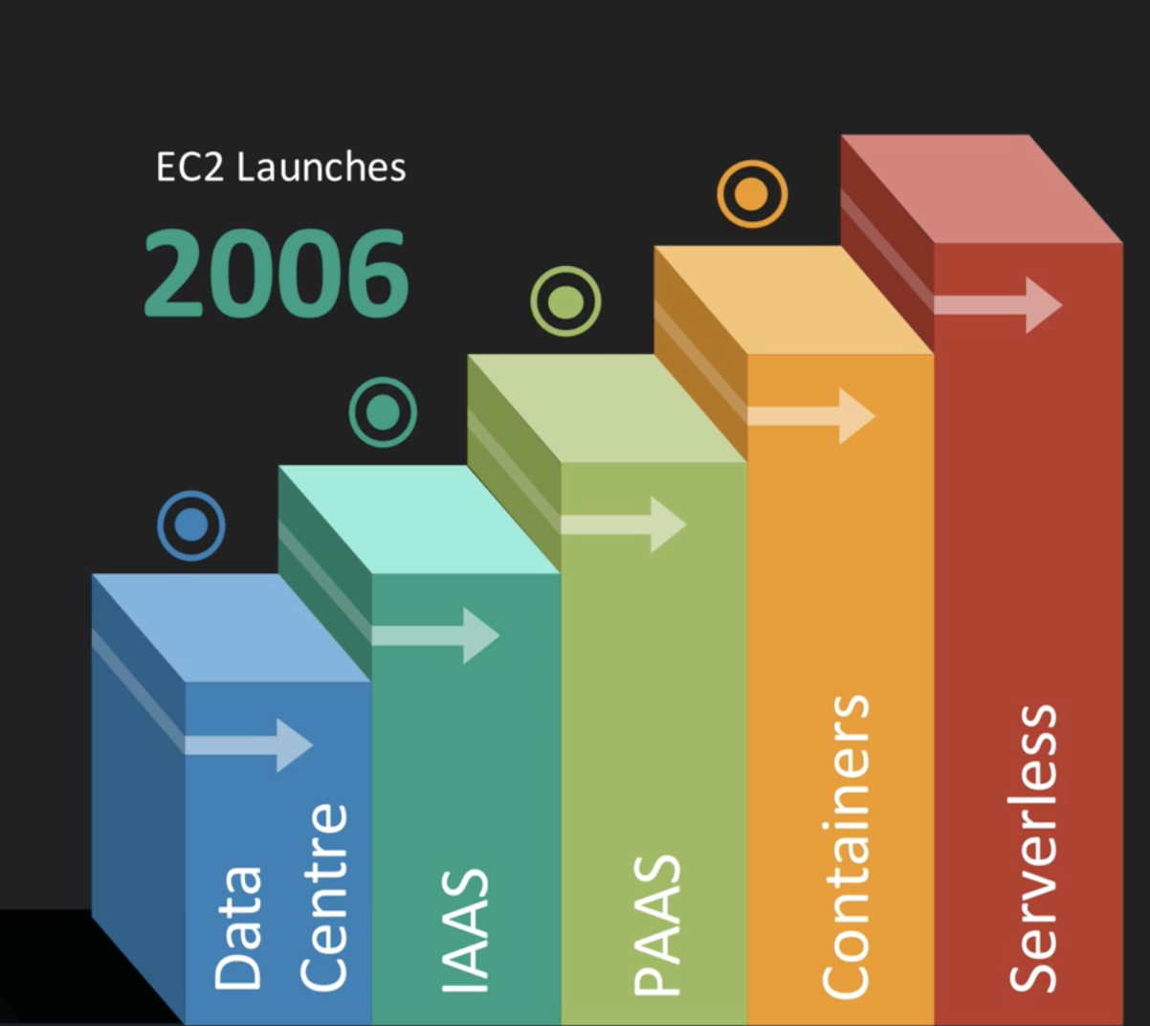

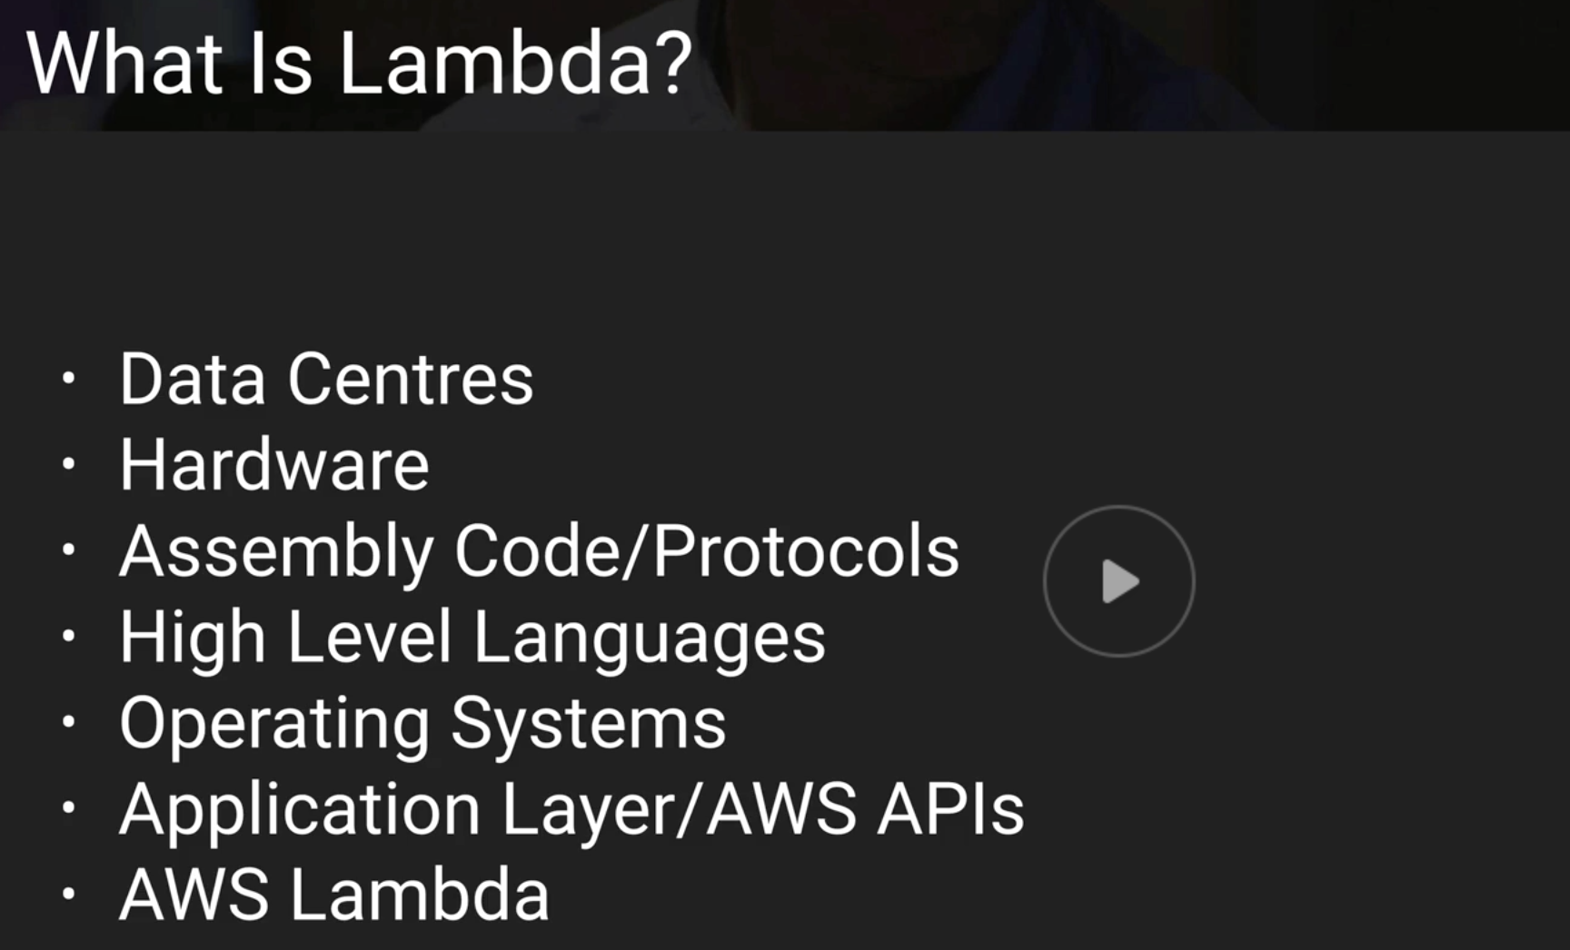

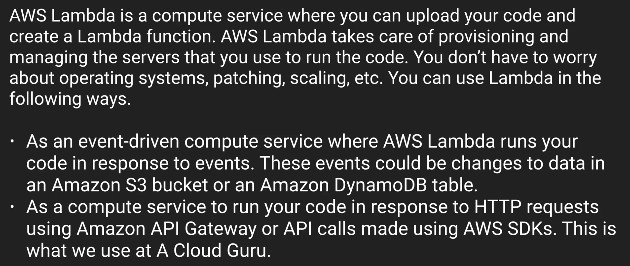

**AWS Triggers: remember all of them**

API Gateway

AWS IoT

Alexa Skills Kit

Alexa Smart Home

CloudFront

CloudWatch Events

CloudWatch Logs

CodeCommit

Cognito Sync Trigger

DynamoDB

Kinesis

S3

SNS

If 3 users send 3 http requests(eg: cloud guru web address), API gateway will create 3 different lamda functions (very very imp). If there are million users, then it will create million lambda funcs

Run time Languages:

Node.js, Python, C#, Java, Go

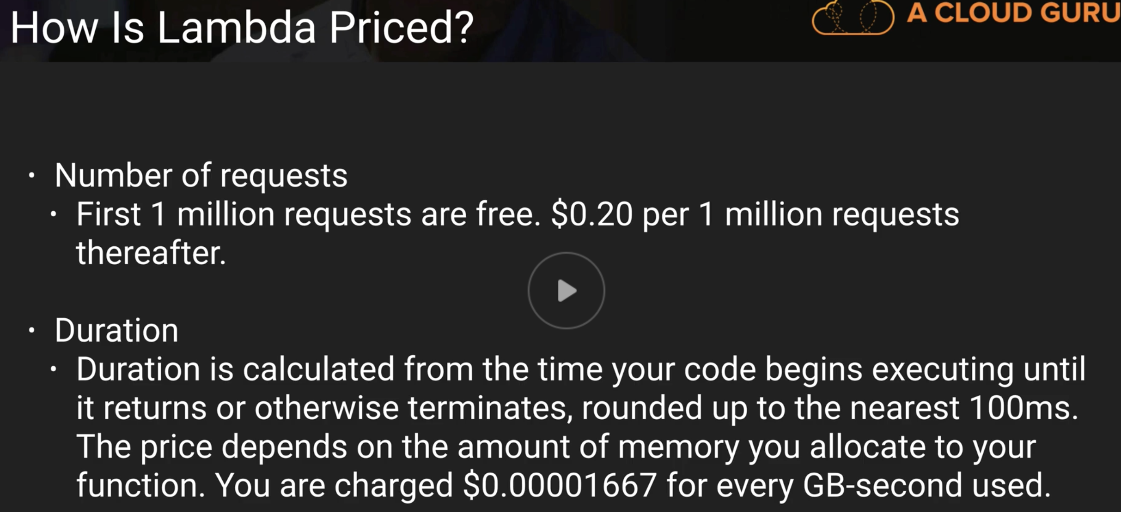

**Why is Lamda Cool?**

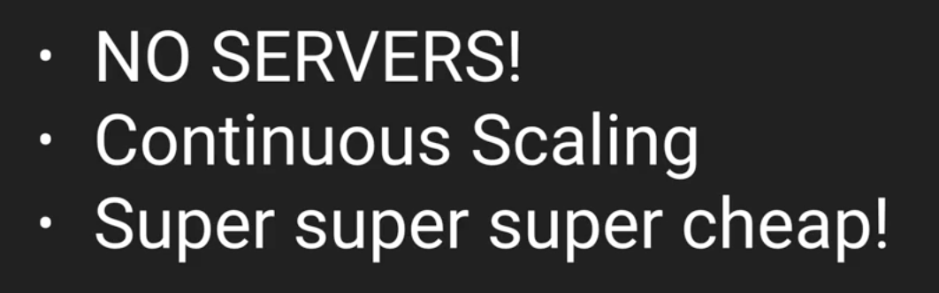

Eg: Every time you speak to Amazon Alexa, It is creating a Lambda function

It is important to understand which services are serverless..

DynamoDB, API gateway,…the list from above page

Note: EC2 is not serverless

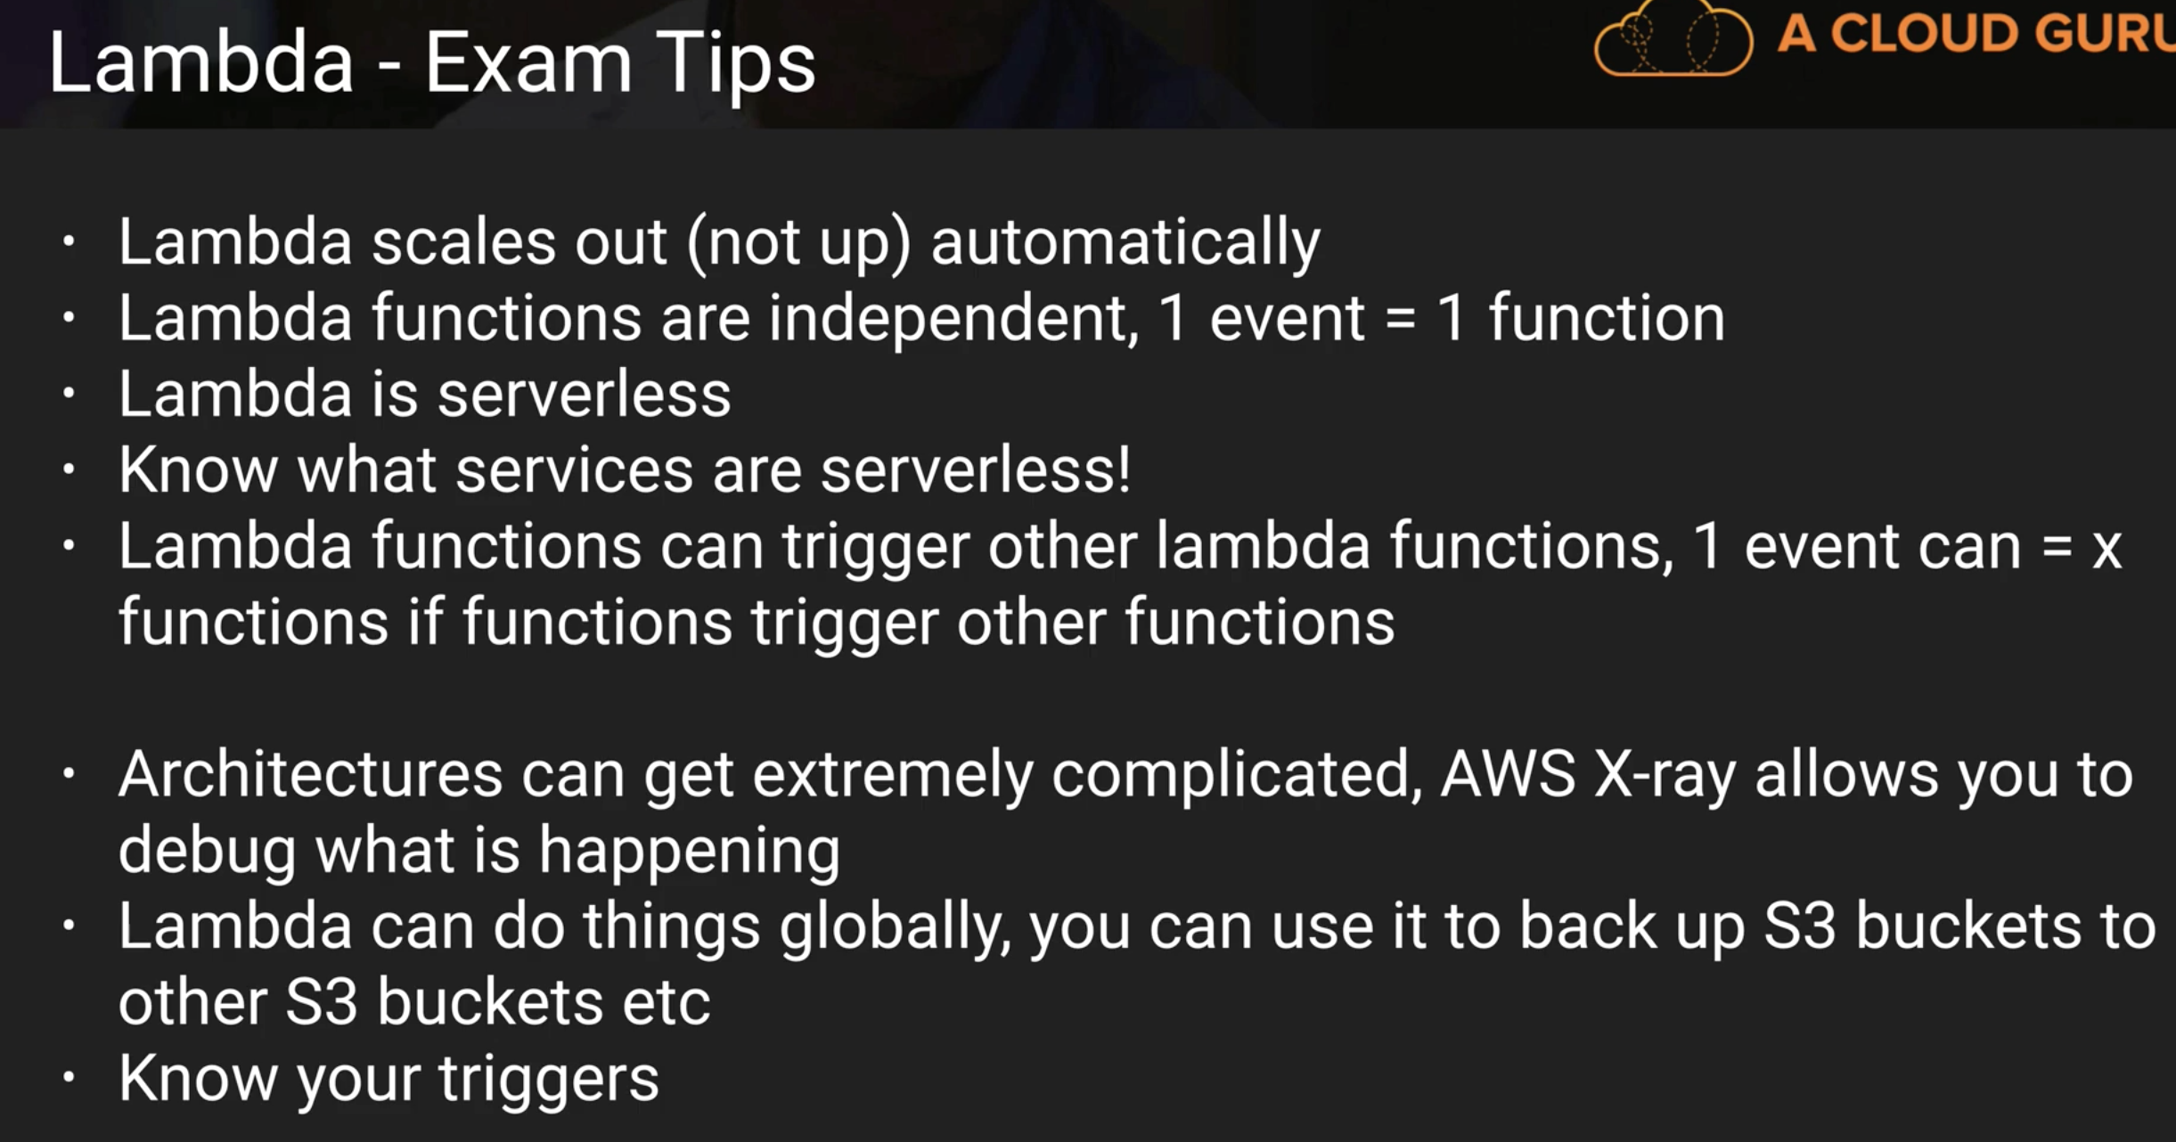

Lamda’s max duration time is 5minutes. Beyond that you have to divide functions in to multiple ones.

**Install PHP Composer Lab:**

You want autoload.php file to use PHP SDK automatically

**Interacting with S3 using PHP SDK:**

**EC2 instance Metadata:**

curl http://169.254.169.254/latest/meta-data/public-ipv4

you can use this to get your ip address. This is like looking for metadata instead of user data.

You don’t get Load balancers IP address. You will only get DNS Name.

Because it can change.

App load balancer operates at application level.

Some important points on Load Balancers Go through classic and app load balancers.

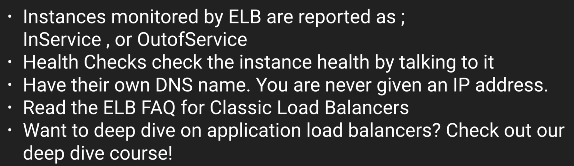

**SDK Exam Tips:**

**Available are:**

**https://aws.amazon.com/tools/**

Android, ios, Go, Python, PHP, java, Ruby, Node.js, C++, javascript(a.k.a browser), .NET, AWS mobile SDK, AWS IOT SDK

Some SDKs have default region. Eg: Java

Some SDKs don’t have default region. Eg: Node.js

Default region is always **us-east-1**

**EC2 Total Summary:**

[**https://docs.aws.amazon.com/AWSEC2/latest/UserGuide/Storage.html**](https://docs.aws.amazon.com/AWSEC2/latest/UserGuide/Storage.html)

[**https://aws.amazon.com/ec2/**](https://aws.amazon.com/ec2/)

Read EC2 FAQ before doing the exam.

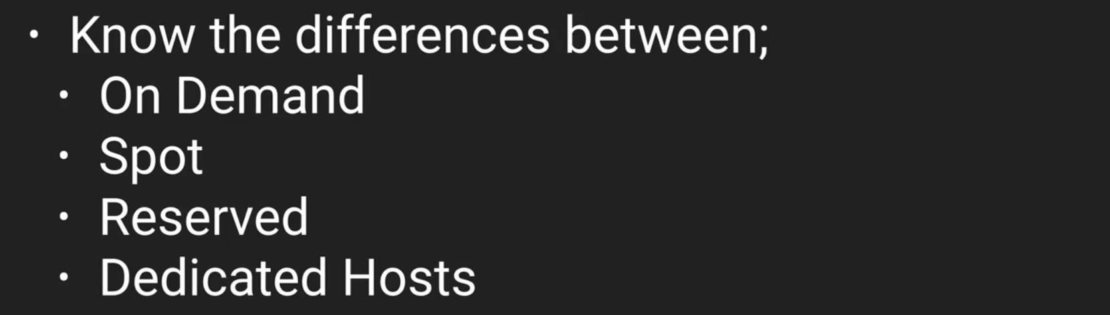

Eg: A company who have huge compute environment but have less budget and they can time this at 2 am mrng.

Ans: Spot instances.

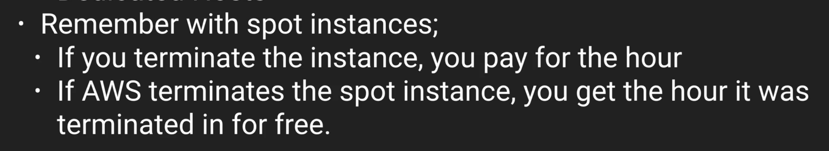

Eg: You have a fairly steady state web app with 10k users. Then which type of instance to use:

Ans: Reserved option

Eg: Blac Friday sale. Scale for 72 hrs and then go back.

Ans: On demand

Eg: Govt related, Privacy, NO multi tenants, Etc

Ans: Dedicated hosts.

Trick to remember EC2 family types - DR Mc GHIFT PX – anagram \

EBS:



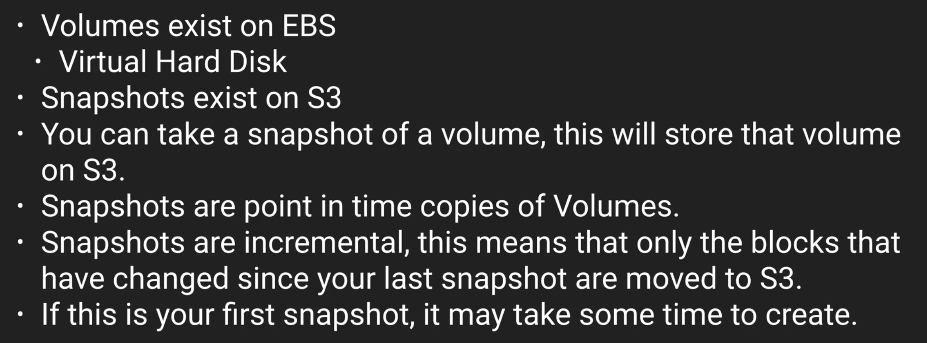

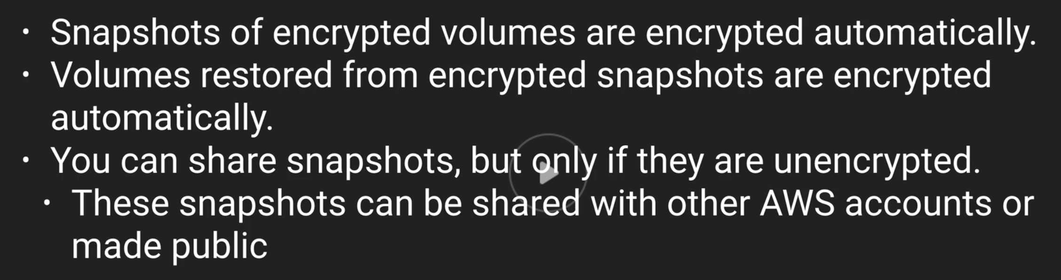

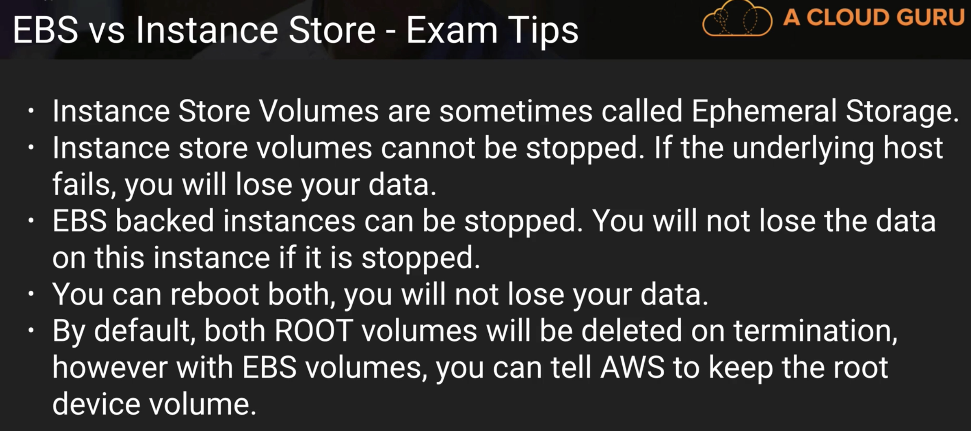

Below two might not be in the lectures:

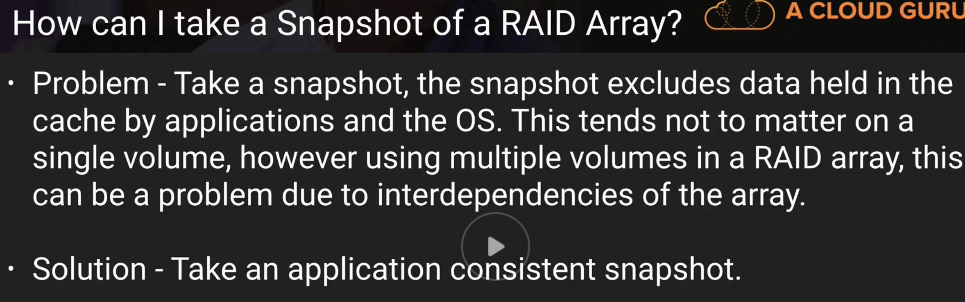

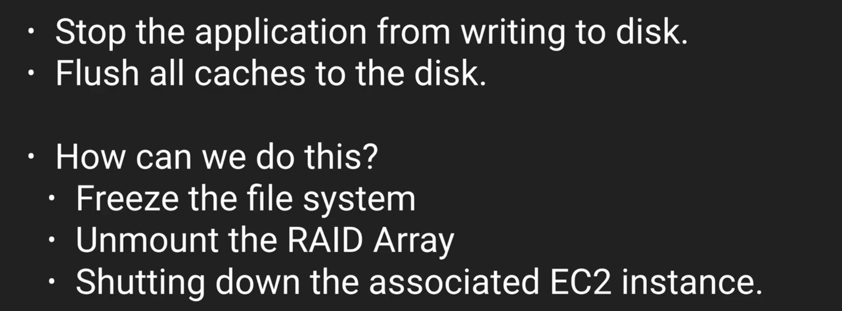

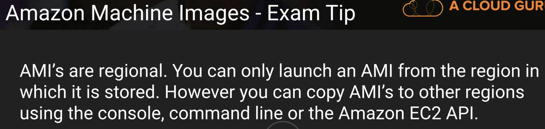

Cloud Watch is different from cloud Trail.

Cloud watch is for performance monitoring. Cloud trail is for audits.

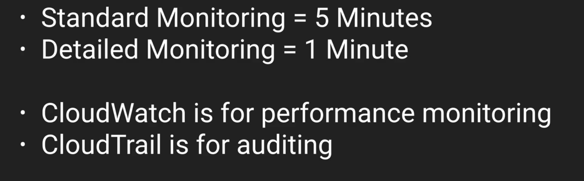

In the above slide, for detailed monitoring, you have to pay extra. You don’t have to pay for standard one.

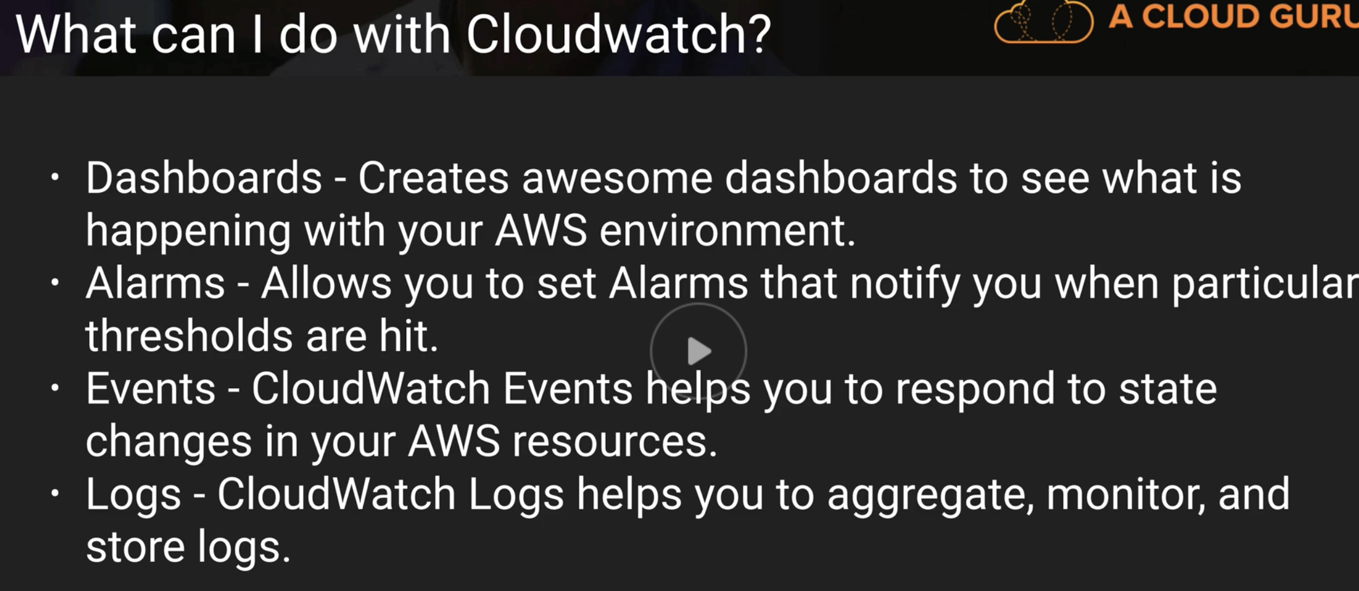

**Roles**

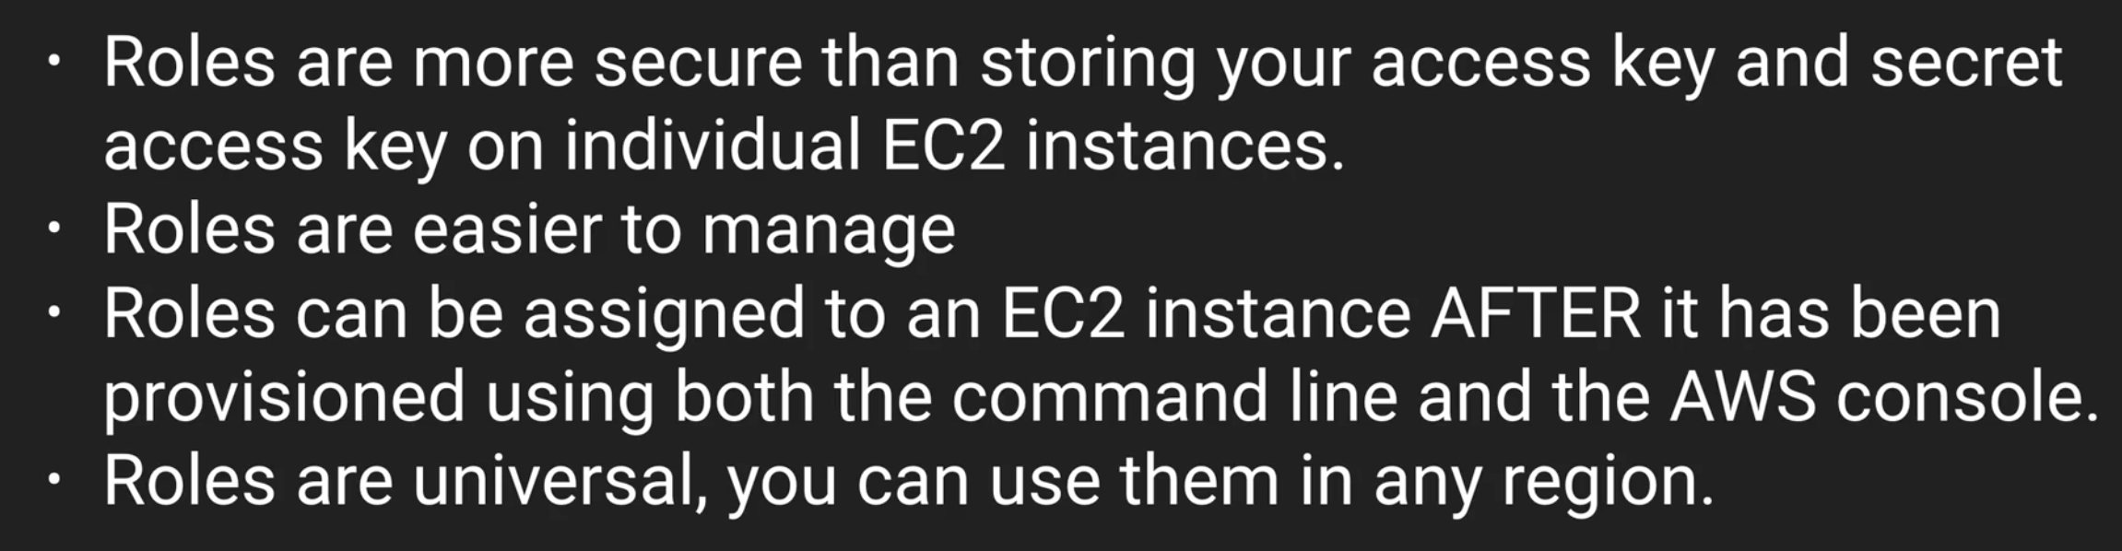

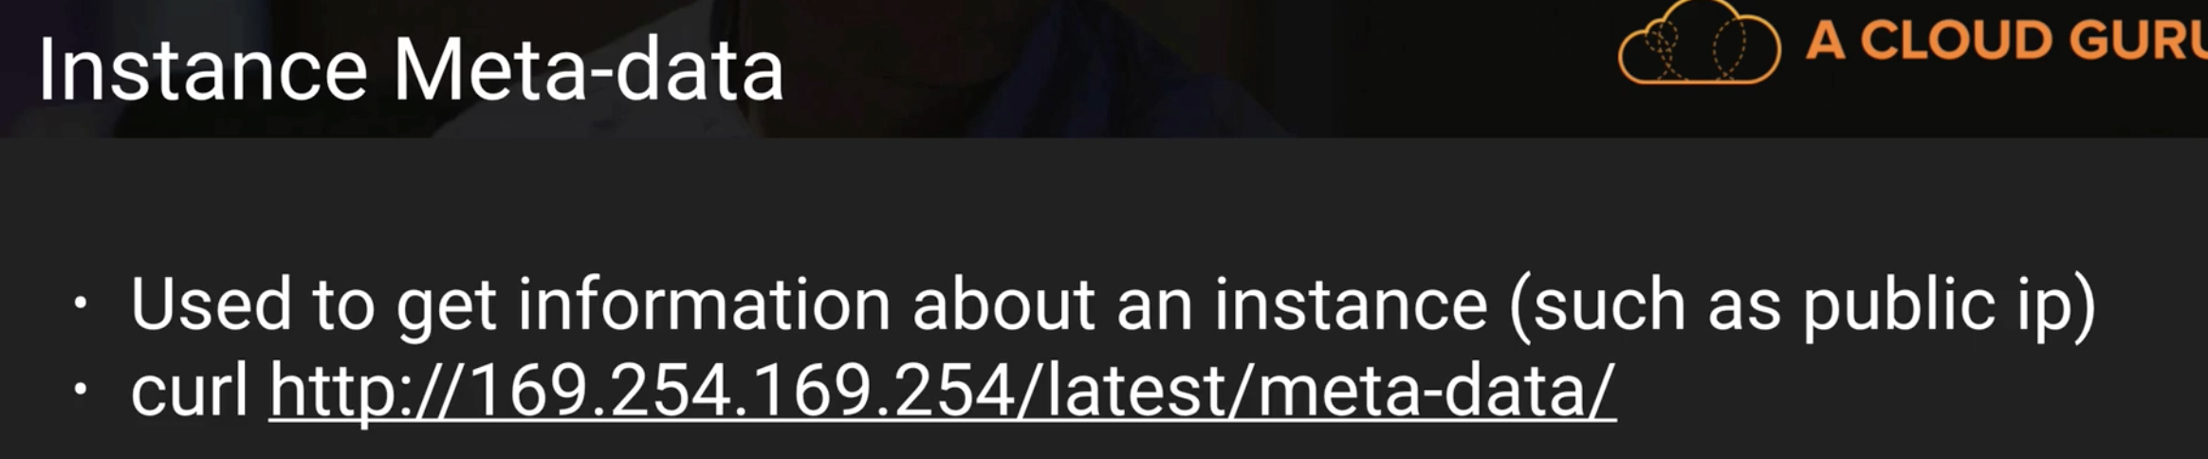

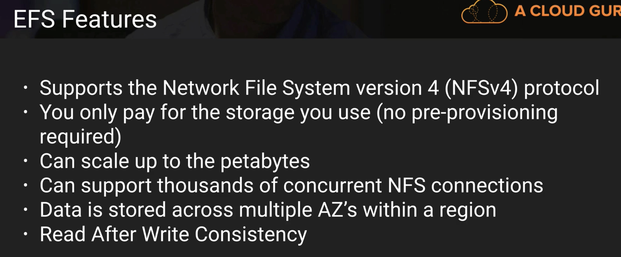

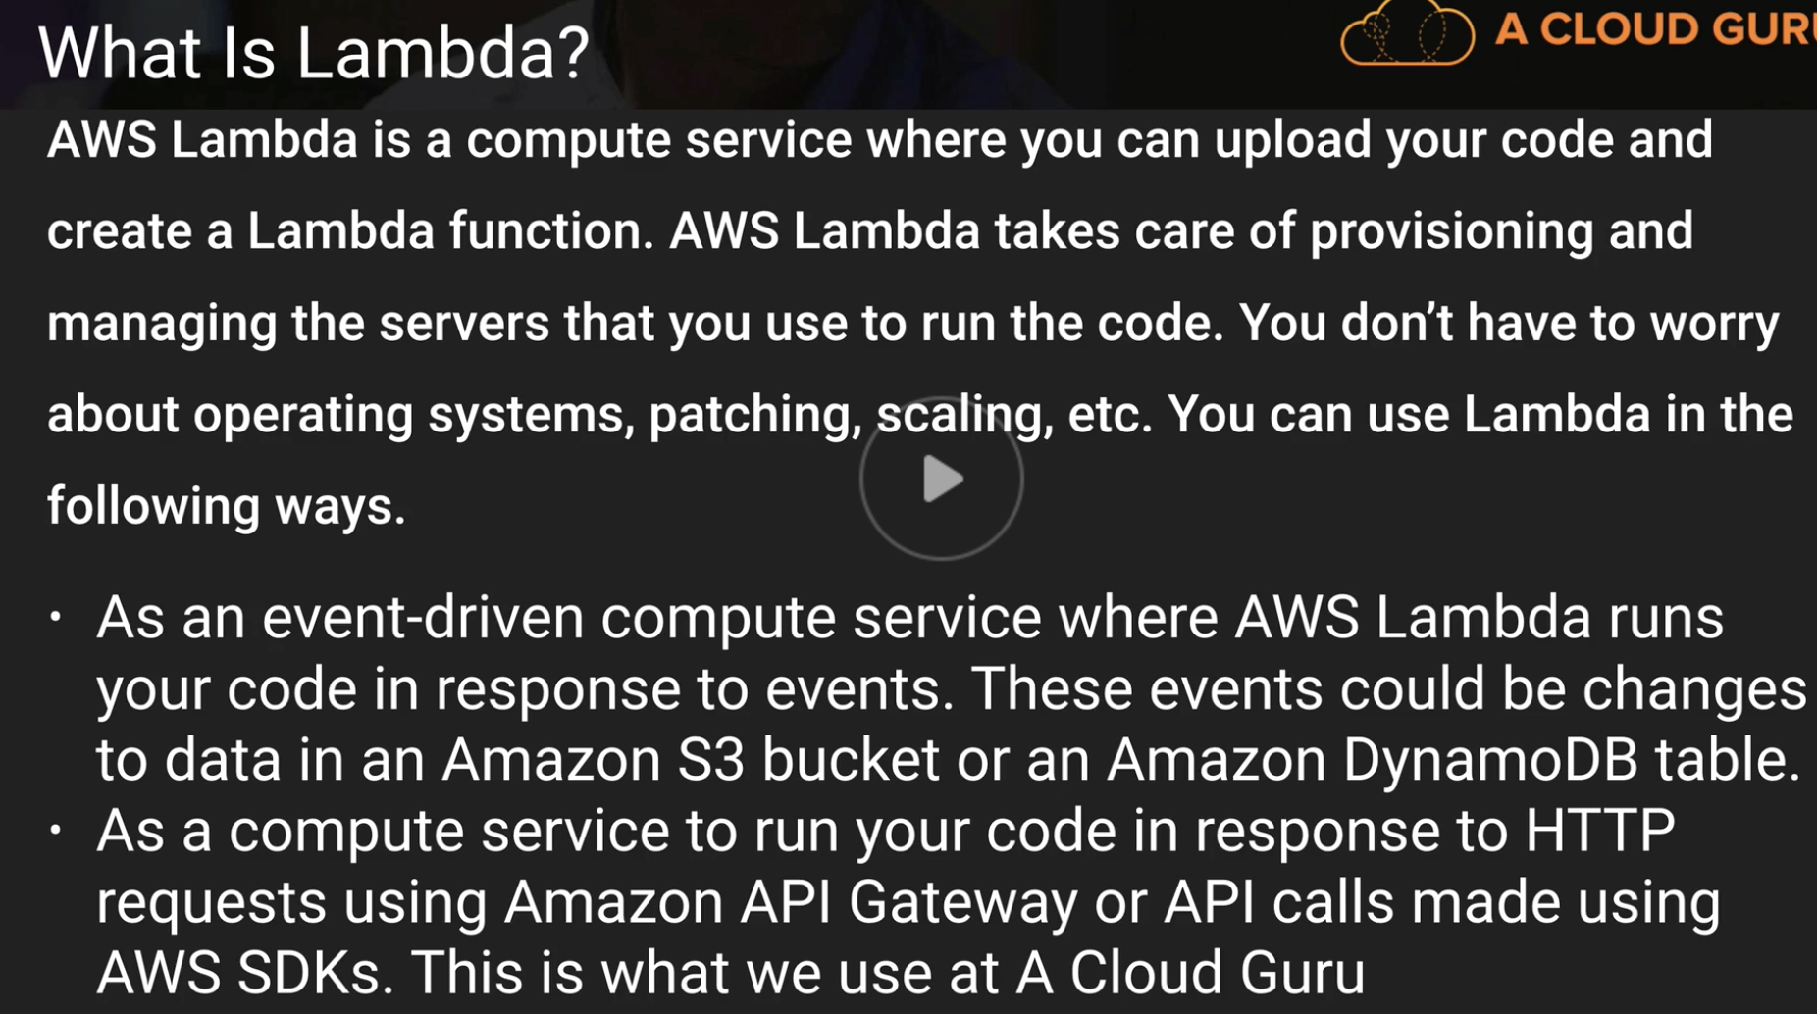

**HTTP Errors:**

[1xx Informational responses](https://en.wikipedia.org/wiki/List_of_HTTP_status_codes#1xx_Informational_responses)

[22xx Success](https://en.wikipedia.org/wiki/List_of_HTTP_status_codes#2xx_Success)

[33xx Redirection](https://en.wikipedia.org/wiki/List_of_HTTP_status_codes#3xx_Redirection)

[44xx Client errors](https://en.wikipedia.org/wiki/List_of_HTTP_status_codes#4xx_Client_errors)

[55xx Server errors](https://en.wikipedia.org/wiki/List_of_HTTP_status_codes#5xx_Server_errors)

**Q)**

To accommodate the hosting of multiple sites, you can have multiple SSL certificates on an Elastic Load Balancer.

**Ans: False. You can have only one**

**SIMPLE STORAGE SERVICE – S3**

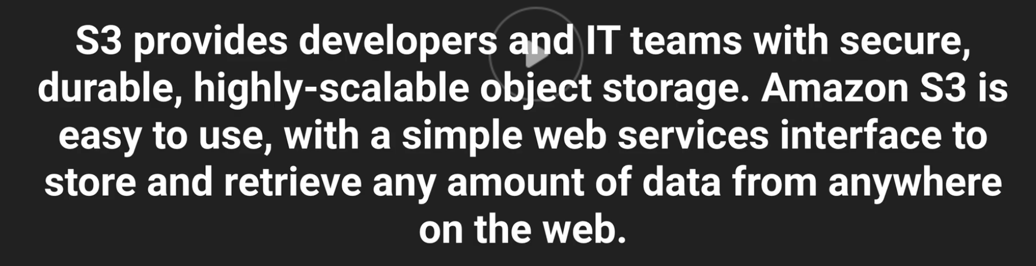

S3 is not block based storage (E.g.: you can’t install OS) but an Object based storage.

Object based storage is storing videos, pics, pdfs, docs, etc. basically storing **flat files.**

The data is spread across multiple devices and facilities.

Bucket is like a Folder. S3 is universal namespace, that is names must be unique globally

In the below slide, last but one point is format. Imp for exam.

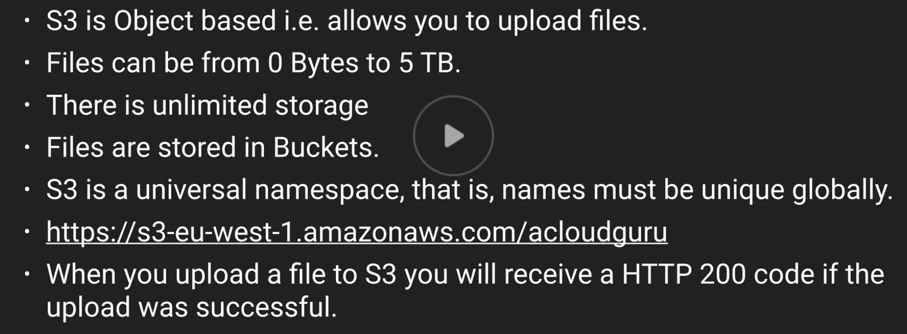

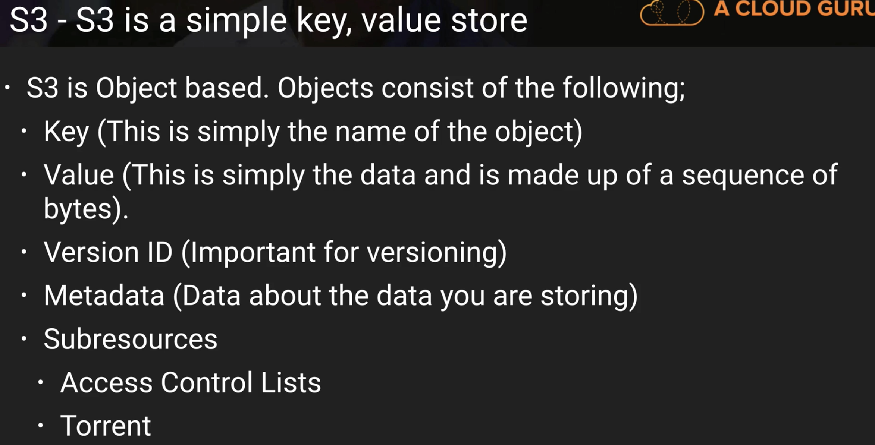

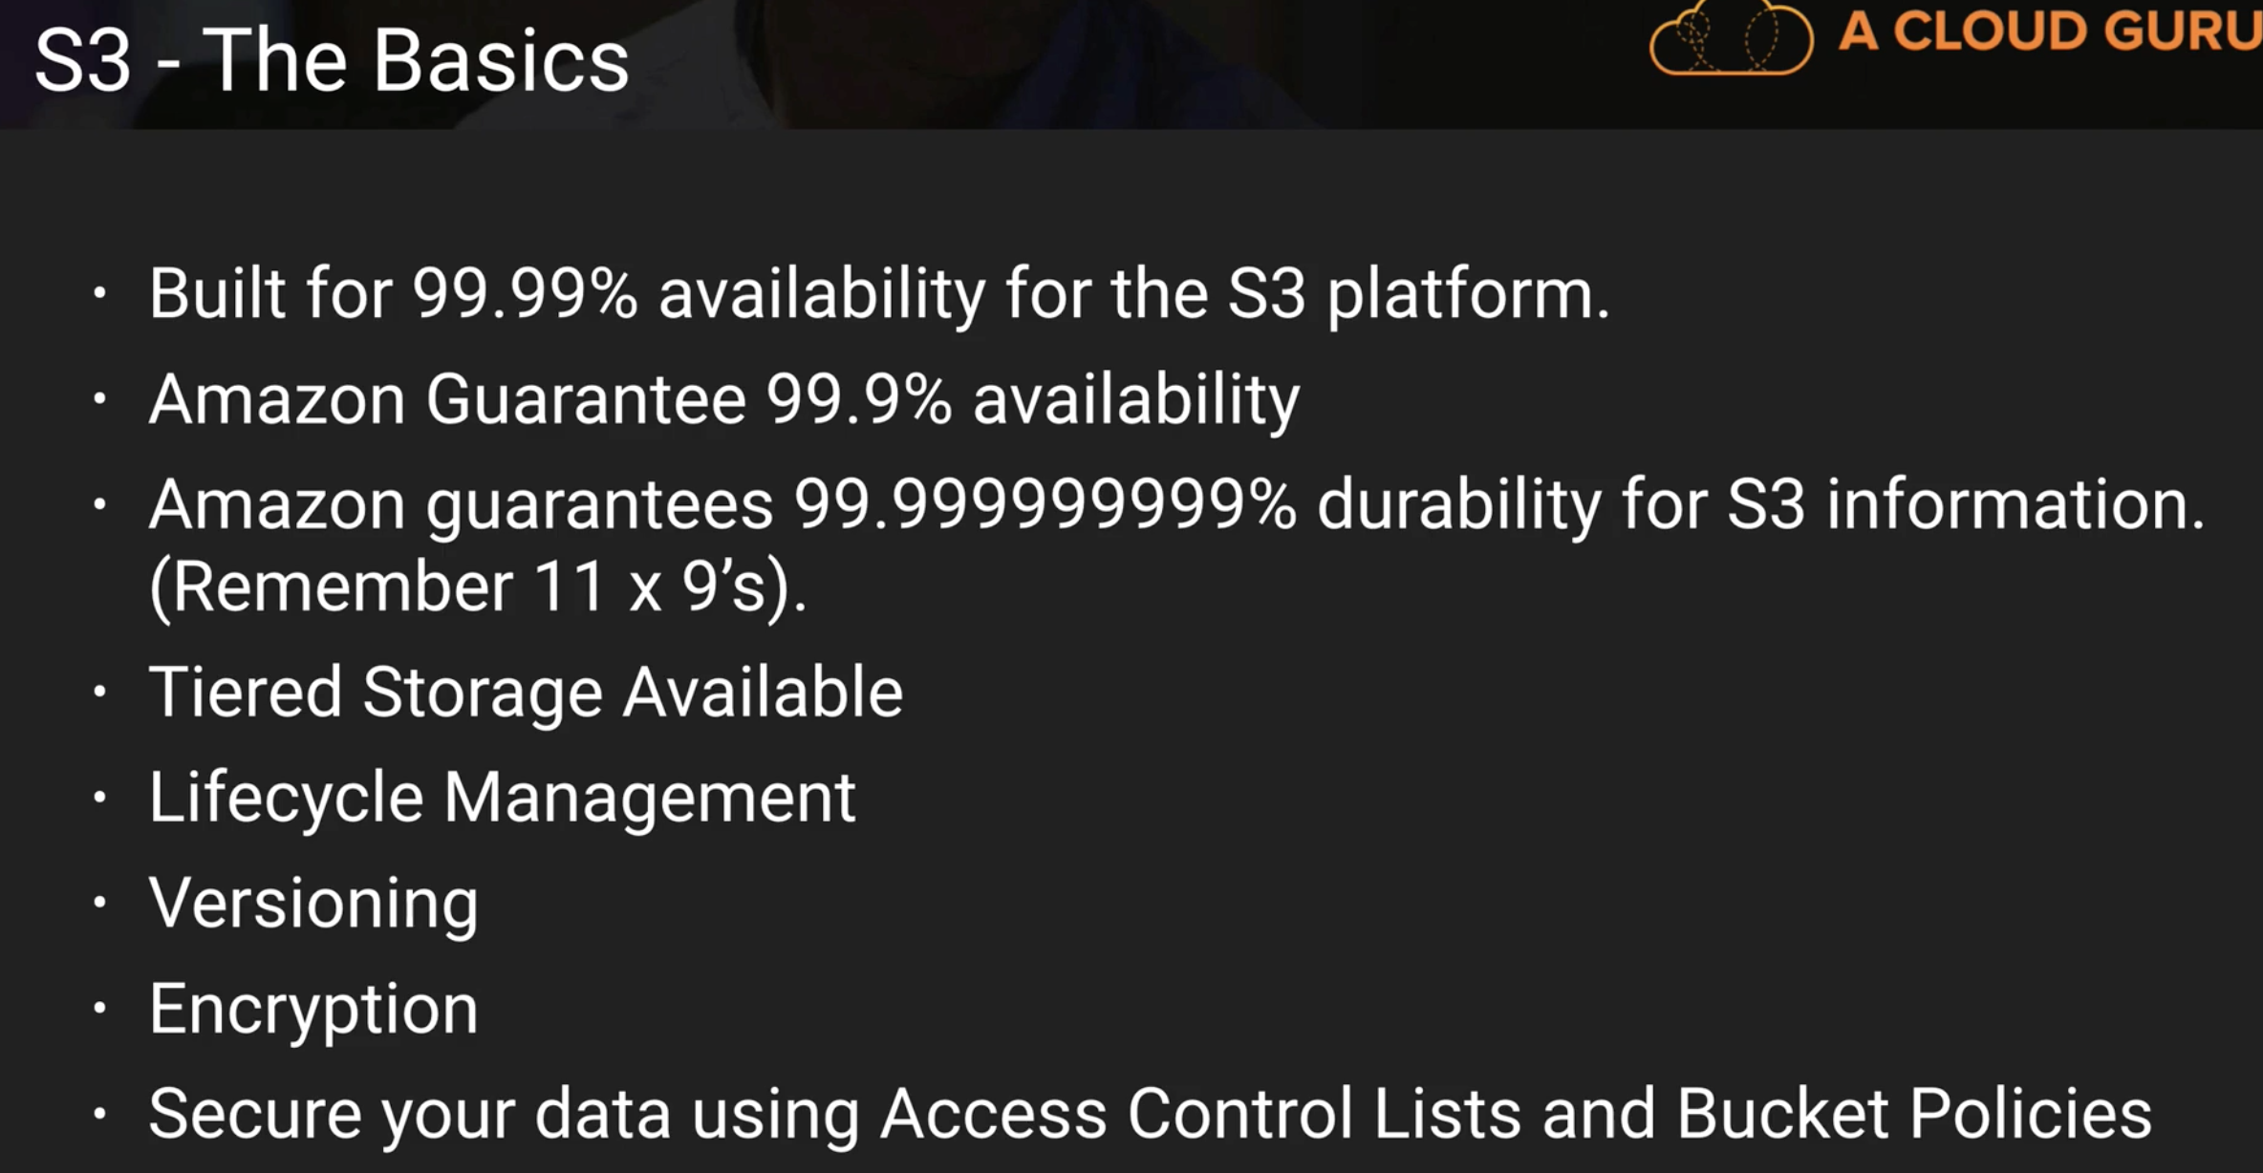

About the below slide, there will be many situational based questions:

If you have data about payroll and you want it not to take much time to access, but you access it infrequently then you choose S3 - IA (Infrequent Access)

Glacier is for data archival only. Very IMP for exam

S3 – 99.99% is the standard S3. It is costlier than Reduced Redundancy Storage.

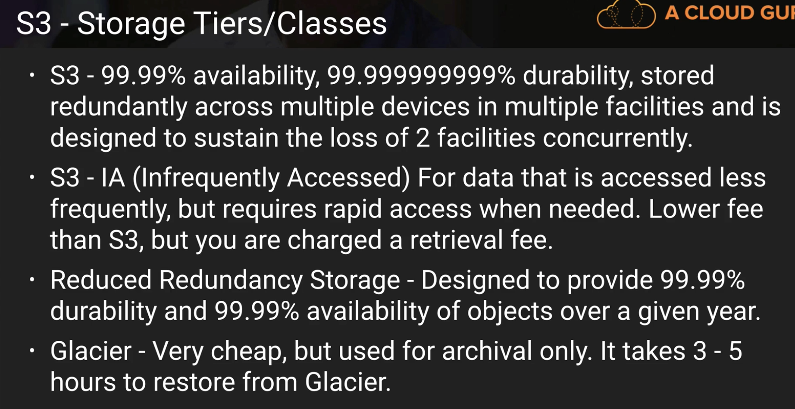

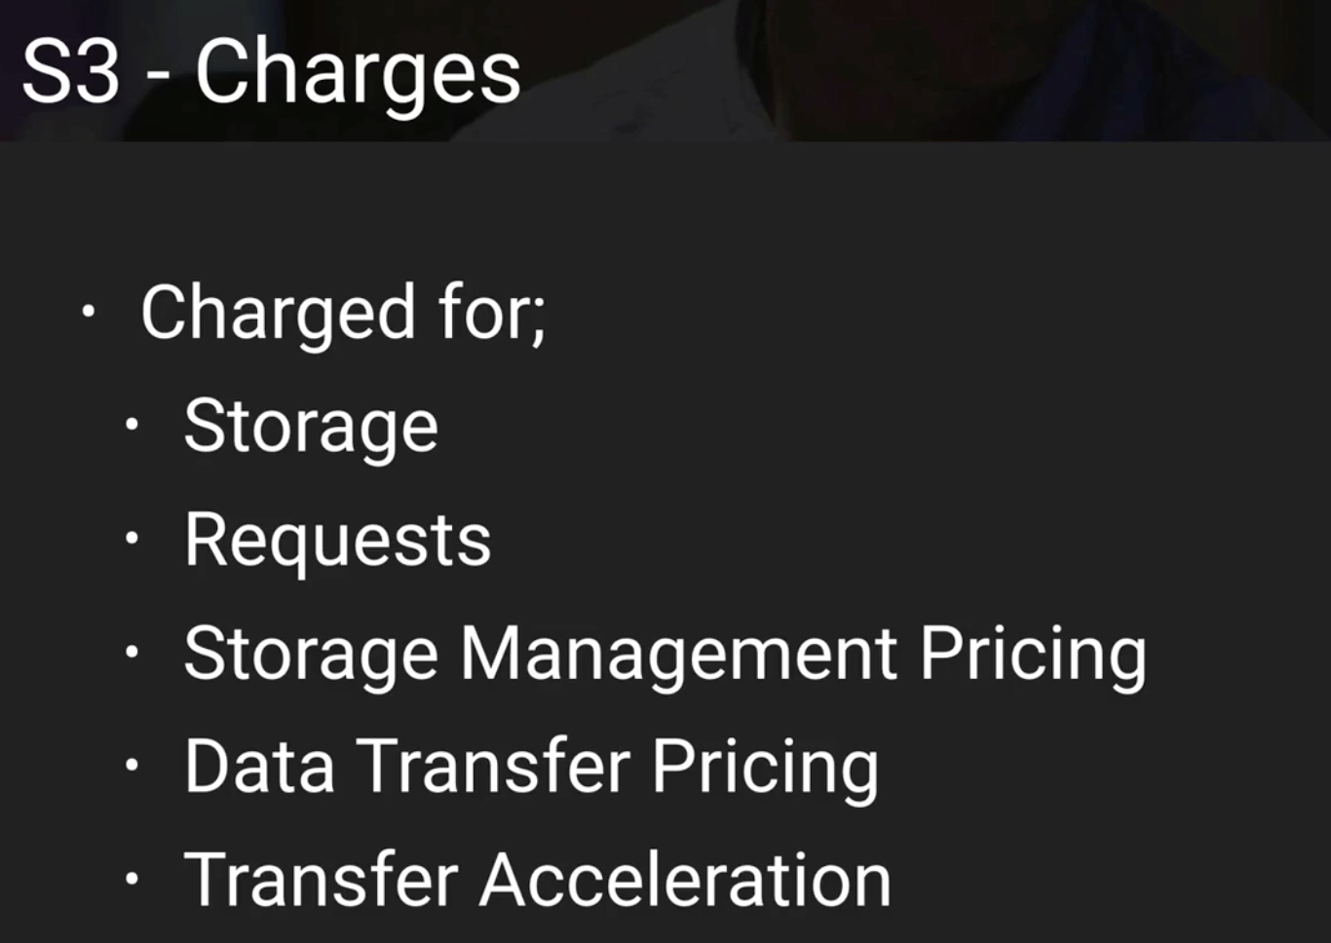

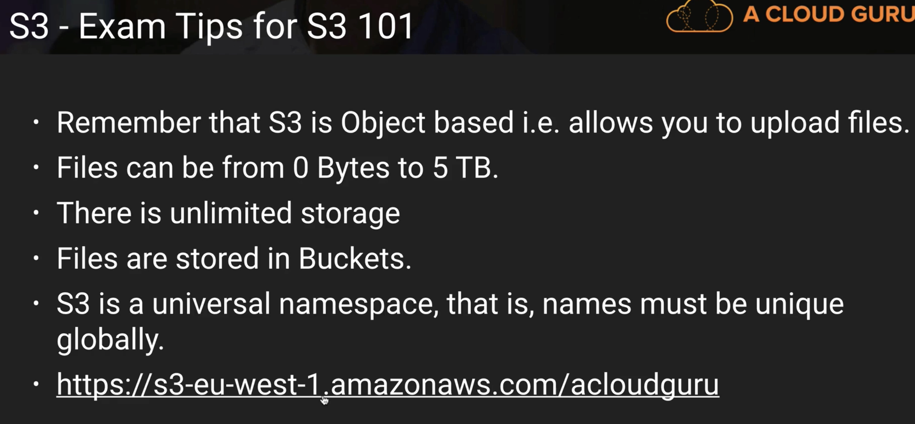

**Data Consistency: IMP**

*If you are uploading a new data to S3, you will be able to read it immediately.

*If you are updating or deleting, it might take some time to be consistent across different facilities.



By default, S3 buckets and items in a S3 buckets are private.

You can add tags to S3 buckets, but these tags are not inherited by objects in S3 bucket. So you can add tags to each item in bucket

You can control permissions to S3 bucket using **Access Control Lists or Bucket Policies**

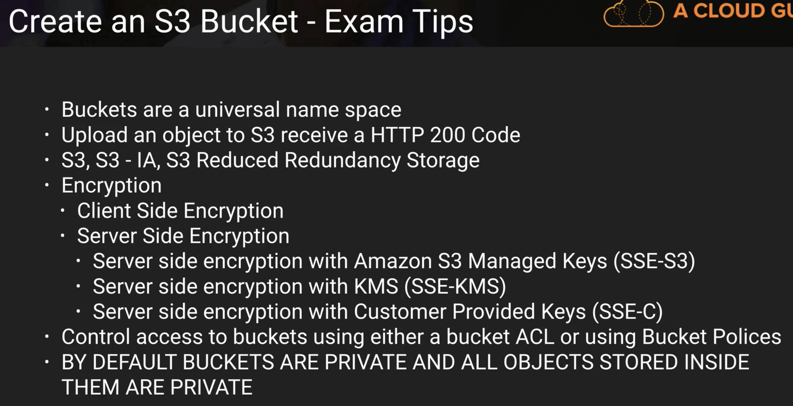

If you want to host a website using AWS, you have to use bucket name and route 53 domain same. For example, you want to host Hotmail.com, then s3 bucket name is Hotmail and domain name is Hotmail.com on route 53

Format for static web hosting is

Bucketname.s3-website-regionname.amazonaws.com

**Cross Origin Resource Sharing:**

Allowing different buckets to talk to each other.

You have to allow permission to parent bucket to call the child bucket.

Polly service – text to speech

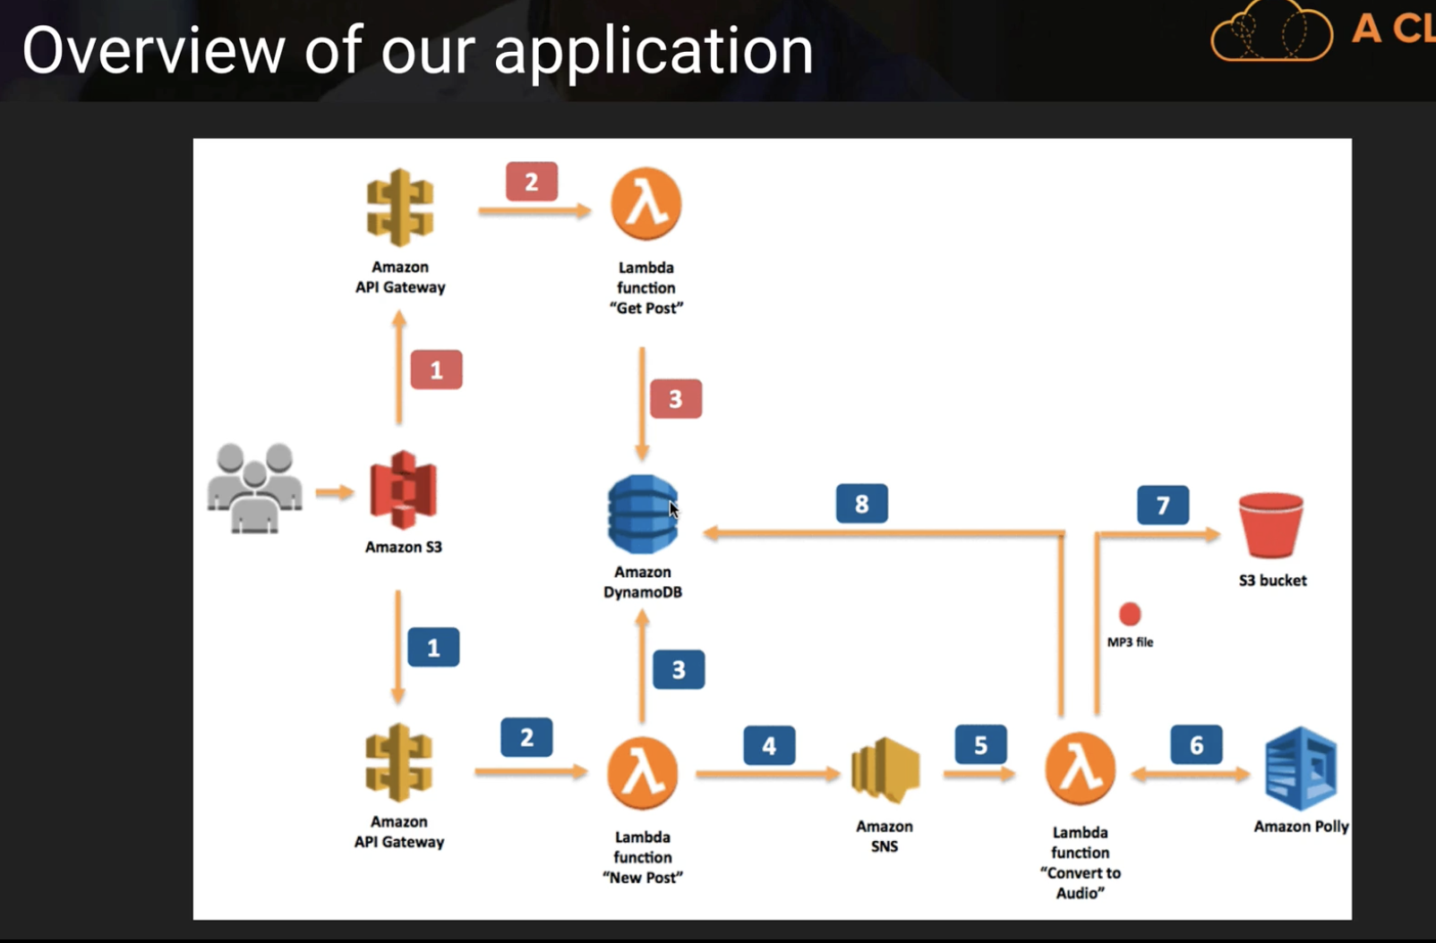

**S3 Version Control**

Once you turn on a versioning in S3, you cannot turn off it. You can only suspend it.

You can use MFA delete in S3 to add multi factor authentication to S3 buckets for versioning or to delete items in bucket.

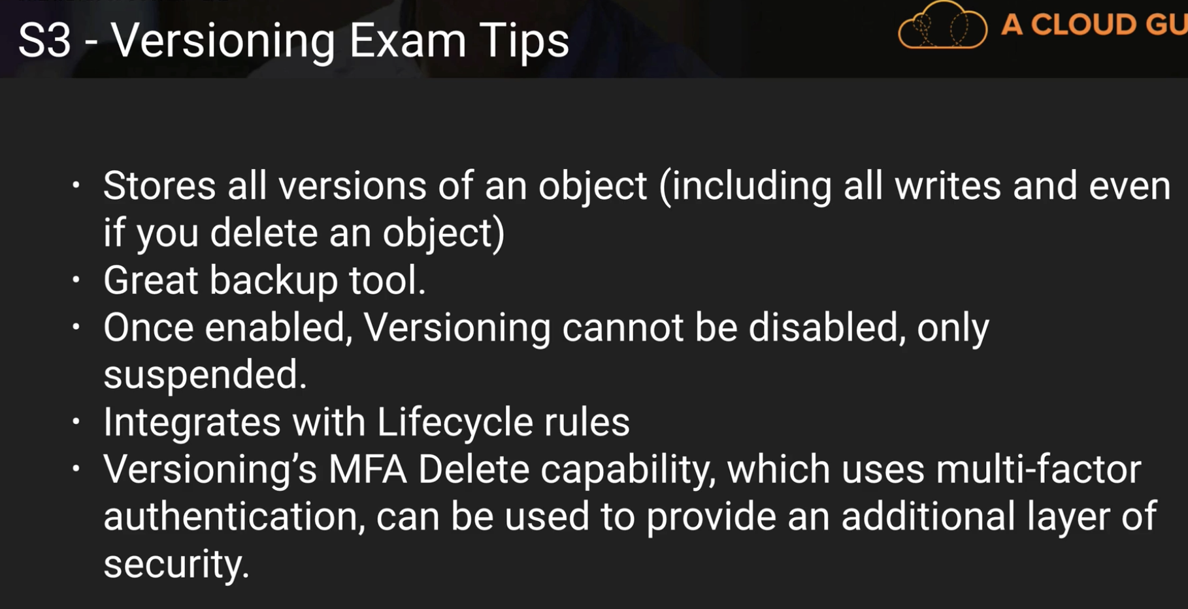

If you delete an item in bucket A (which has cross region replication turned on to bucket B), then item will be deleted in bucket B too. Of course, since the versioning will be on, the deleted items will just have **delete marker** in both buckets.

But if you will try to **delete** a **delete marker** in bucket A, then **delete marker** in bucket B won’t be deleted.

If you try to update an item in bucket A, then item will be updated in bucket B.

A new object’s permissions in bucket A will be replicated to bucket B’s copy.

Below slide is very important:

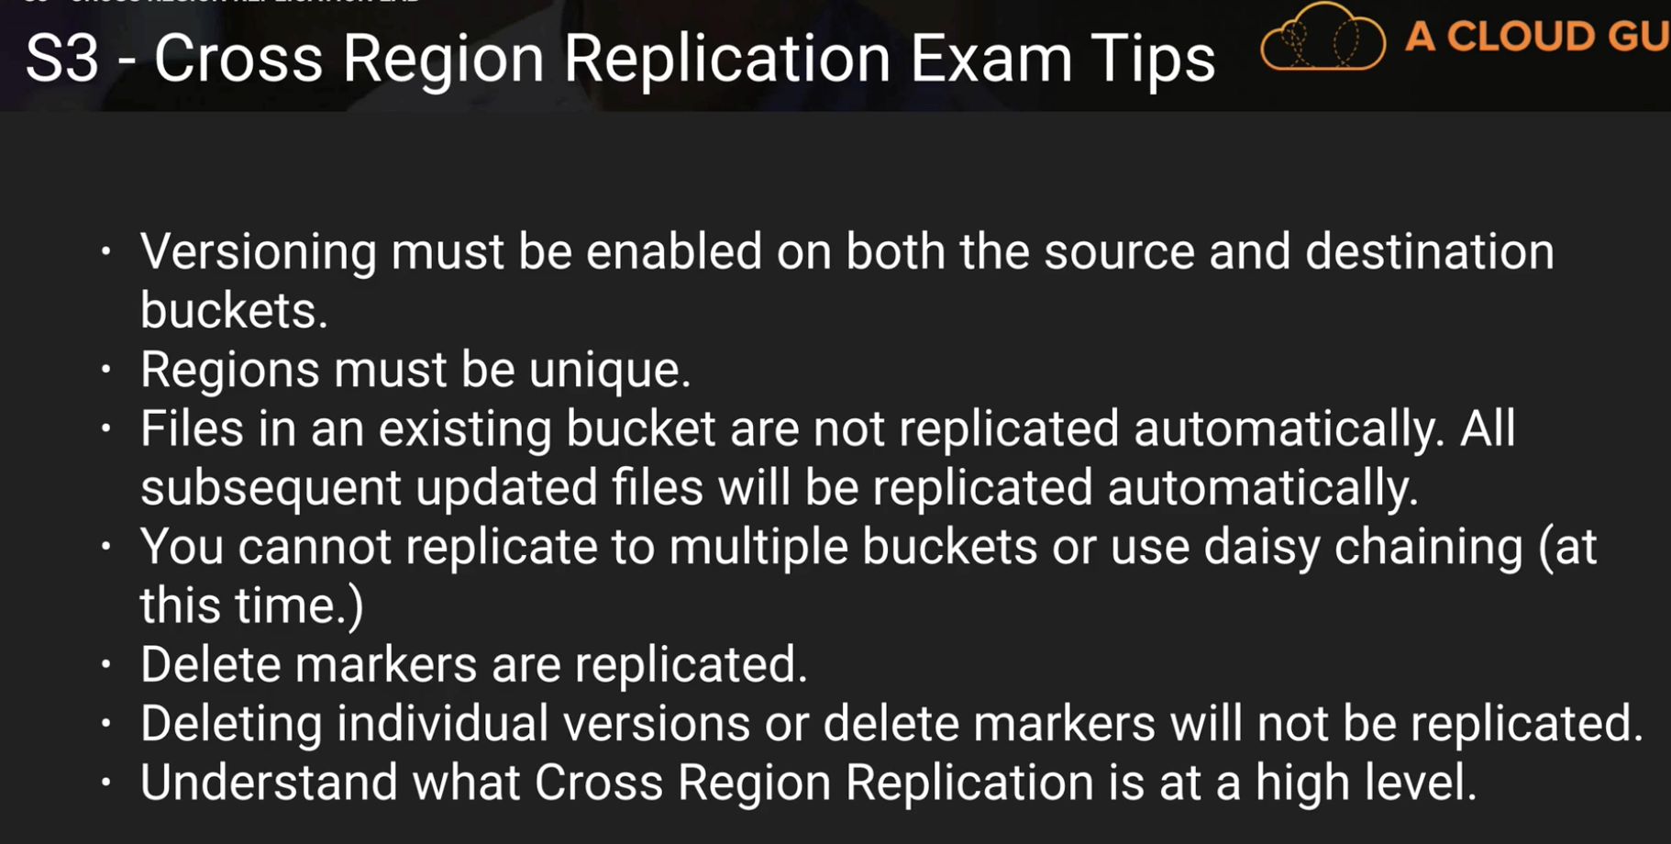

**Life Cycle Management S3 – IA and Glacier:**

Lifecycle management is like moving your items to different bucket types as the time goes.

For example, you have employee pay roll records and you want them to be redundant at one point and then infrequent(IA) and then may be move to archival(Glacier) after 60 days.

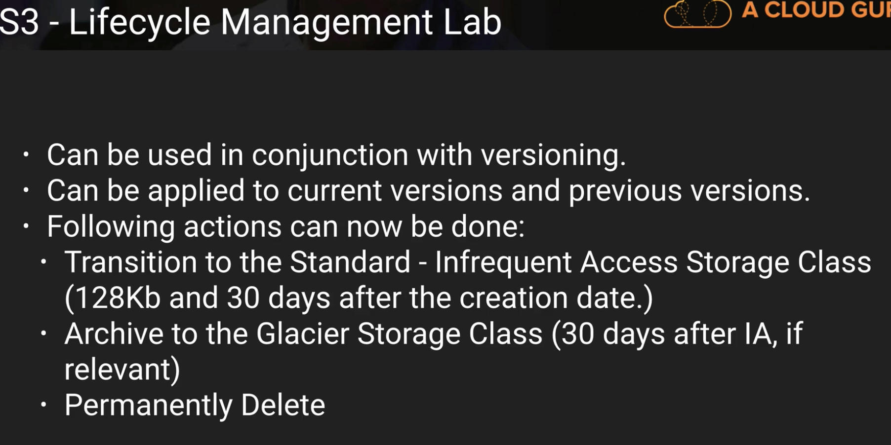

**Cloud Front View:**

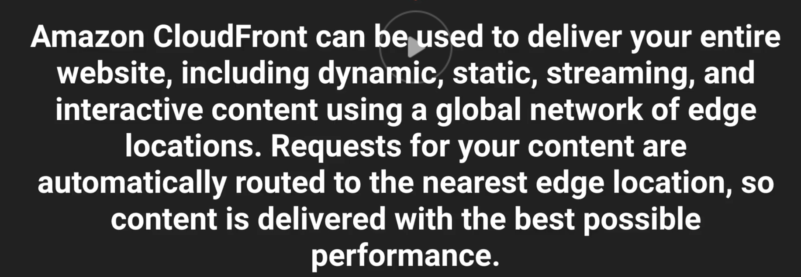

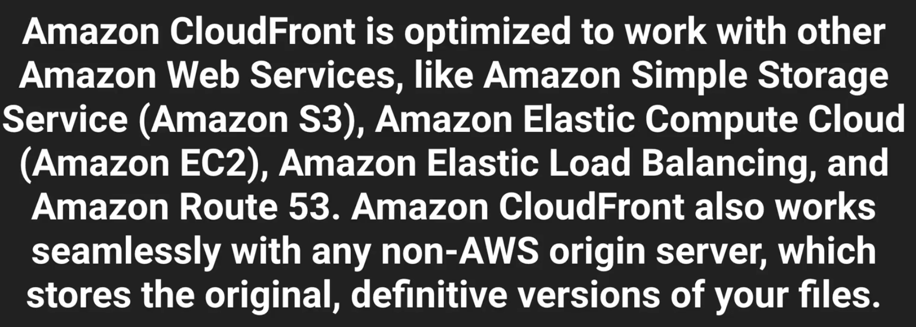

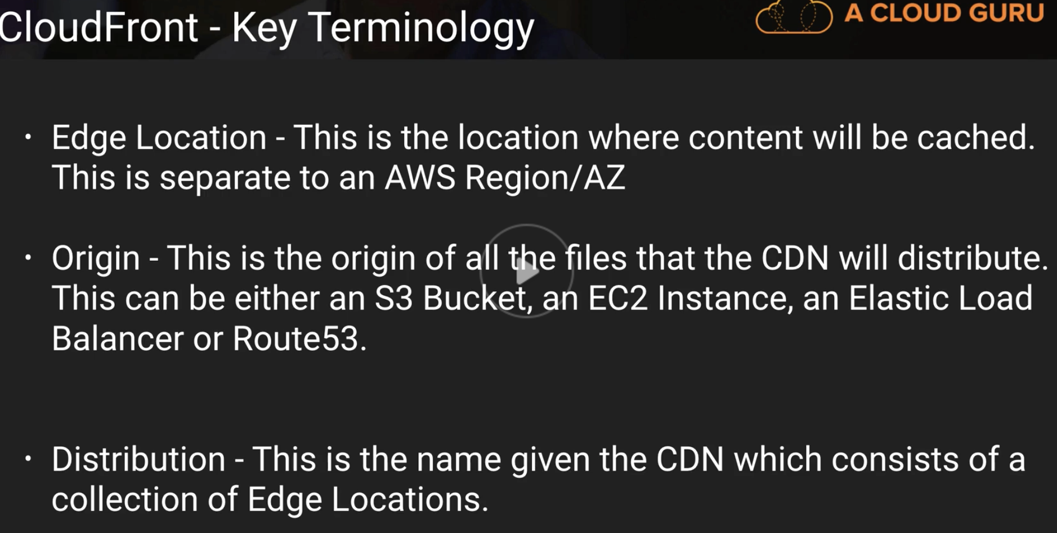

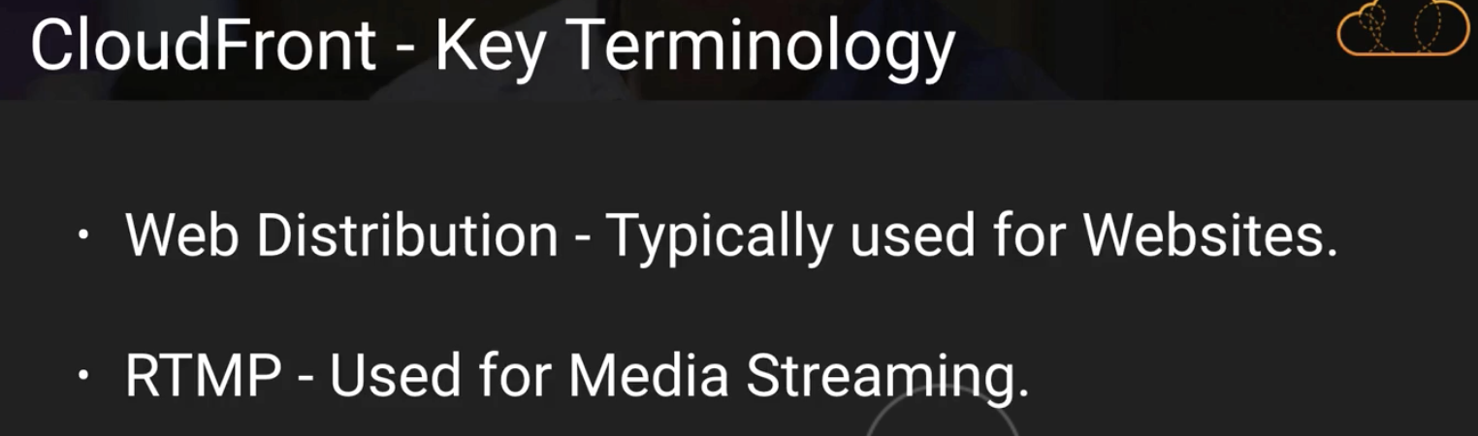

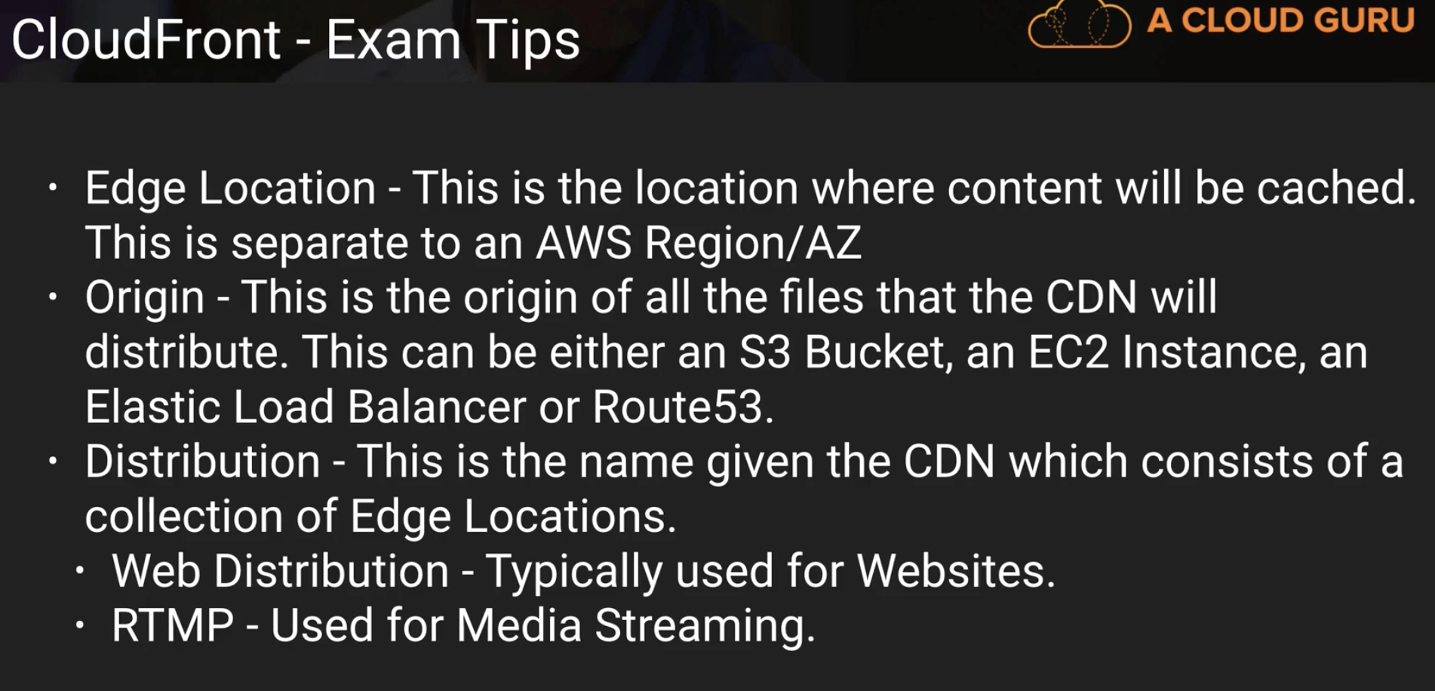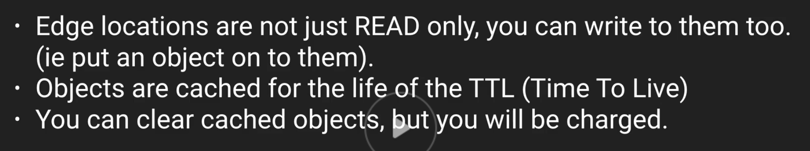

You can create two types of distributions in Cloud front.

**Web** – for websites – html, css, php, etc. these files are delivered over https.

**RTMP** – for streaming video

Default TTL value is 24 hours – 86400sec

To secure cloud front objects, you can use “**Restrict Viewer Access**” which means using **signed URLs and signed cookies**.

You can blacklist or whitelist countries in cloud front.

**Create Invalidation:** If some kind sensitive info is cached in edge location, then you can use this **Create Invalidation** to push out objects from there but this will cost you.

**Securing S3 buckets:**

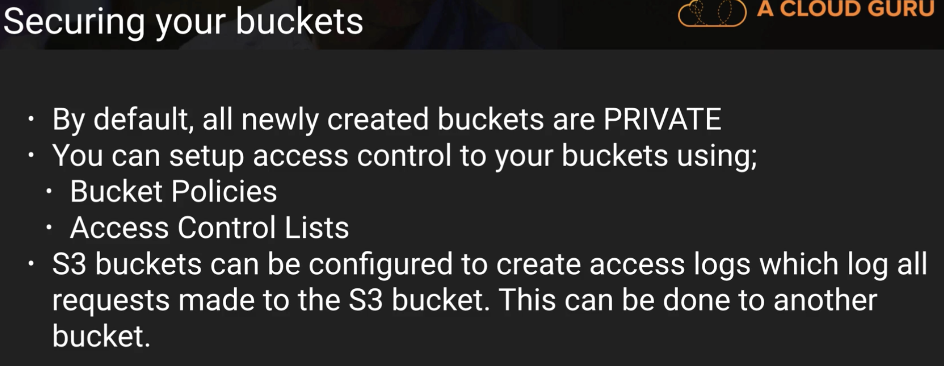

**Different types of Encryption for S3:**

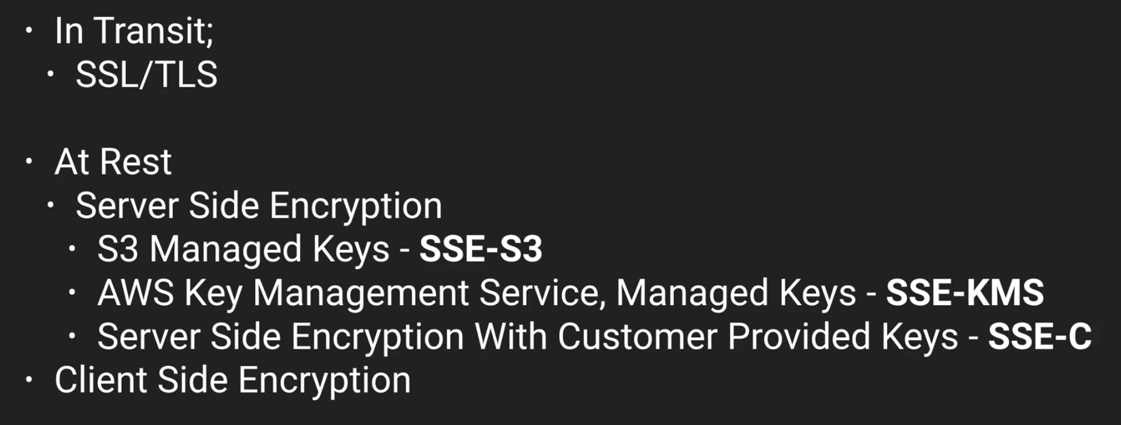

**Storage Gateway:**

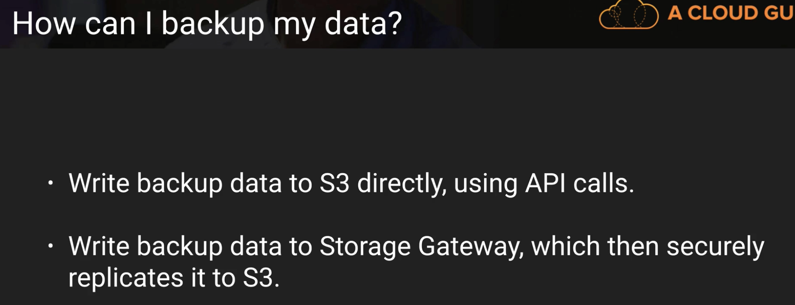

In the above slide,

You can use the first one - (writing data to S3 directly) as an individual.

But at an enterprise level, you would want to use **Storage gateway** instead of running scheduled tasks for all employees. Here in below slide, sub-points are old headings which are imp.

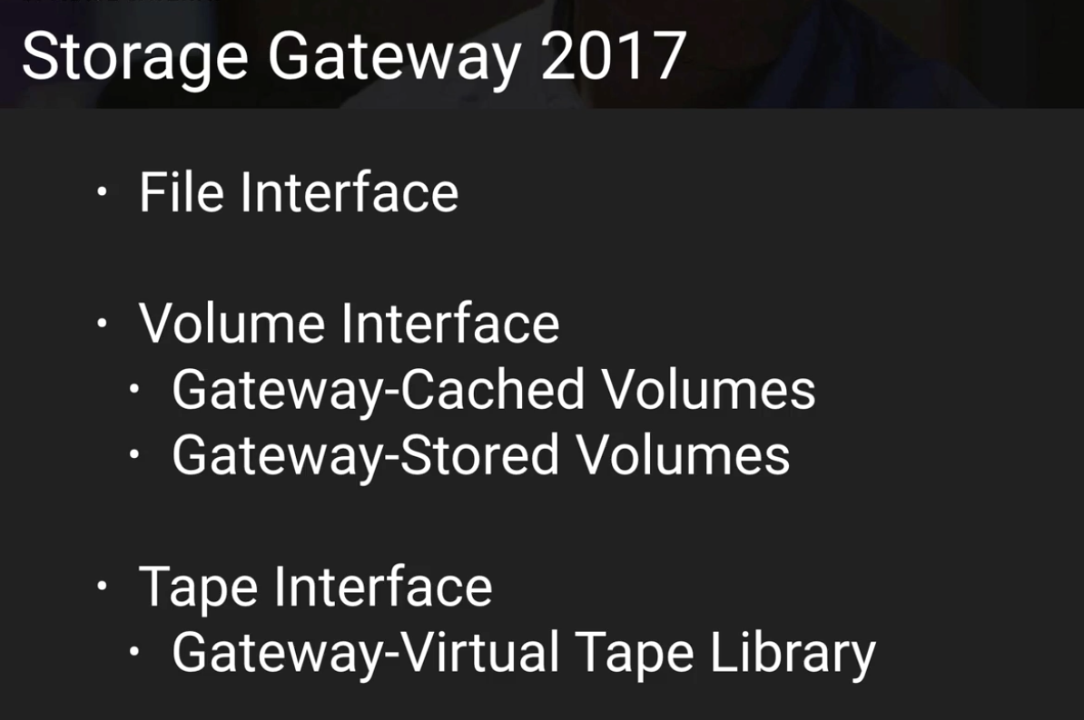

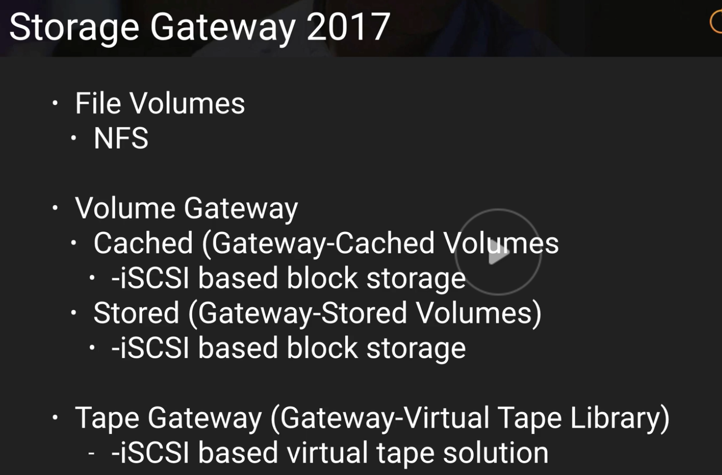

**Below are the explanation for all these different storage gateways:**

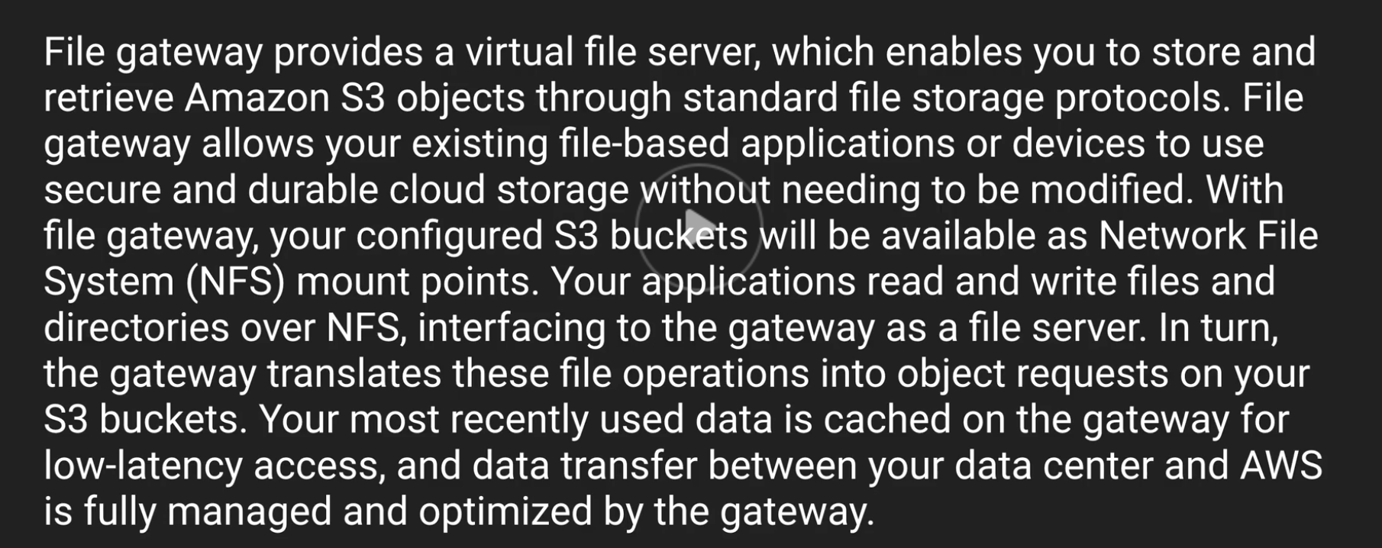

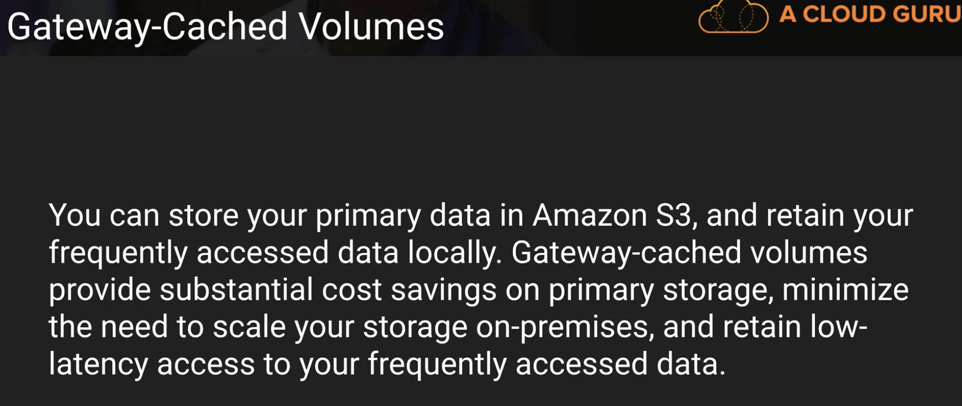

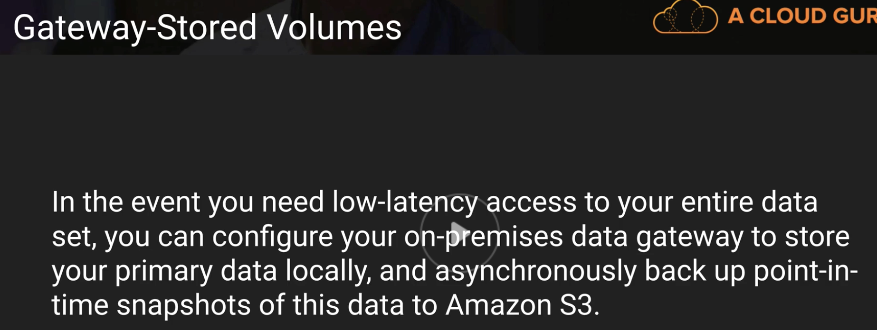

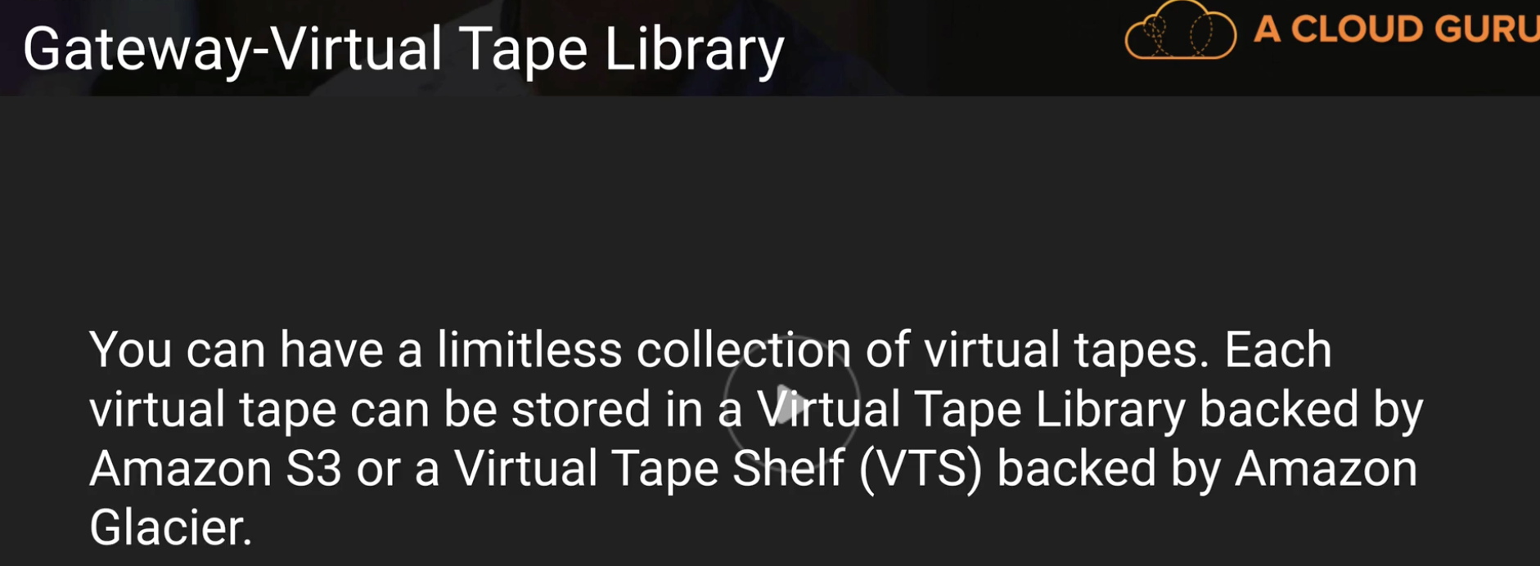

Don’t worry about remembering these number in below slide:

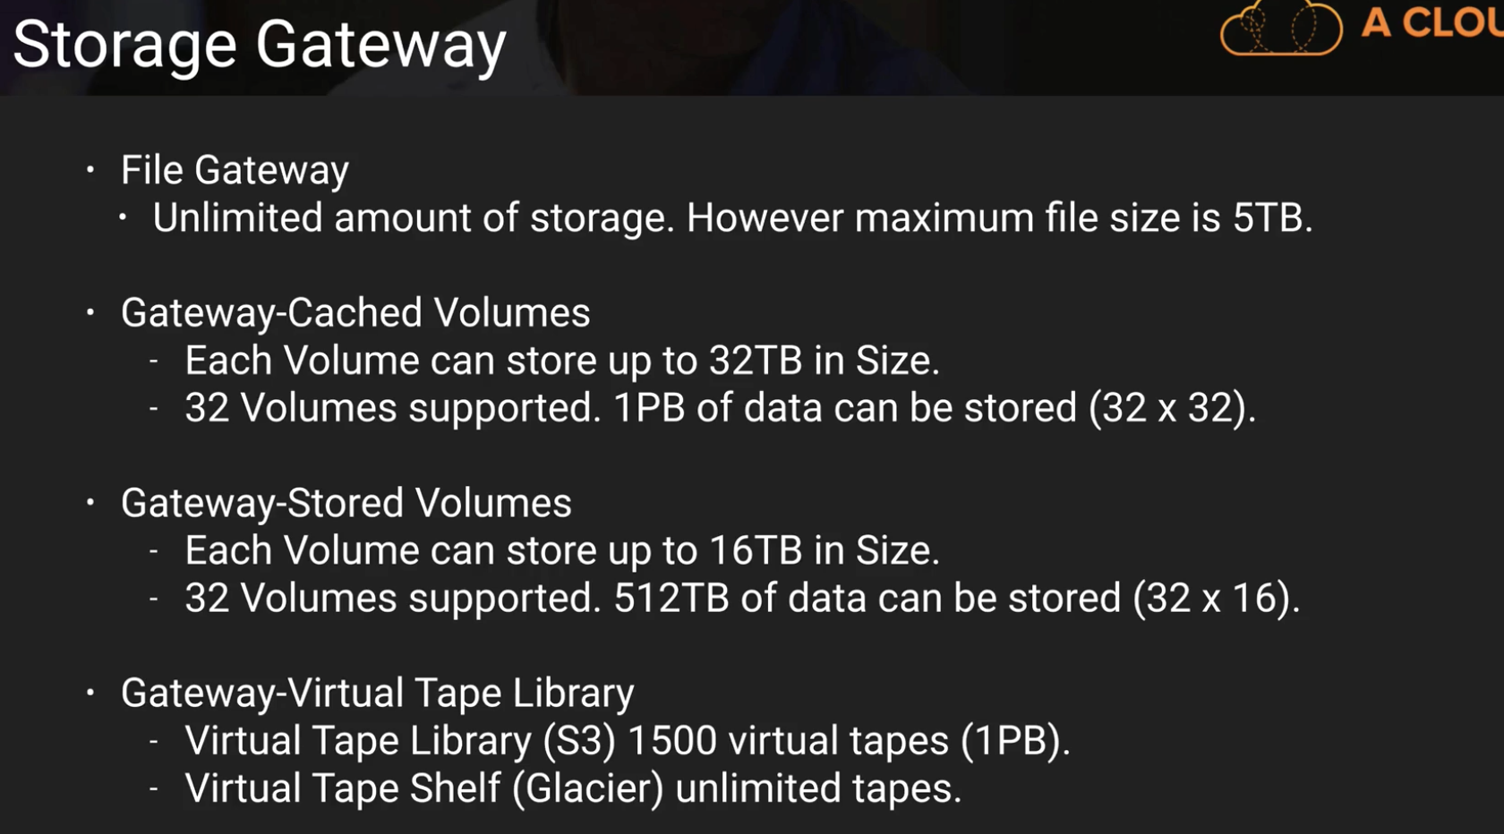

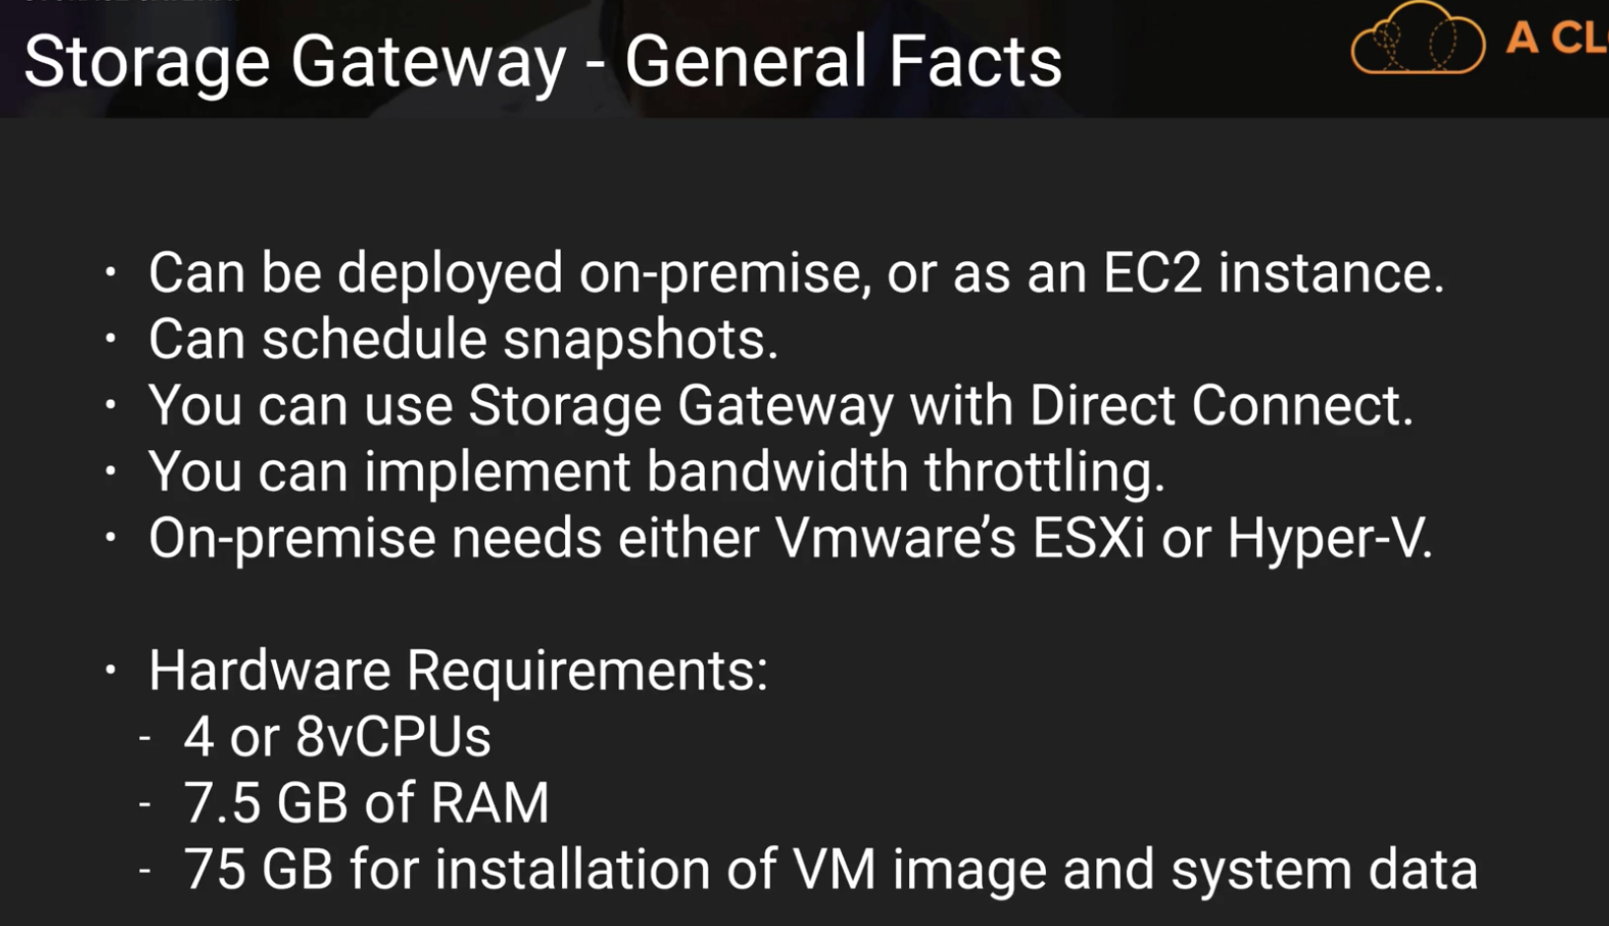

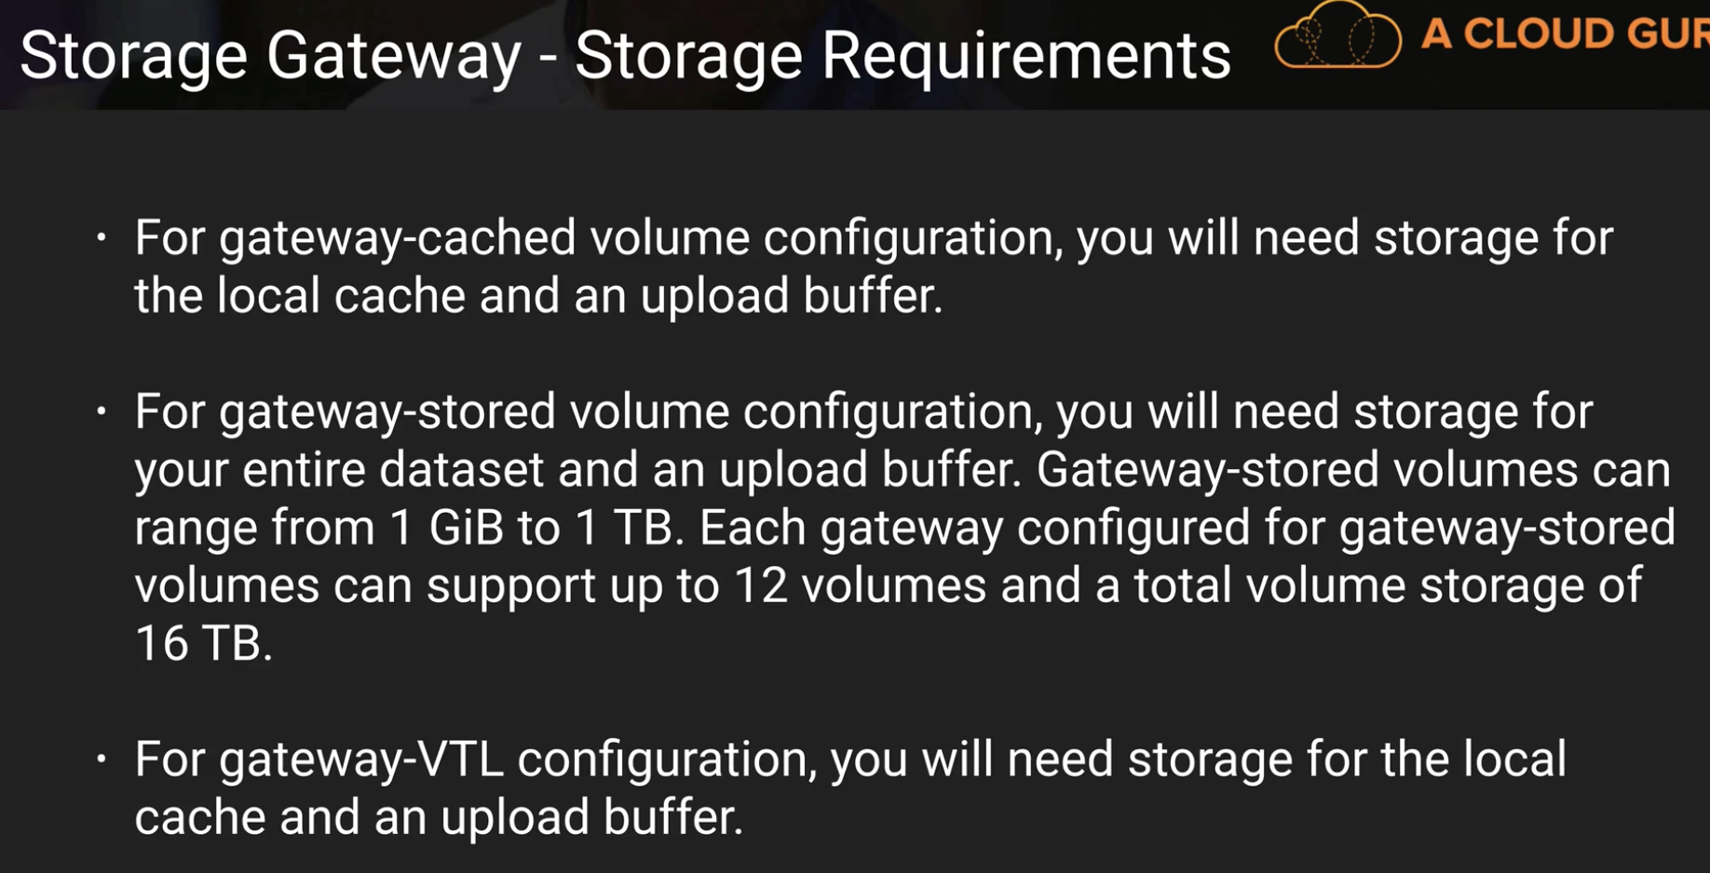

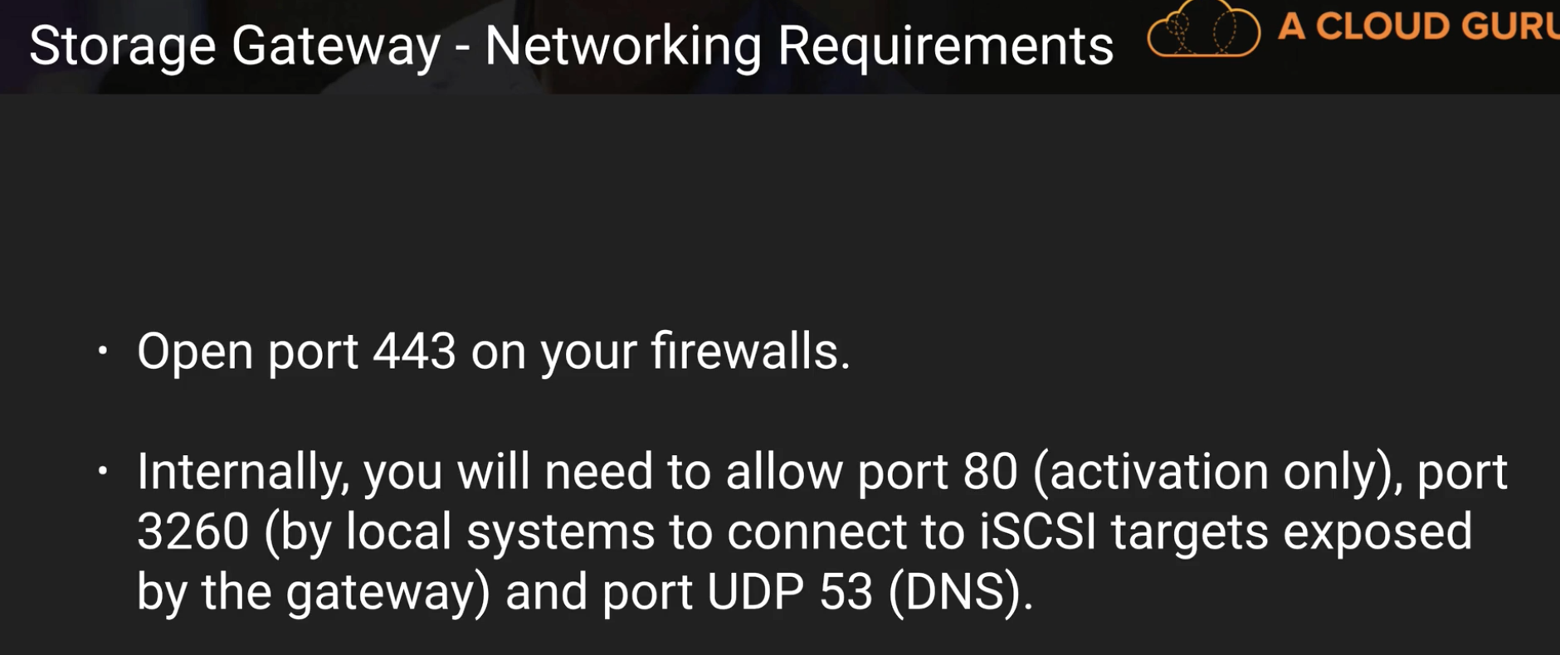

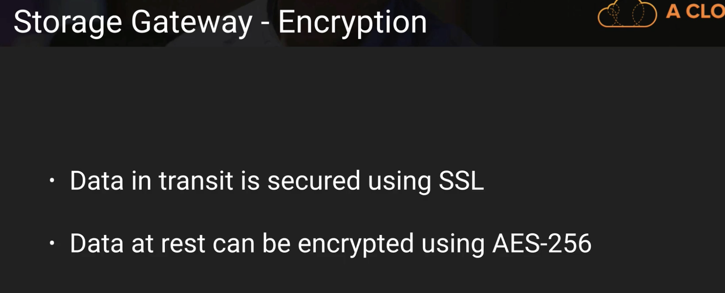

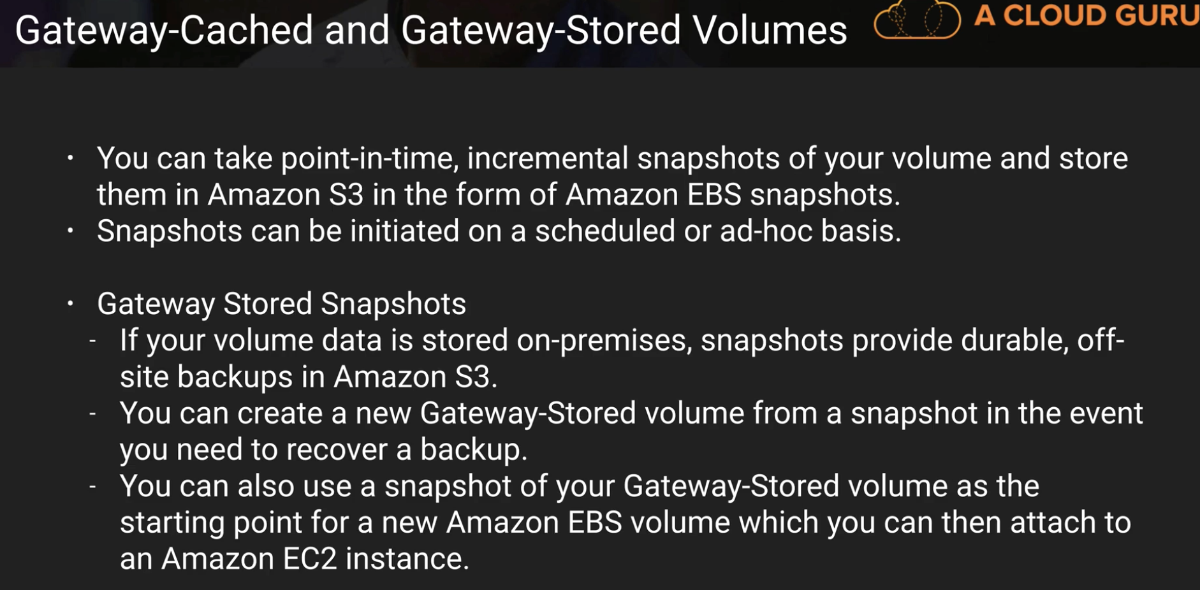

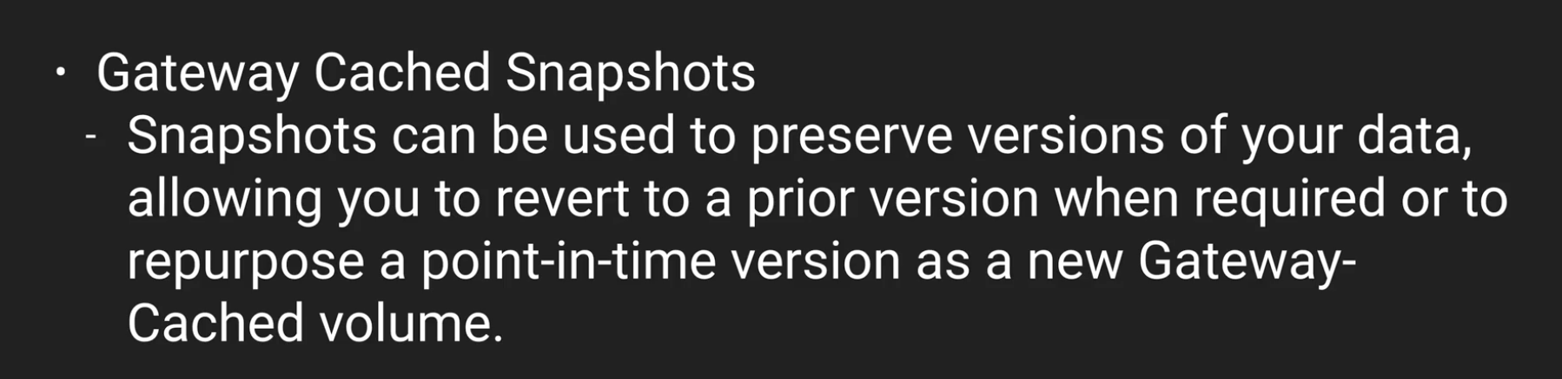

below is an important slide:

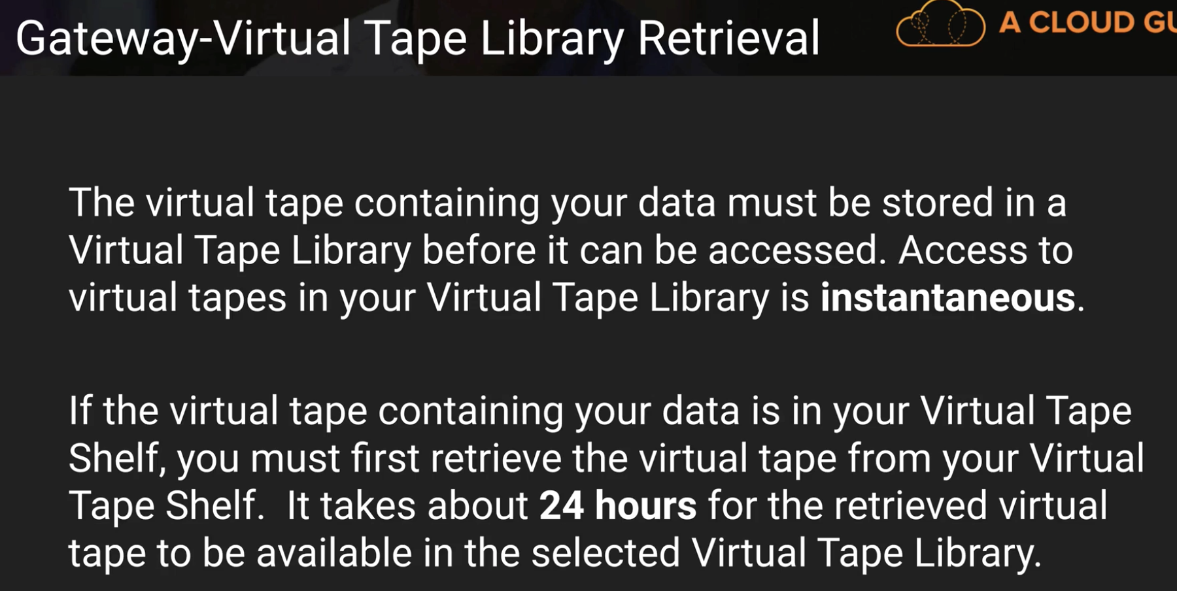

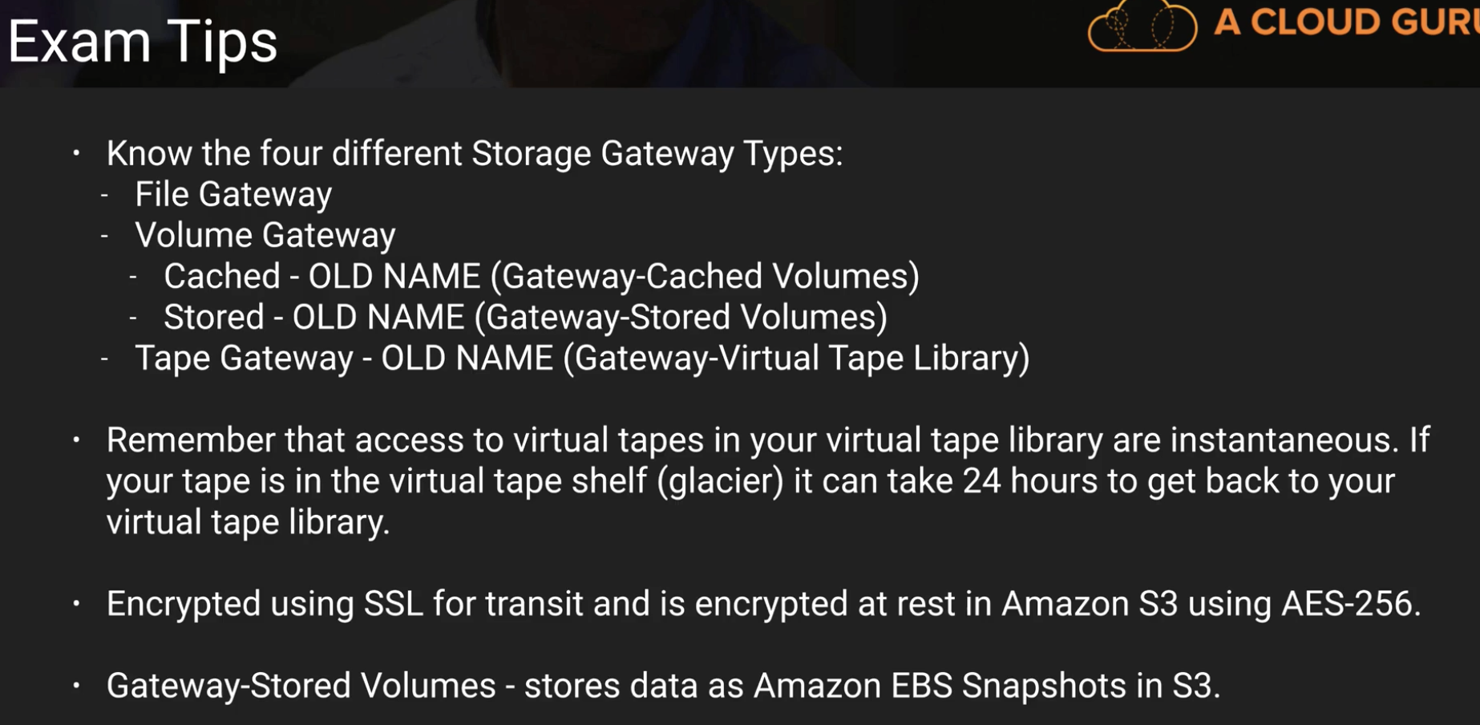

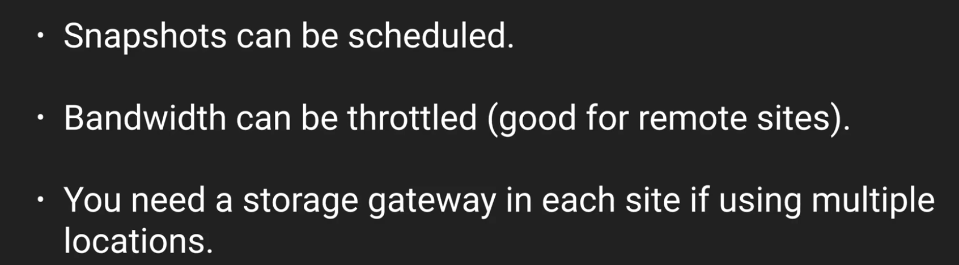

**Snowball:**

Before snowball, Amazon used portable disks to transfer data physically from some places to S3, typically where internet is very very slow.

Different Types:

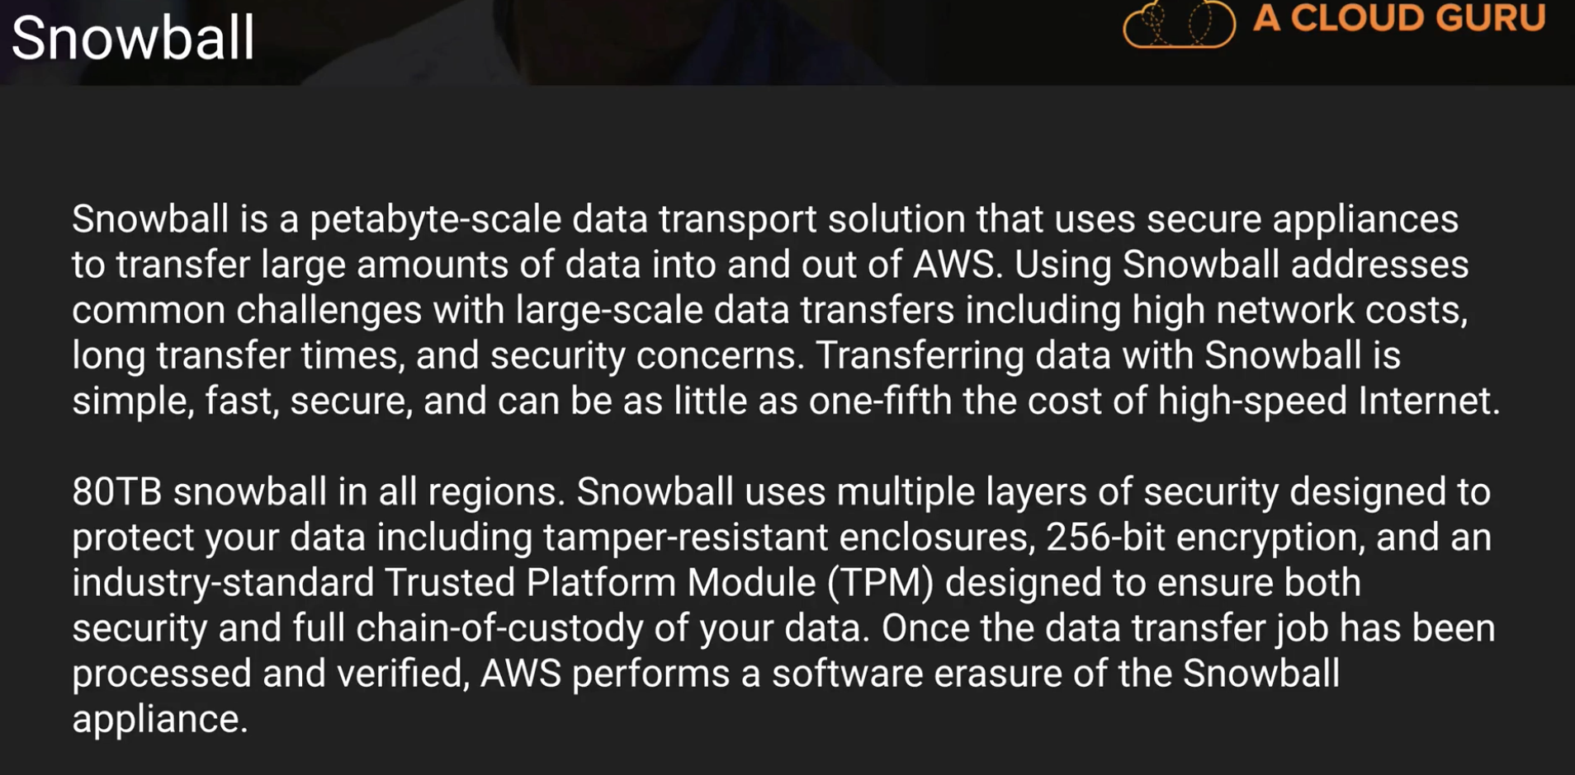

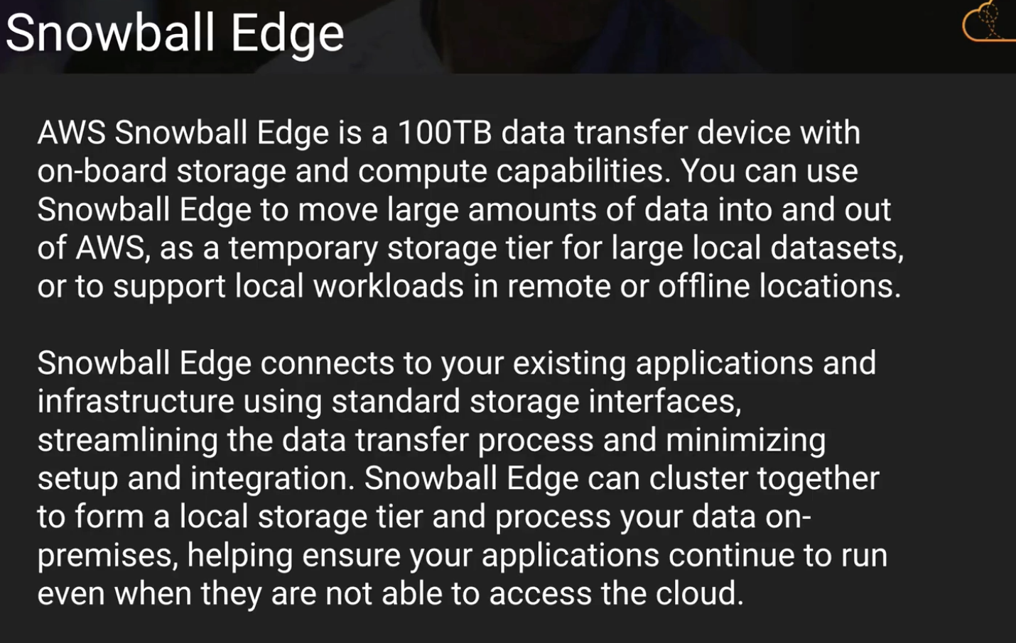

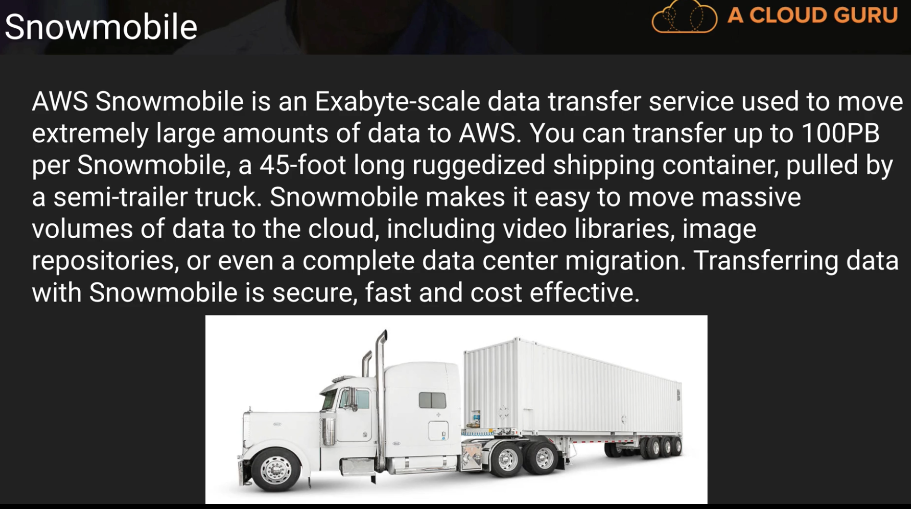

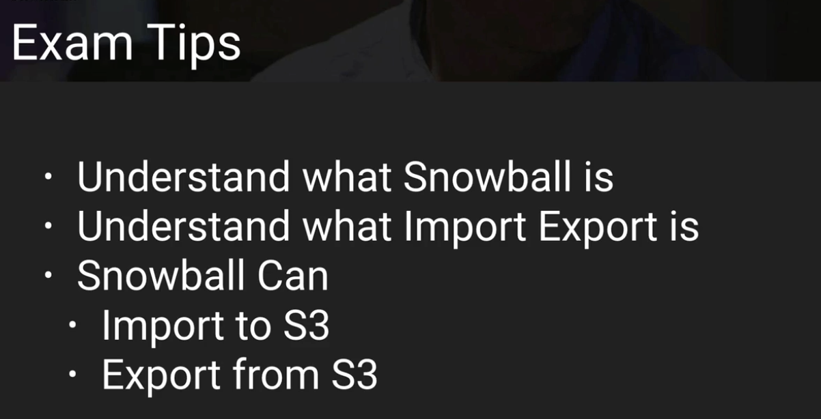

**S3 Transfer Acceleration:**

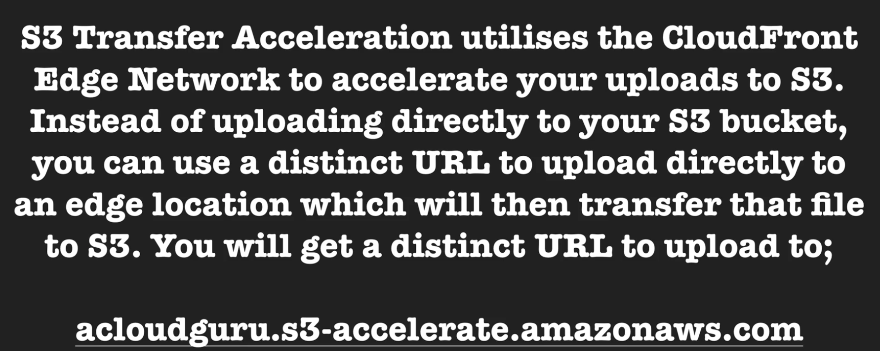

**Summary of whole S3**

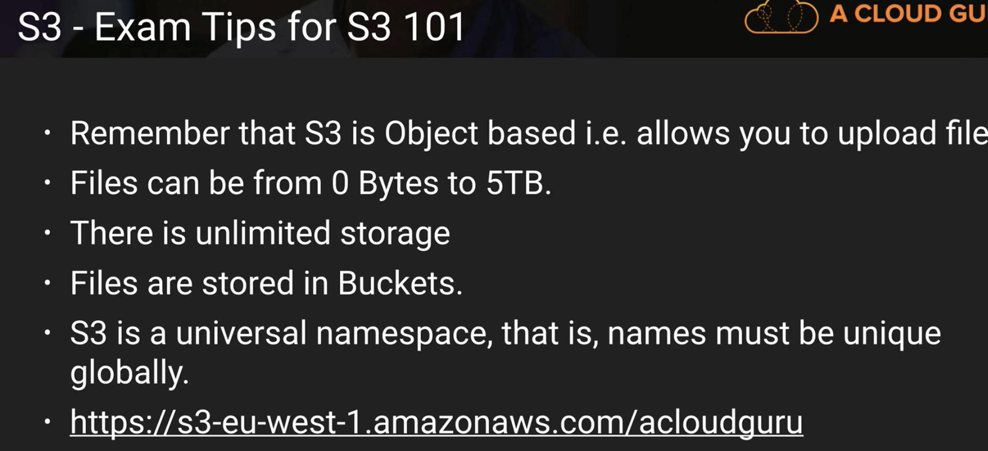

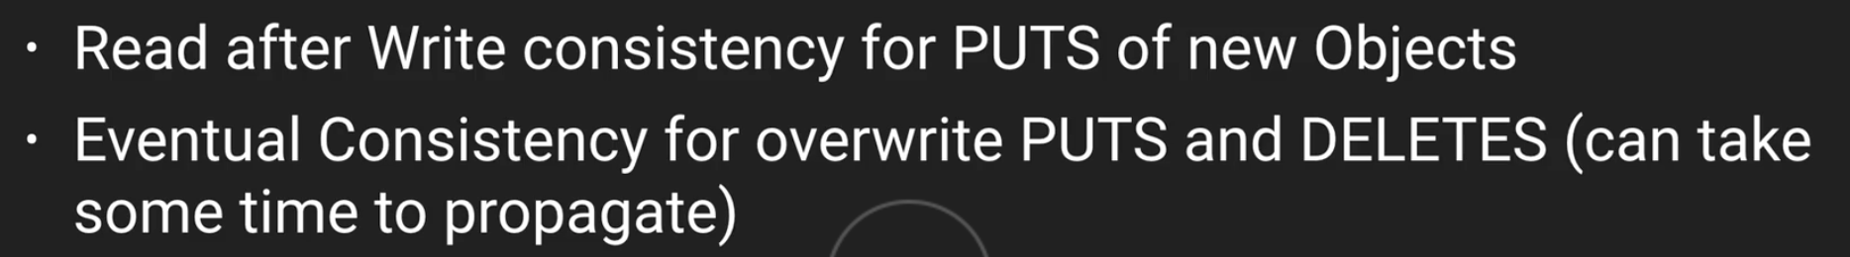

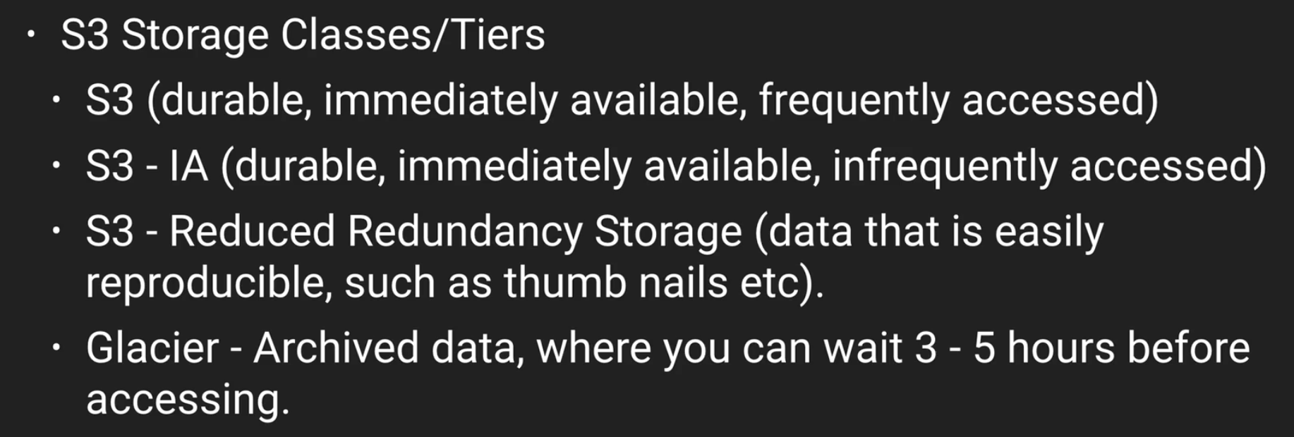

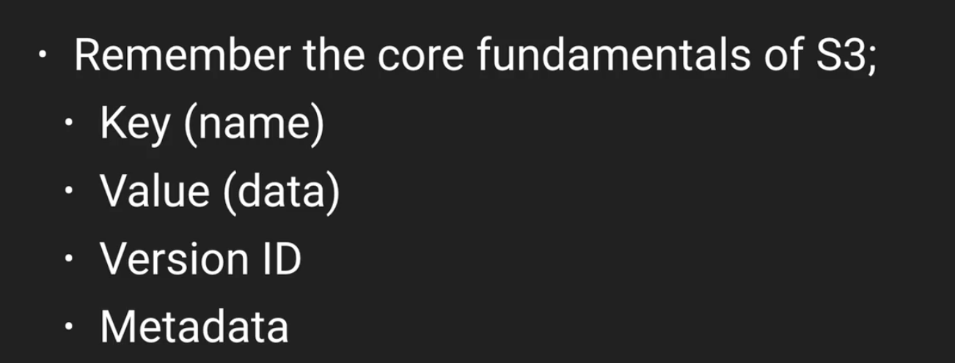

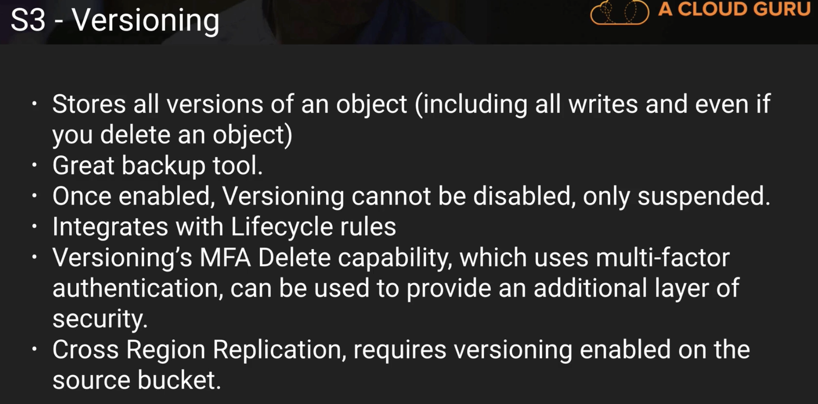

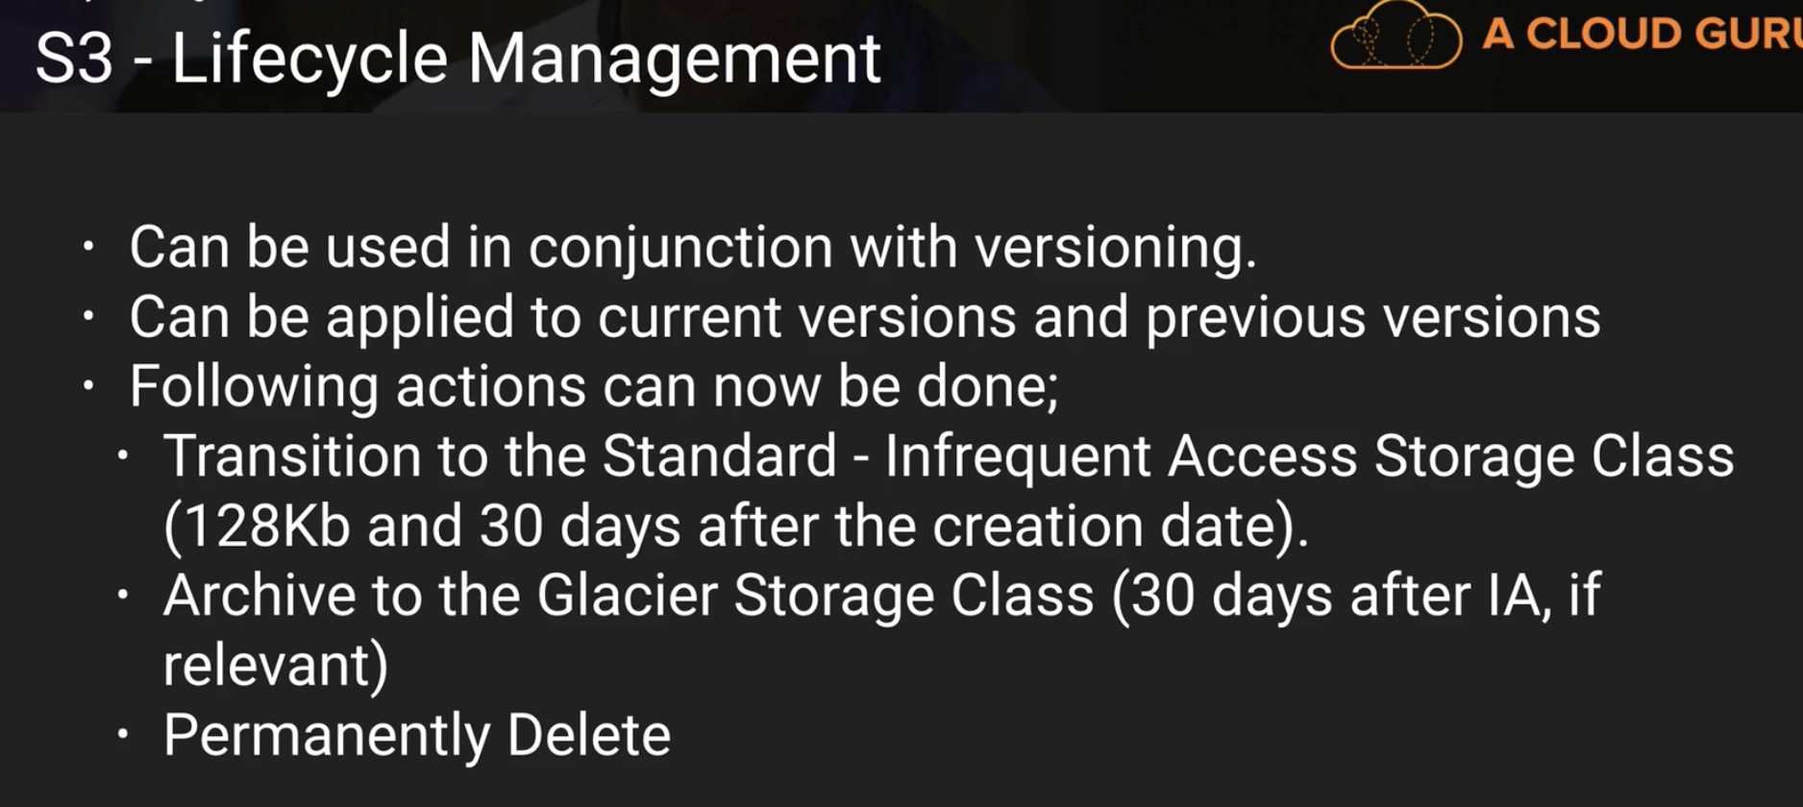

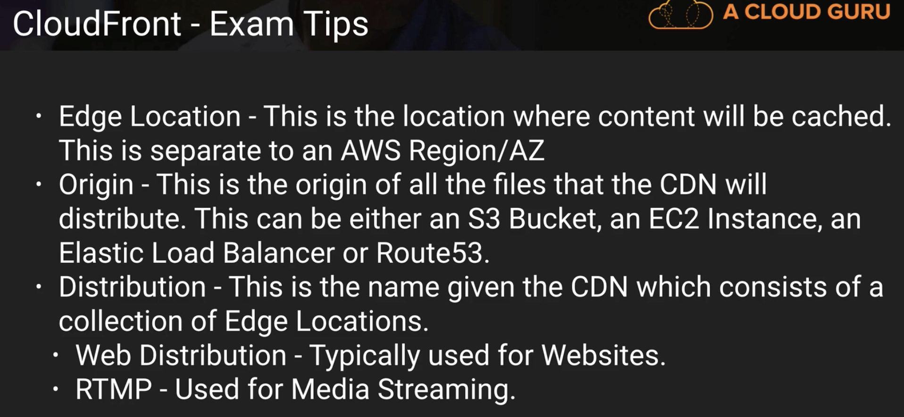

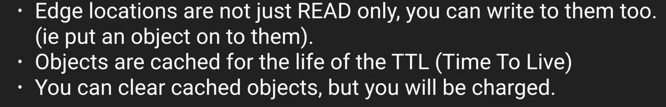

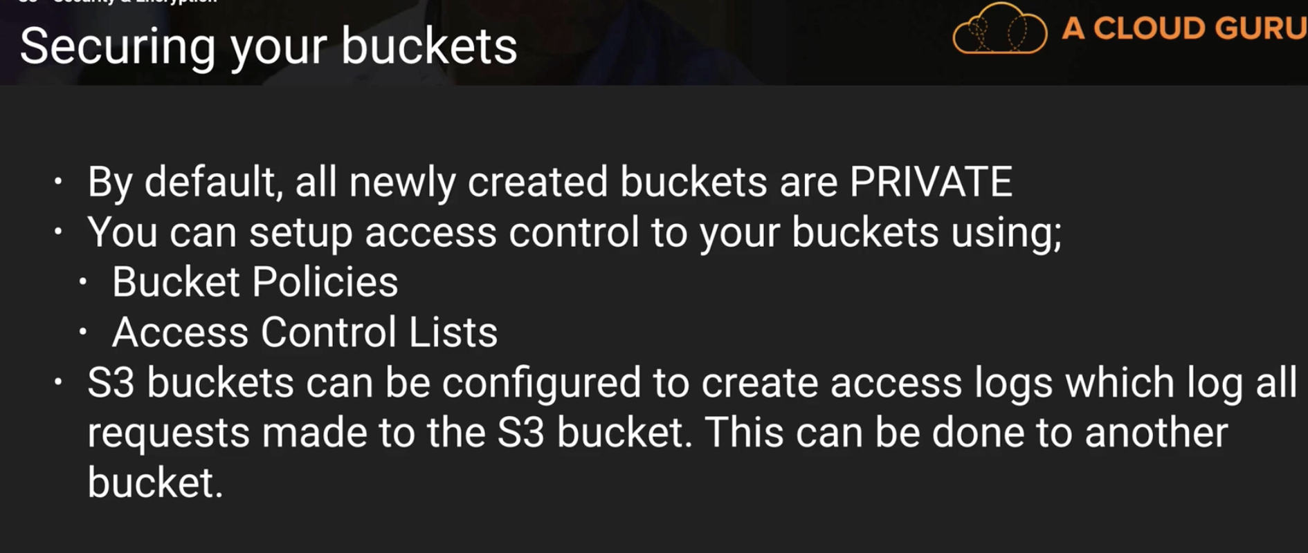

Here in the below slide,

AWS – KMS has actually more options than ordinary SSE S3, like:

* You can have envelope key which protects data’s encryption key.
* You can also find out which encryption is used by whom and when

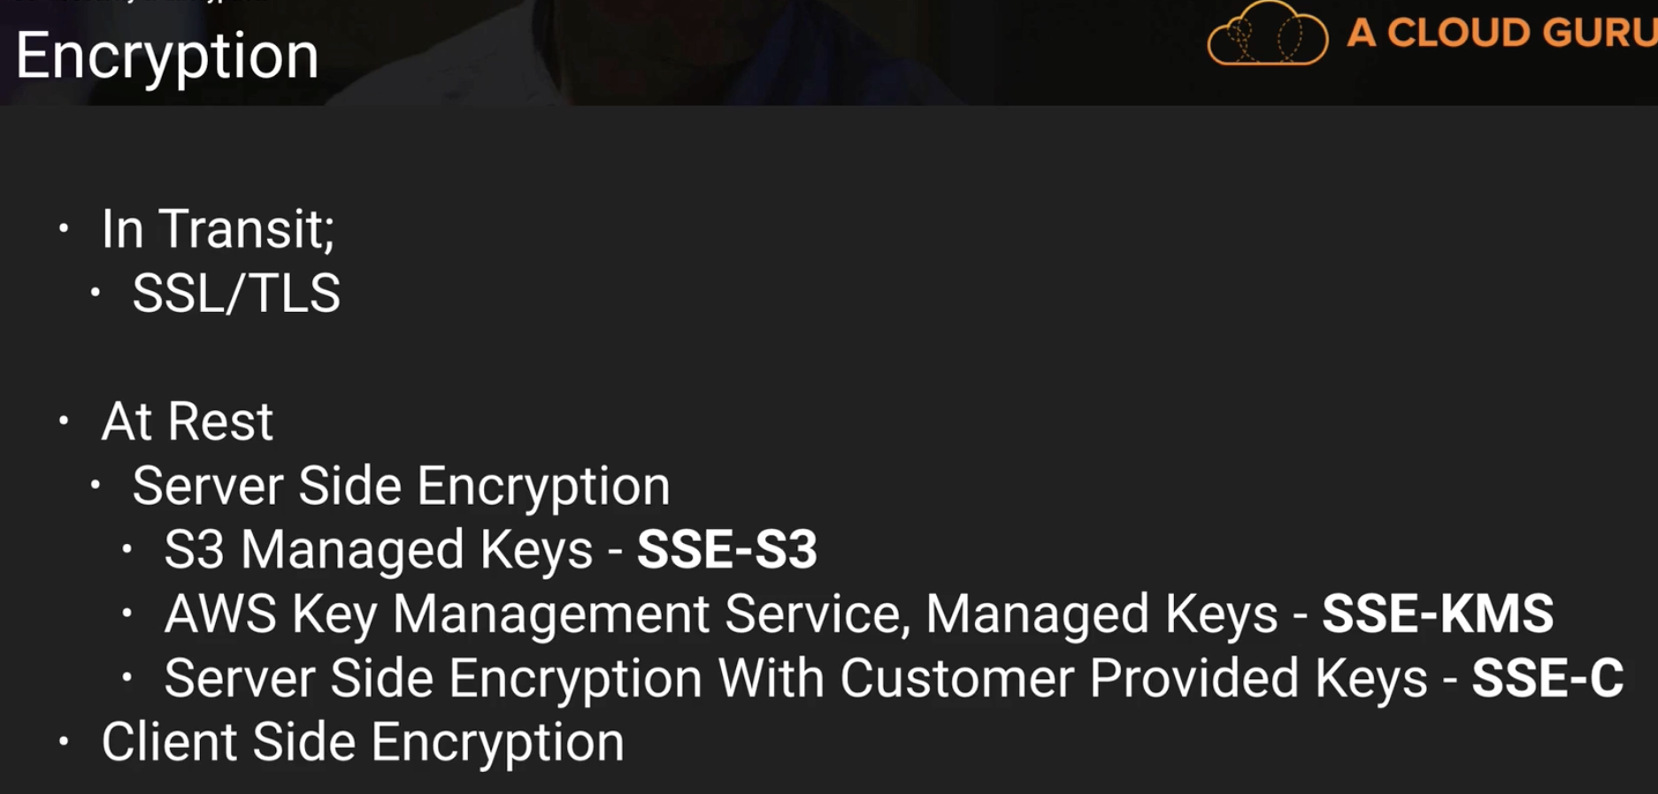

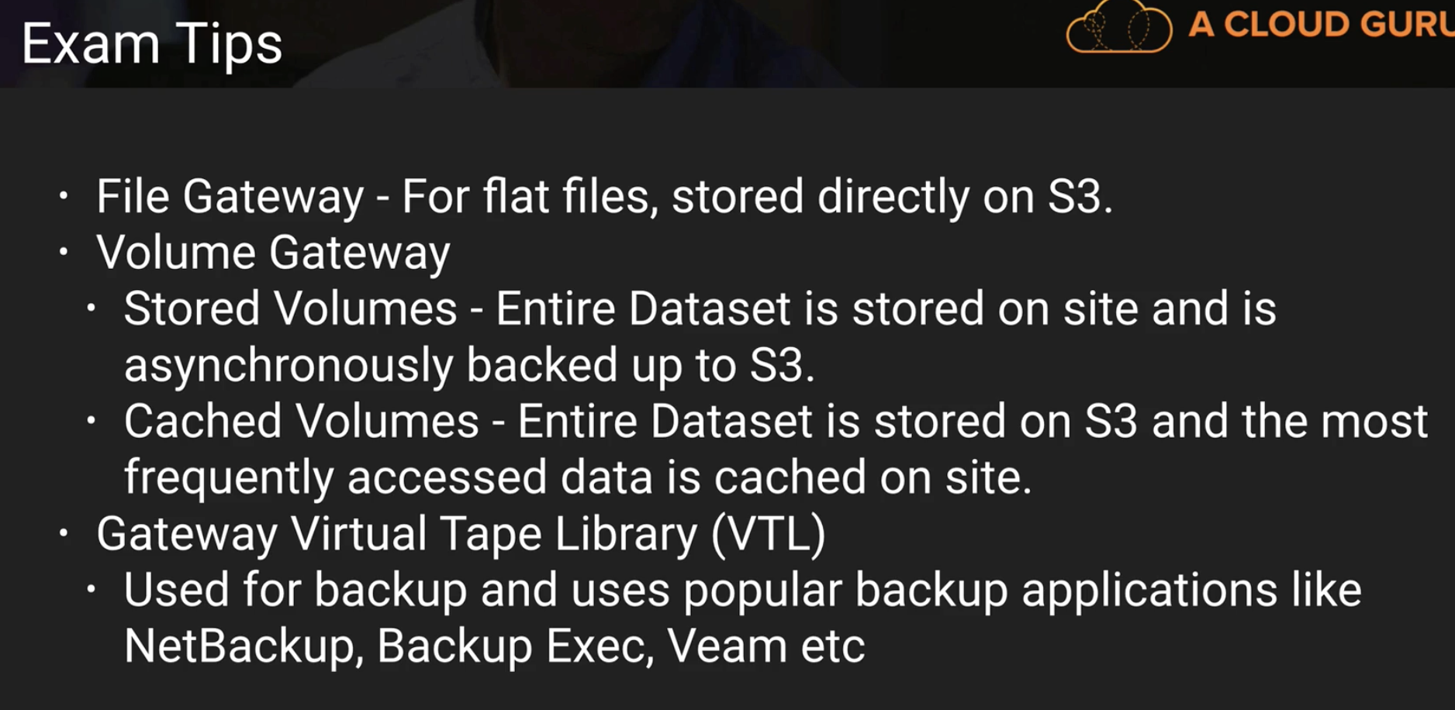

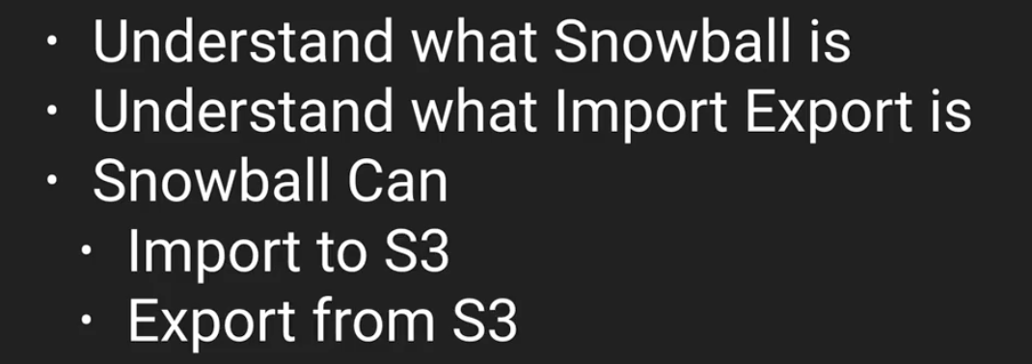

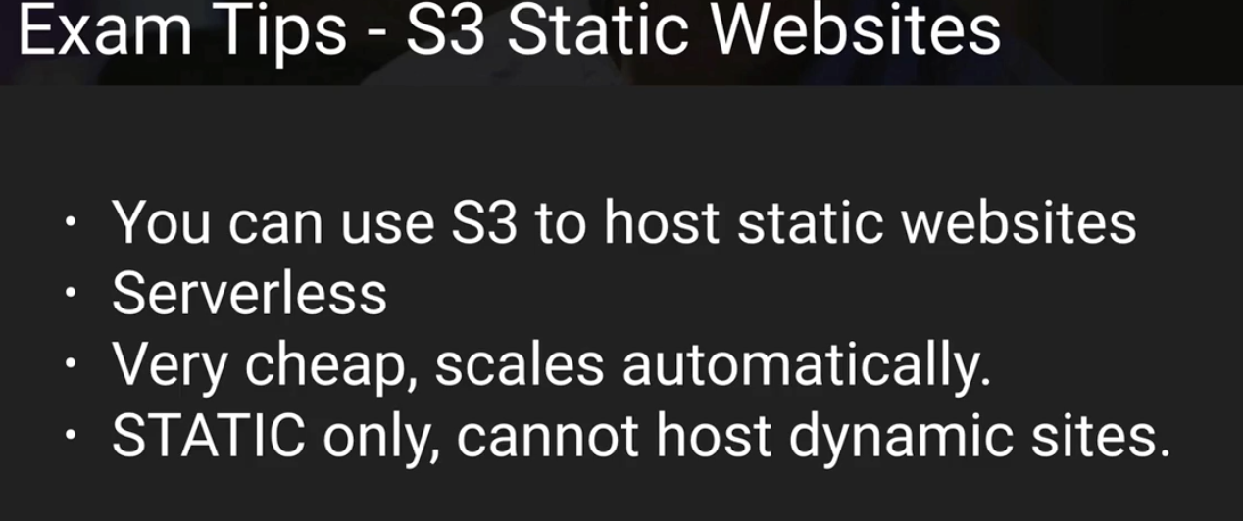

In the below slide, make sure you can differentiate between S3 website and S3 bucket.

Tip : look for word s3-website

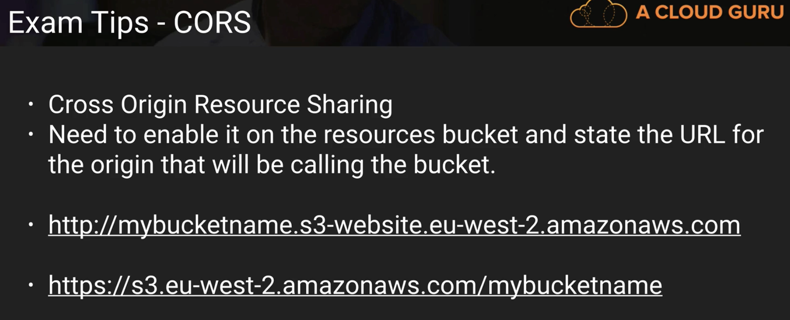

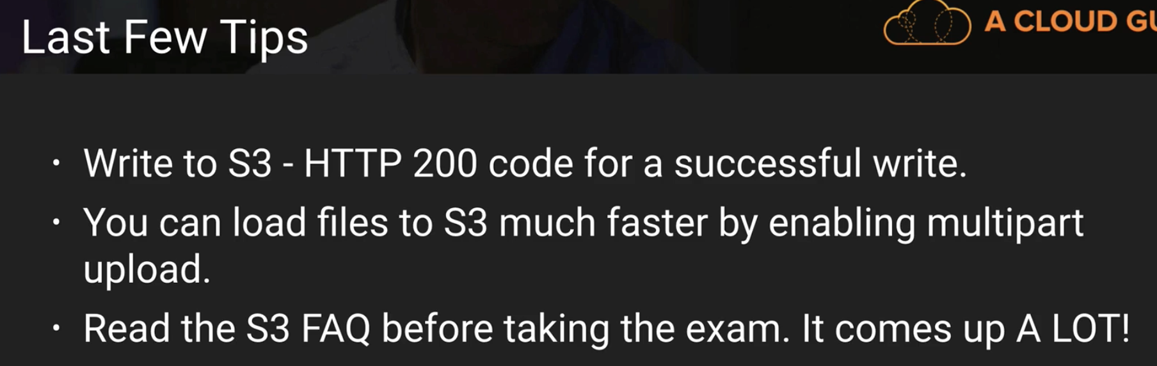

If you want to enable a user to download your private data directly from S3, you can insert a pre-signed URL into a web page before giving it to your user. - TRUE

What is the largest size file you can transfer to S3 using a PUT operation? – 5 GB

You are using S3 in AP-Northeast to host a static website in a bucket called "acloudguru". What would the new URL endpoint be? - http://acloudguru.s3-website-ap-northeast-1.amazonaws.com